beautician  dietician  electrician  mathematician  paediatrician  physician  musician  magician  optician  Superstition | beautician  dietician  electrician  mathematician  statistician  physician  musician  magician  optician  Superstition | musician  magician  optician  dietician  physician  given  joyful  impress  recall  superstition | musician  magician  optician  dietician  physician  give  joy  press  shake  superstition | love  made  make  man  many  may  more  much  must  joy

Friday 13th October
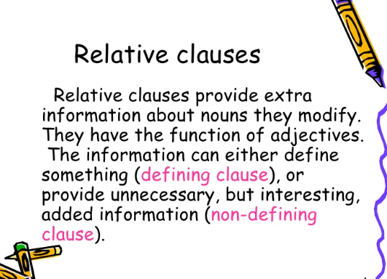
Homework task
Create fact cards based on the information you have learnt during your topic lessons or showing your own research.
These facts can be about; pyramids, Pharos, slavery, the river Nile, gods, history, language or any information you like
Can you use a relative clause to add the detailed information?
Here is an example;

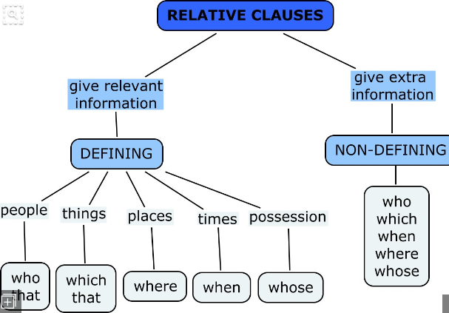
The great pyramid of Giza, which was over 140 metres tall, took over 20 years to build.

