Our School
Art Gallery
opens on
Monday
18th June
2018
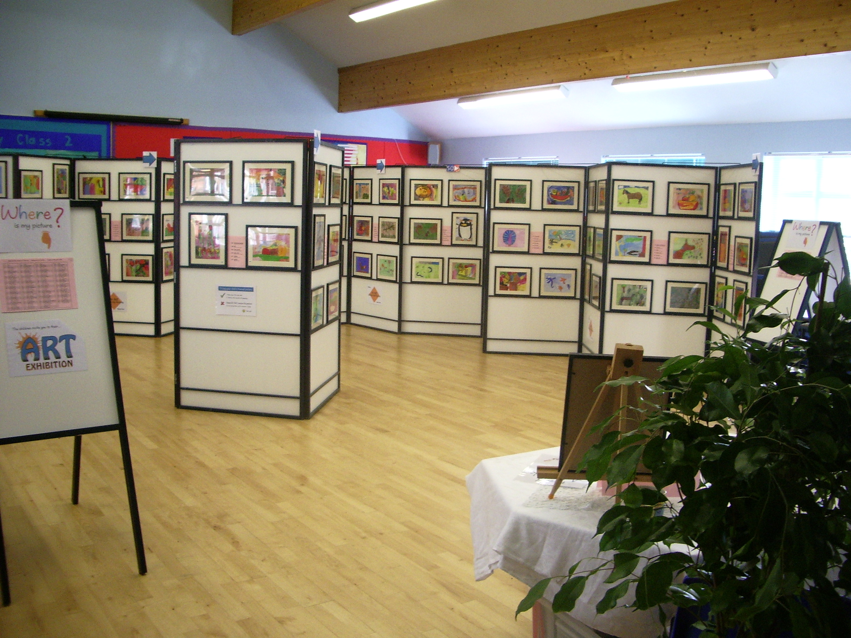

The school cordially invites all parents and friends to an exhibition of the children’s artwork to be held in the school gallery on Monday 18th June 2018 from 3:30pm until 6:30pm. It’ll be quite an event. The PTA committee will kindly be providing refreshments for you to buy while you look around the exhibition. The children have produced some stunning art and we’re sure that you’ll be delighted when you see their beautiful pictures professionally mounted, framed, catalogued and displayed in the gallery (the School Hall!)

The Visual Arts play a big part in the life of the school: it’s an activity that every child can enjoy and play a full part in. Having their pictures framed and displayed will be a big occasion for the children and having someone to show it to will add an important finishing touch, so please make a space in your diary for this very special event.

There will be an opportunity at the exhibition to purchase these framed original pictures in support of school fundraising. Extra framed laser prints of the original can also be produced - a unique gift for friends & family members. Copies can be ordered in advance or – at the very latest – on exhibition day.

Please note that pictures can’t be removed until after the exhibition – we’d like the gallery to remain in place for everyone to enjoy. Sold pictures will be handed out in class during the week after the exhibition.

We very much look forward to welcoming you to this special event.

Yours sincerely,

Mrs Jukes

-------------------- <<< Please detach the tear-off slip here >>> ---------------------
CAN’T MAKE IT TO THE EXHIBITION? or WANT TO AVOID QUEUING?
You can order your child’s picture by completing this reply slip and returning it to the school office, along with cash or cheque made payable to the school. Thank you.

Name of Child: _______________________________ Class: ______________

◻ I would like to buy my child’s original framed picture PRICE: £8.50

I WOULD LIKE TO ORDER ◻ ADDITIONAL framed laser PrintS @ £8.50 each
(N.B. Additional framed prints must be ordered in advance, or on the day of the exhibition. They will be delivered to the school a week or two after the exhibition.

£

TOTAL AMOUNT ENCLOSED: 

