Wednesday 5th September 2018
Re: Mindfulness
Dear Parents/Carers,
Stressed? Worried? Annoyed? Most of us can relate to these emotions. But can we deal with these feelings and move on when they hit us, or do we wallow in them and let them get even worse? Mindfulness helps us to understand our emotions and feelings, and greatly reduces the risk of mental health problems such as anxiety and depression.
Why do we need Mindfulness?
Modern life is busier than ever before, for both adults and children. The school day is crammed from start to finish, with jam-packed lessons, assemblies, lunchtime and after-school clubs, PE and swimming, trips, tests and responsibilities. Often this is followed by evening activities; swimming lessons, Brownies, Scouts, homework, reading and so on. For adults, attention then turns to cooking tea, getting children ready for bed, packed lunches, food shopping, housework and checking children have done their reading, homework, got PE kits ready… and more! And this is without any time spent on themselves yet! Modern technology then adds another huge factor, as very often we are receiving texts and phone calls, checking emails or social media or taking photos at the same time as doing all these other things. The benefits of these busy days and opportunities are endless and result in well-rounded children with many skills, and it is wonderful to be able to so easily keep in touch with photos and messages using modern technology. But having to manage all of this every day can easily become stressful for children and parents.
Life is unlikely to get ‘less-busy’ and, as parents and teachers, we want to continue giving children the best education and opportunities that we can. As they grow up, they will continue to face extremely busy days with lots of pressure, and one day they will become adults and parents themselves, facing many of the challenges that we do. To help children cope well with their current and future lives, we can teach them tools and skills to do so. Mindfulness teaches children the importance of understanding their emotions, not hiding from them. It teaches techniques to manage negative emotions, like stress or anxiety, and quick ways to overcome these feelings. Most importantly, practising mindfulness regularly reduces the amount that these emotions affect us in the first place.
How do you actually ‘do’ mindfulness?
Mindfulness is any activity where you are completely focused on yourself and the thing you are doing. The aim is to not think about anything else and be completely present in the moment. It can be any amount of time and there are no right or wrong activities! There are two situations in which you might practise mindfulness:
- A ‘quick fix’ when you have a moment of stress, panic etc. These would generally be a short, quick, easy activity like a breathing exercise or doodling.
When we are stressed, our brain activates our adrenal gland. This causes adrenalin to shoot around our body, increasing our heart rate and making us feel even more panicky! By doing an exercise that focuses on breathing slowly, we in turn slow down our heart rate and send a message to our brain that everything is ok, and it stops causing the excess adrenalin.
- Regular mindfulness, to reduce the need for the above ‘quick fixes.’ This might be things like running, yoga, reading, gardening or jigsaws.

Mindfulness at NJS
On Friday 14th September, will are holding a mindfulness day called ‘Feel Good Friday!’ Children will experience a range of different mindfulness activities, exploring and discussing which ones feel good for them and the benefits of them. A key aim for the day is to show the children that mindfulness is for everybody, it doesn’t have to always be serious and there are no rules when it comes to choosing your own way of doing it!
Following Feel Good Friday, we will be practising mindfulness daily in school using a resource called Calmer Classrooms (see website at end of letter.) There is a focus for each day:
Meditation Monday
Take a Breath Tuesday
Wake Up Your Body Wednesday
Thoughtful Thursday
Get That Friday Feeling
Through practising mindfulness and showing children how valuable it is, we hope to create relaxed and happy children who have a growing bank of skills, strategies and resources to use to manage the challenges of everyday modern life. It will support them to look after their mental health and is something they will be able to use throughout their lives, making them strong and resilient people.
If you have any questions about mindfulness or what we are doing in school, please don’t hesitate to email me or catch me on the playground after school. I would love to hear any feedback (from grown-ups or children!) about our new mindfulness ventures. I’m sure the children will enjoy teaching you what they learn at home!
Happy mindfulnessing

Miss Megan Hardy
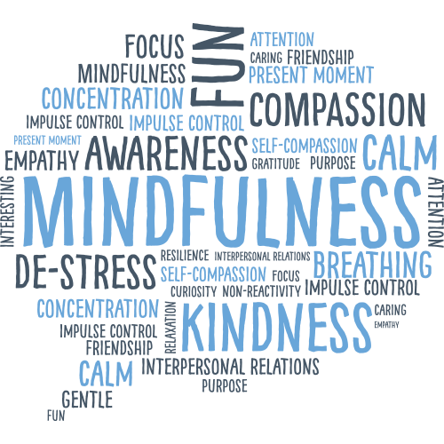
megan.hardy@taw.org.uk
www.calmerclassrooms.co.uk

