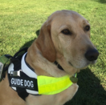
Guide Dog
Woody

invites you to join him for
tea and cakes
in the Church Hall,
Church Aston TF10 9JG
on Saturday 11th May 2019
2.30 – 4.00 pm

£3.00 adults / £1.00 children

in aid of Guide Dogs for the Blind

