

**Lilleshall**

**Cricket Club**

**www.facebook.com/LilleshallCC**

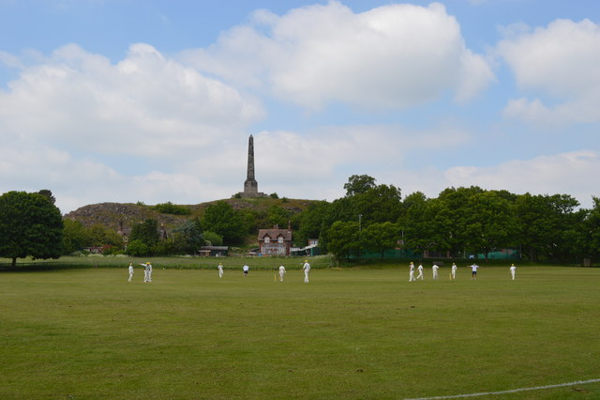

**Cricket for Everyone!**

**We consistently manage to put 4 teams out every weekend – our 1st,2nd and 3rd XI on Saturdays and our 4th XI on Sundays!**

**We also have All Stars running for kids 5-8 years old, so come on down and have some fun!**

We are looking for you future stars between 9-15 years old so come along to training and show us your skills!

**Lilleshallcricketclub@talktalk.net**

**www.twitter.com/LilleshallCC**