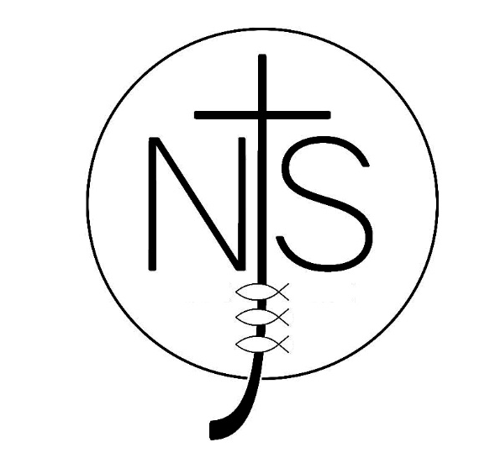
Newport CE Junior School
Uniform Policy
Adopted by Governors February 2018
Aims
Our policy on school uniform is based on the aims that uniform:
- Promotes a sense of pride in the school.
- Engenders community and a sense of belonging in school.
- Is practical and smart.
- Identifies children with our school.
- Is designed with health and safety in mind.
- Is regarded as suitable wear for school and good value for money by most.
The Role of the Governors
The Governing body are ultimately responsible for this policy and expect the Head teacher and school staff to implement it. If there are serious reasons, for example religious grounds, why parents may want their child to wear clothes that differ from school uniform, the school will look sympathetically at such requests. It is the Governors responsibility to ensure that the school uniform meets equal opportunity guidance. If parents or carers have any concerns they should firstly approach the Head teacher.
Monitoring this Policy
School staff will work with the School Council to praise children who take pride in their uniform. If, for an unavoidable reason, a child cannot comply with the policy a home link message should be sent to the class teacher to explain and give detail about when it is anticipated the child can be back in uniform. If there has been no communication from a parent or carer, children who do not comply with this policy, will in the first instance be given a verbal reminder and in a second instance a letter will be sent home.

The Uniform
School Uniform
- A bottle green sweatshirt or cardigan bearing the school logo.
- White polo shirt (these can be purchased with or without the school logo)
- Grey trousers, shorts, skirt or pinafore.
- Plain white, bottle green, grey or black socks or grey, bottle green or black tights.

Summer Options (Summer term)
- Bottle green and white checked cotton summer dress.

Footwear
- Sensible black shoes
- Sensible, flat, plain black ankle boots may be worn in the Winter months between 1st November and 1st March.
(Children are not allowed: trainers or shoes that look like trainers; plimsolls; sling backs or heels.)

PE
- A plain green, yellow, blue or red (House Team colour) cotton round neck t-shirt.
- Black shorts or jogging bottoms.
- A pair of trainers
(In colder weather children may wear plain jogging bottoms and a plain round neck sweatshirt. No PE clothing should display a logo, badge or crest.)

Swimming
- Shorts, trunks or a one piece swimming costume.
- A swimming hat
- A pair of goggles (recommended but optional)
- A towel

Jewellery
- Jewellery should not be worn other than watches or plain, small stud earrings.
- In PE stud earrings are to be removed or covered with plasters.

Hair
- Long hair should be tied back.
- Hair ties, clips and bands should be black, brown, green or white.
- No oversized clips are allowed.

This new uniform policy applies from September 2018. There will be a period of transition during the 2018/2019 academic year during which the old school logo and yellow polo shirts are permitted. From September 2019 this exact uniform is compulsory for all children.
Uniform can be purchased from Marys Tots and Teens, Stafford Road, Newport.

