Newport CE Junior School

Worship and Spirituality Policy

Date Policy Written and Agreed by Governors: | Date of last review: | Date of next review:

‘We aspire to ensure that our inclusive, welcoming and loving church school gives children and adults the opportunity to reach their full potential, so that through God’s love they can make a difference to the world around them.’

Learning to make a difference through God’s love.
Jesus said, ‘Love one another as I have loved you’ John 13:34

The Collective Worship Policy at Newport CE Junior School pays due regard to statutory requirements and is consistent with the practices and principles of the Church of England. Worship will be wholly or mainly of a broadly Christian character.

Definition of Collective Worship
Collective Worship is a time when the whole school, year groups or classes, meet together in order to express praise and thanksgiving to God. It is a time when those with a faith can affirm their Christian values and attitudes. We share our common concerns, issues and interests. It offers all pupils an opportunity to worship through engaging in relevant, meaningful experiences and provides opportunities for the pupils’ spiritual, moral, social and cultural development.

Aims of Collective Worship
During our Acts of Collective Worship we aim:
- To enhance the spiritual development and response of pupils
- To foster reflection, prayer and silence
- To foster an awareness of and a respectful attitude to God
- To foster empathy and imagination, enabling pupils to participate in a variety of ways
- To explore and enjoy praise, prayer, and the rituals of Christianity.
- To affirm the Christian faith and belief in Jesus as Son of God ➢ To enable pupils to reflect on the experiences of Christians ➢ To foster and value a search for a faith to live by.
- To learn about and reflect upon Christian Teaching, Biblical material and Christian festivals, in a way that relates to the pupils’ experience and to living together in community
- To worship together rather than apart (whilst taking into account the nature of our community, its mix of those with a faith and those without, and those from a different faith background)
- To use the significance and meanings of our Core Christian Values to anchor our worship into clear Christian belief by relating them to Bible stories and readings

The Organisation of Collective Worship
Collective Worship is organised across the week and will usually take place in the school hall, or in one of the classrooms. However, we recognize that Collective Worship can also take place outside too.
Acts of worship will usually last for approximately 15/ 20 minutes, although it is recognized that this time will be shortened or lengthened when it is appropriate.
Day | Group | Leader | Content/ Focus
Monday | Whole School | Headteacher/SLT  Rector | The content for these acts of worship will be linked to our Core Christian Value.
Tuesday | Whole School | Mrs Green | Singing  Worship- Core  Christian Value.
Wednesday Wk 1  Wednesday Wk 2 | Whole School  Class | Open the Book  Class Teacher  Child led | Worship linked to the Gospel.  Core Christian Value.
Thursday | Whole School | Headteacher/SLT | Celebration.  Headteacher Awards.  Worship linked to Core Christian Value.
Friday | Whole School | Child led.  Class Teachers  Child led | Class Assembly to Parents.  House Team  Meeting

There will be special acts of Collective Worship at points in the year
- Visits to Church
- Harvest
- Christmas
- Easter
- Leavers Service

Planning Acts of Collective Worship
Acts of worship are planned in line with our focus Core Christian Value for the half term. Other areas for worship might be drawn from the Church calendar or from events outside school either locally, nationally or globally.
Our Core Christian Values are:
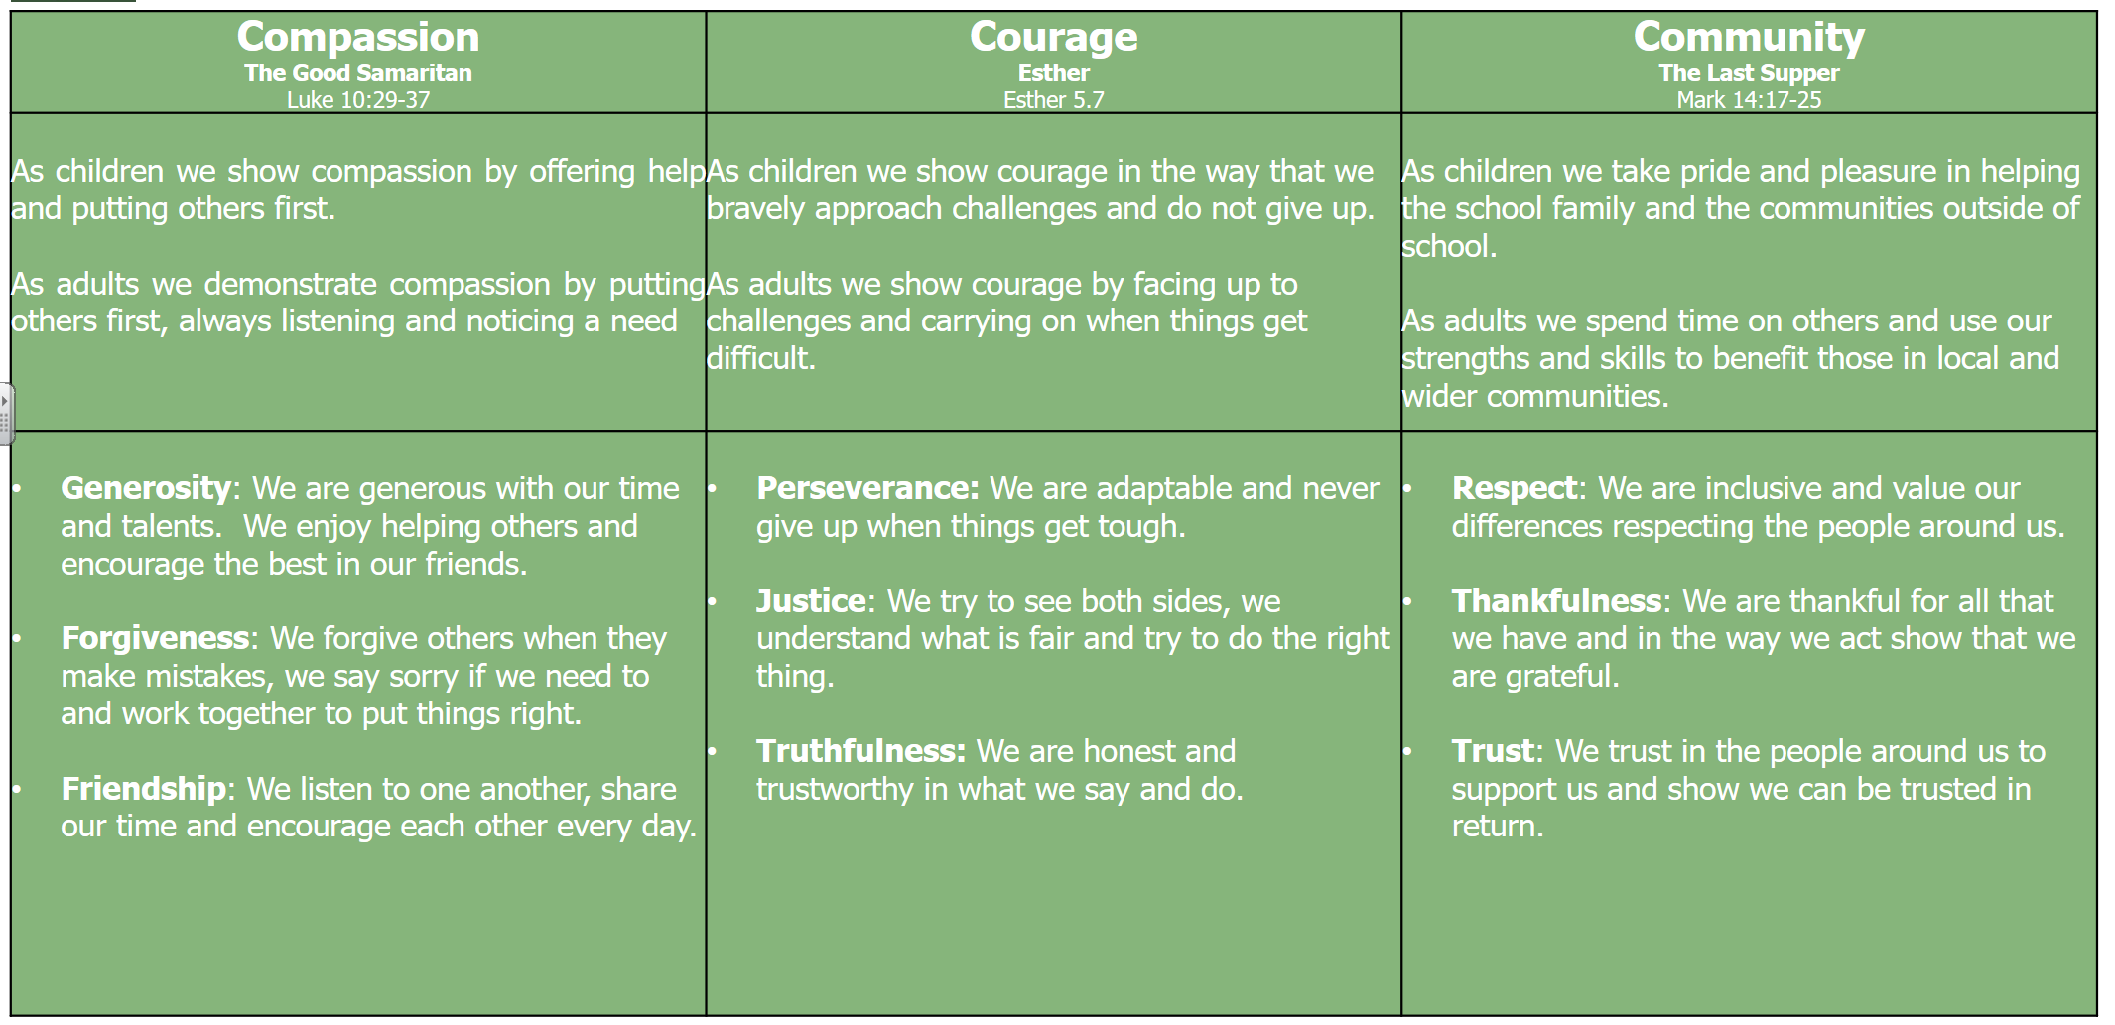
There is a termly focus on one of these Core Values.
We have used these same Core Christian values to underpin the children’s learning as modelled by our Learning Tree, where the Values appear as the skills children use in all their learning in school.

The Act of Collective Worship
Collective Worship is a distinctive part of the school day and a key characteristic of Newport CE Junior School.
A variety of teaching and learning styles; active and interactive methods are appropriate in acts of Collective Worship.
Depending on the setting for worship (hall, classroom, church) worship leaders may choose to use:
− Music to signal the beginning and end of worship
− A focal point such as a candle, artefact or image on OHP or projector
− A welcoming or closing phrase with a pupil response
− Hymns or worship songs
− A bible reading
− A period of quiet reflection or prayer
− Involvement of pupils in leading parts of the worship
Announcements will be made preceding the act of worship and a clearly defined break between them and the act of worship will be made.

Monitoring
Collective worship will be regularly monitored by Foundation Governors. This may take the form of sitting in on acts of Collective Worship as well as talking to pupils. Foundation Governors will provide the SLT with feedback from these conversations.
The Headteacher and Worship Coordinator will use this feedback to further develop worship within the school through the Worship Group or the School Development Plan.

Withdrawal
Any parent who objects to their child attending an act or acts of Collective Worship may request in writing that their child is withdrawn.
Parents are encouraged to discuss this with the Head teacher.
Any pupil who is withdrawn from an act or acts of Collective Worship will be supervised during that time by a member of the school staff.

Statement of Spirituality
Spirituality is:
‘Spirituality is like a bird - if held it too tightly it will choke, but if held too loosely it will fly away.
It is not easy to put spirituality into words because it is about unknowable things rather than everyday concerns.’

Spirituality is intangible - the hidden curriculum- dealing with feelings, emotions, responses and interpretations
- It is subjective
- Gives a sense of meaning and purpose
- Encourages a sense of empathy with others
- Develops a sense of pattern, sequence and order
- Gives an ability to deal with change
- Gives a sense of life’s joy
- Gives an appreciation of life’s gifts (happiness/ security/ faithfulness/ love/ friendship/caring)
- Develops a sense of identity, uniqueness and potential
- Develops a sense of belonging
Spirituality may be developed through time using:
- Awe and wonder
- Reflection
- Stillness
- Inner thought
- Personal response
- Imagination
- Creativity
- Listening to oneself
Spirituality may be recognised in children in these ways:
- A sense of awe and wonder
- Care for nature and living things ▪ Wanting to love and to be loved by people
We endeavour to foster spiritual growth through:

art | music | poetry | prayer | dance
drama | stillness | quiet | play | circle times
story | display | talk | visits | objects
nature | celebration | questioning | thinking | praising

