**For the attention of**

**Parent or Carer**

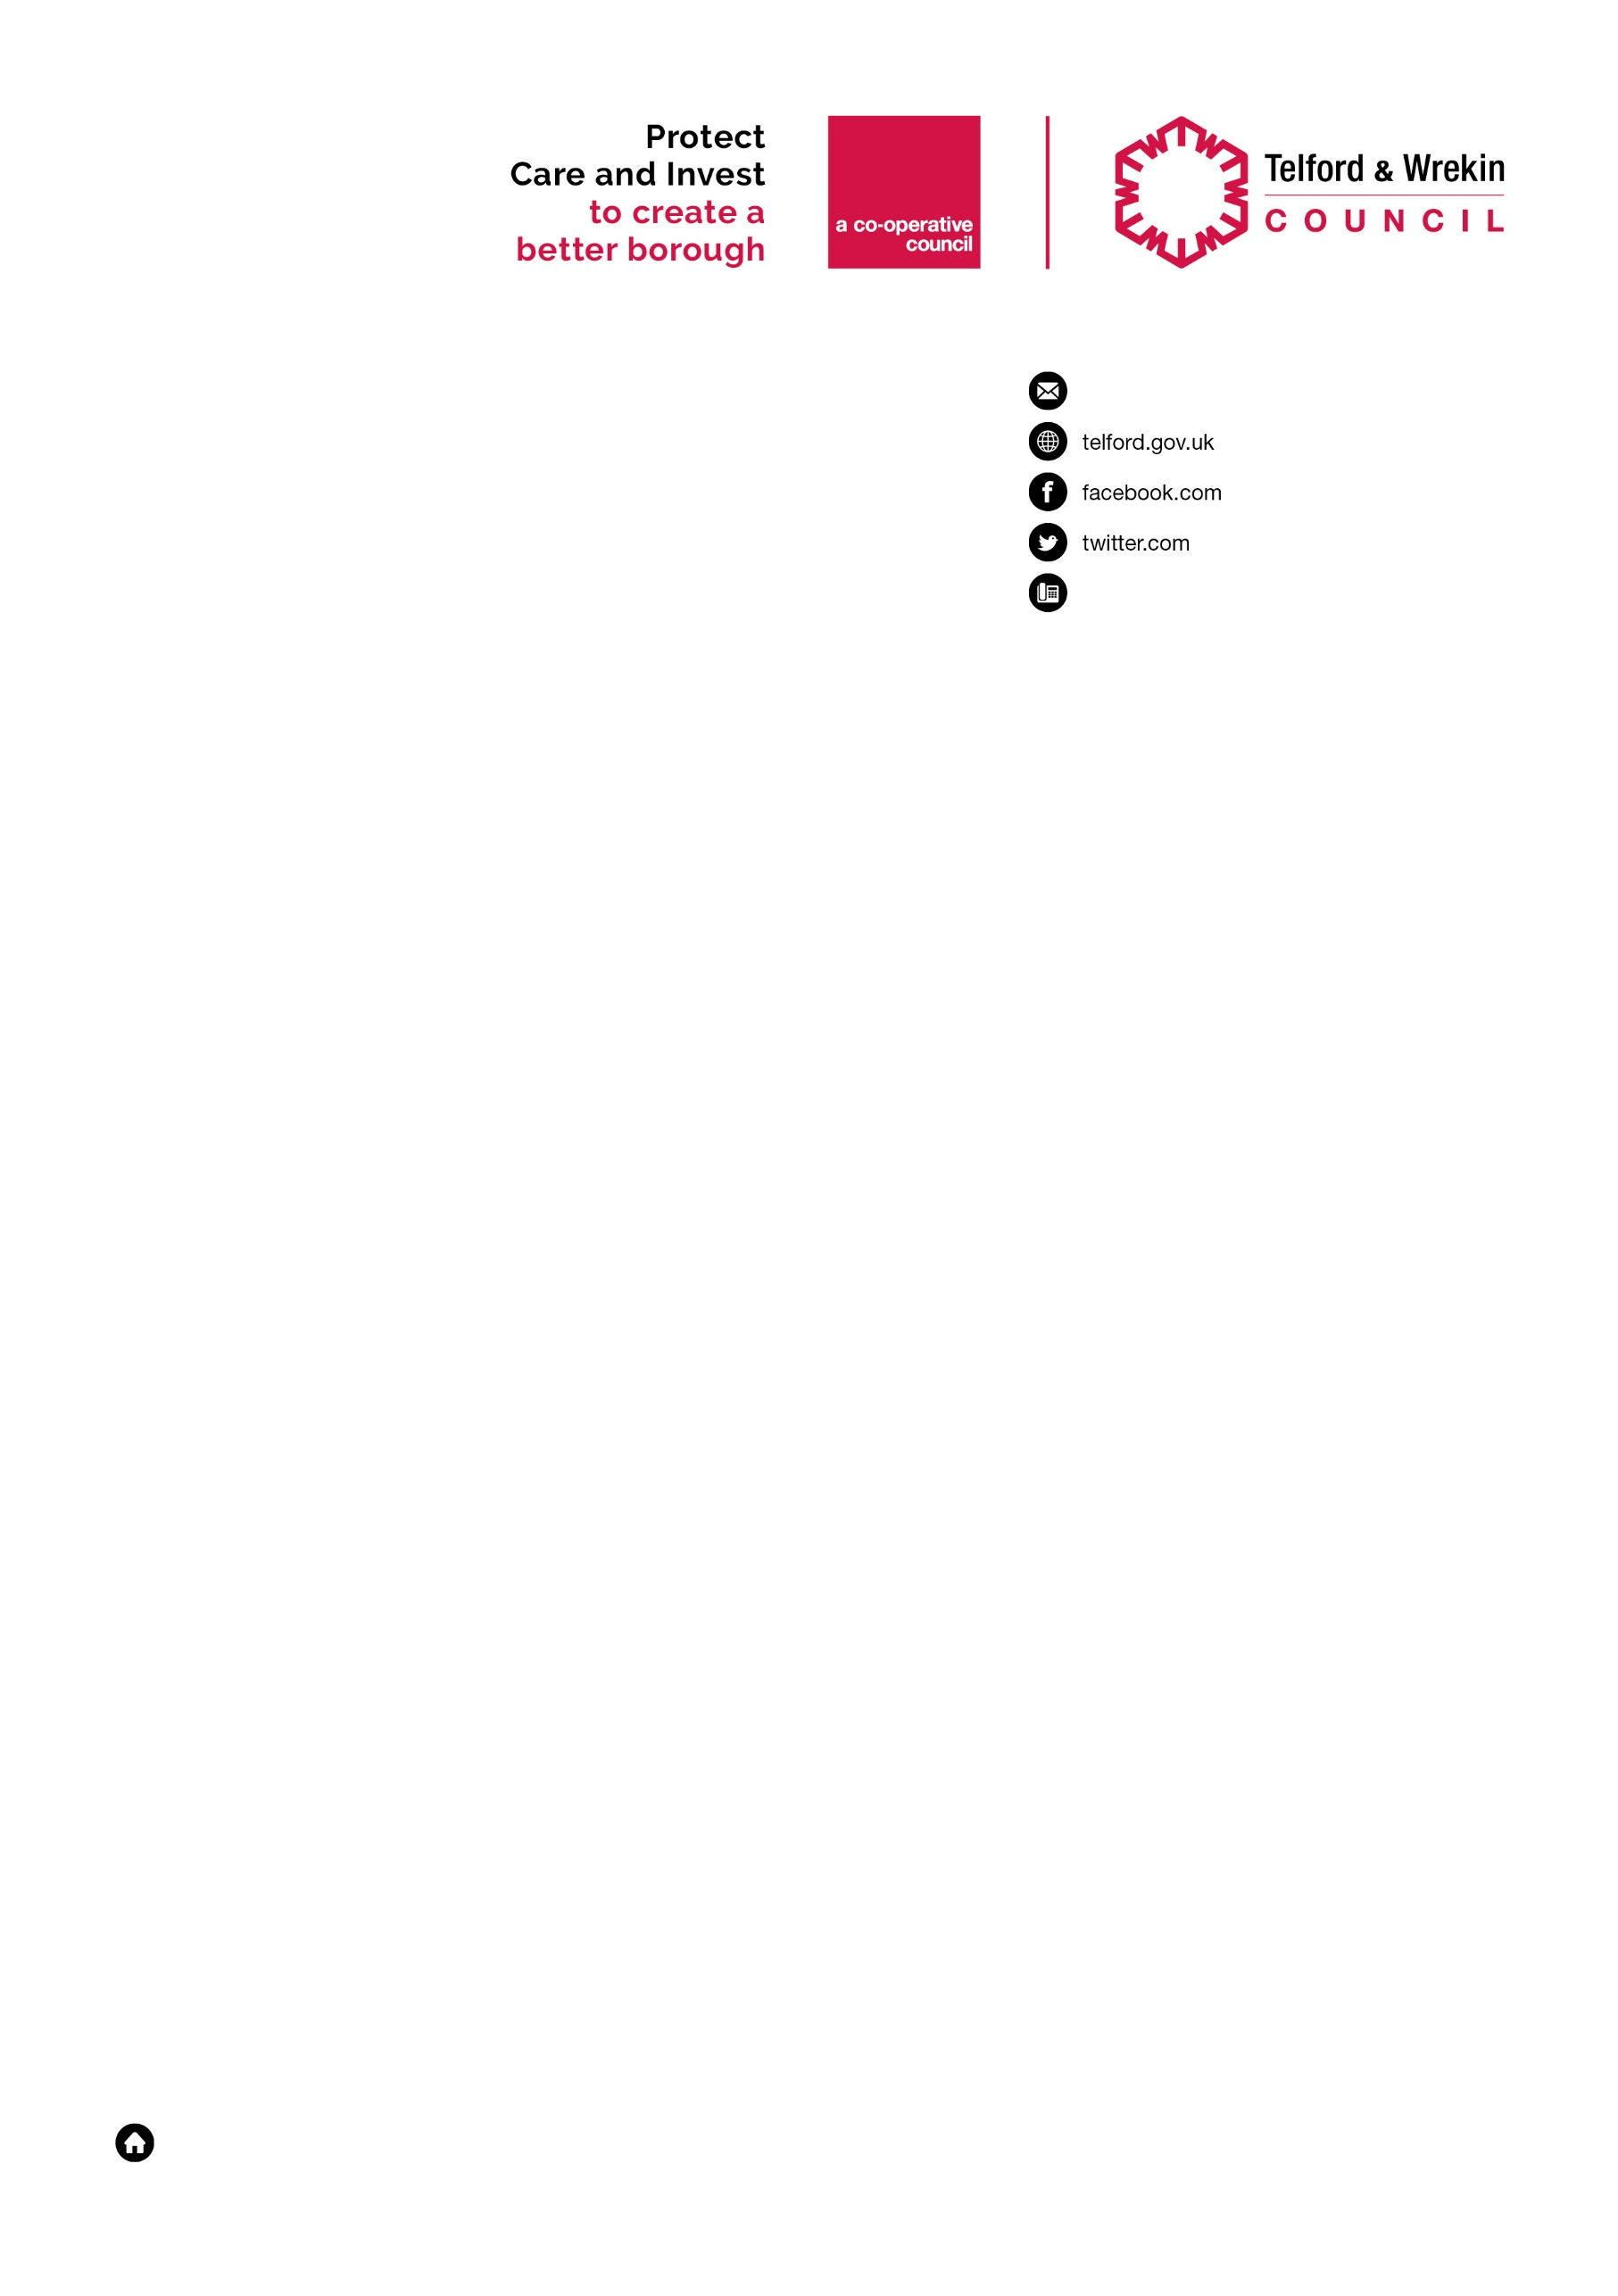

/cllrshaundavies

/cllrshaundavies

Date: 3rd April 2020

Dear Parent or Carer,

As we are approaching the school Easter holidays we wanted to update you in respect of free school meals.

Over the last two weeks, while we’ve waited for the national government scheme to come in, our staff and volunteers have delivered packed lunches directly to your door. The Government have confirmed that their new voucher scheme will start on Monday 20th April after the Easter holidays.

Although free school meal provision does not normally cover school holidays, we recognise that families may be under increased financial pressure at this challenging time. The Council, in partnership with schools, has therefore decided to continue to support children and families eligible for free school meals over the Easter holidays, until the Governments new scheme starts.

As an alternative to the daily packed lunch delivery we will be providing you with access to supermarket vouchers to the value of £30.00 per child to cover the two week Easter holiday period. You will be able to use the vouchers at a range of supermarkets. Children who are attending school over the holiday period will continue to receive a school lunch.

You will receive a separate letter from us by the middle of next week with all the details of how to access your personal food vouchers.

On behalf of the Council we hope that you and your family are safe and well.

Yours sincerely

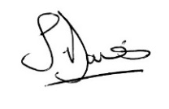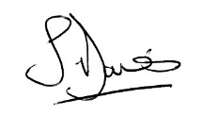



Cllr Shaun Davies Cllr Shirley Reynolds

Leader, Telford & Wrekin Council Cabinet Member for Children,

Young People, Education and Lifelong Learning

