FRIDAY TWO STAR
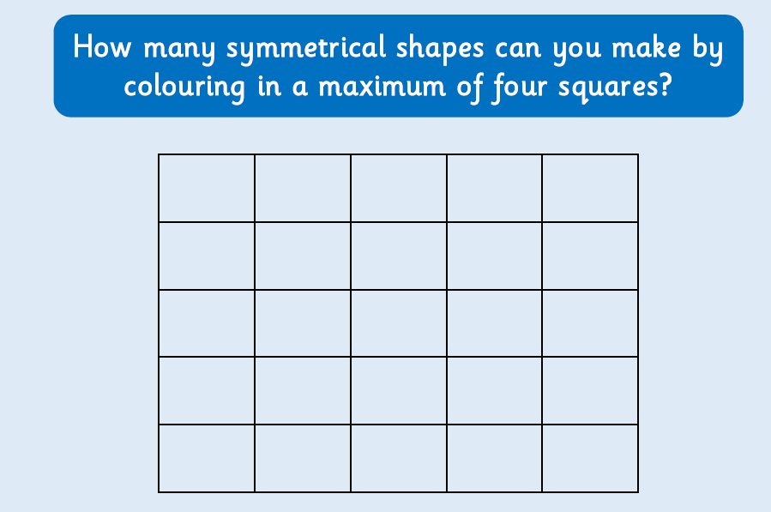

What about if you had 8 instead of 4 squares?

