ONE AND TWO STAR MATHS- THURSDAY
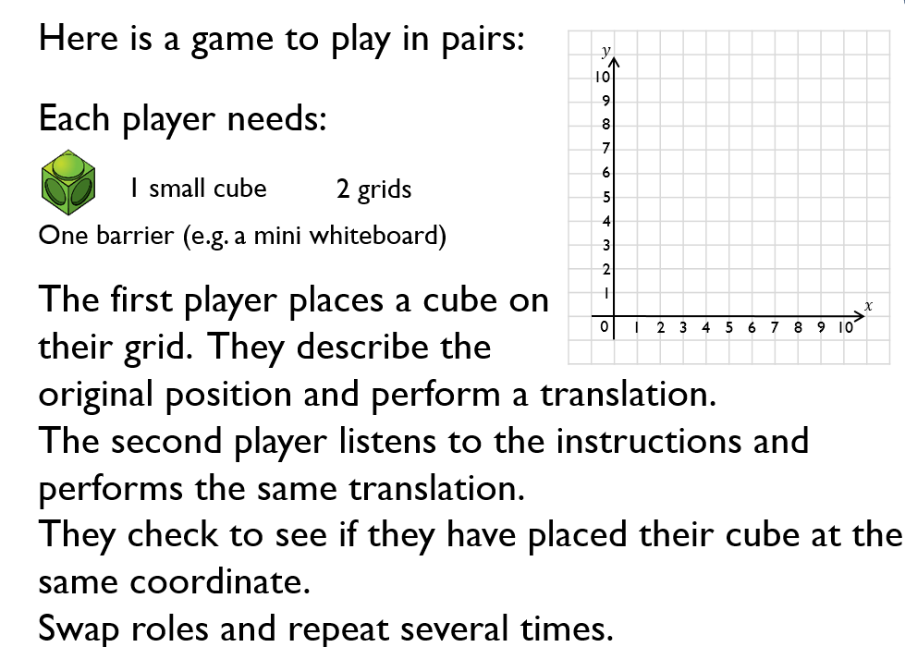

If you haven’t got a partner write down your starting position and then move your cube, counter or whatever you are marking your space with and write down the translation. Repeat several times.

