READING COMPREHENSION REFUGEE WEEK – THREE STAR
What is Refugee Week?
Refugee Week is a UK-wide programme of arts, cultural and educational events and activities that celebrate the contribution of refugees to the UK. It aims to promote a better understanding of why people seek sanctuary. It is usually celebrated around the 20th June each year. Anyone can be involved by organising, attending or taking part in activities.
What does being a refugee mean?
A refugee is someone who has had to leave their own country because they are being persecuted or are in fear of being persecuted. This means that they are afraid of being killed because of their religious beliefs, political opinions or their race. People are often forced to become a refugee due to war, political oppression or natural disasters.
Did you know?
Refugees often come from very different countries compared to the UK. They speak different languages, have a different culture, foods, traditions, religion, artistic and creative skills, and much more. We can learn a lot from people with different experiences to our own.
When did Refugee Week begin?
Refugee Week began in 1998 because there was a lot of incorrect information and ignorance about refugees. People read in the newspapers that refugees were here for financial benefits and ‘free housing’, and there was a lot of negative behaviour towards refugees.
Refugee Week organisers state:
“Our ultimate aim is to create better understanding between different communities and to encourage successful integration, enabling refugees to live in safety and continue making a valuable contribution”
What happens during Refugee Week?
Refugee Week is an exciting time of arts festivals, exhibitions, film screenings, theatre and dance performances, concerts, football tournaments and public talks. It is important that children are involved, as their opinion matters and they will make decisions about worldwide issues like refugees in the future. Schools are invited to have creative and educational experiences to gain more understanding of refugees in the world.
If you want to know how you can get involved, check out this website:
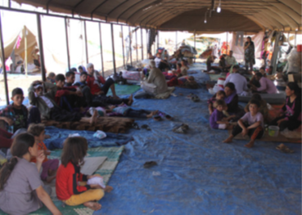
http://refugeeweek.org.uk/
Did you know?
• In 2014, over 300 Refugee Week events took place.
• Over 100,000 people attended an event.
• Over 200 people organised an event, whether it was a group or an individual.

READING COMPREHENSION QUESTIONS THREE STAR
1. Explain in your own words what you understand a refugee to be.
2. Why was Refugee Week started?
3. Explain what ‘sanctuary’ means.
4. What word tells us that people already living in the UK did not show refugees much understanding?
6. What do the organisers of Refugee Week ultimately want for refugees?
5. What surprises you about the facts from the 2014 Refugee Week?
7. How do you think refugees contribute to the UK? Explain your ideas.
8. How do you think a refugee might feel when arriving in a new country?
9. Why do children need to learn about refugees?
10. How would you like to get involved in Refugee Week?

was in a group or as an individual.

