THURSDAY MATHS THREE STAR
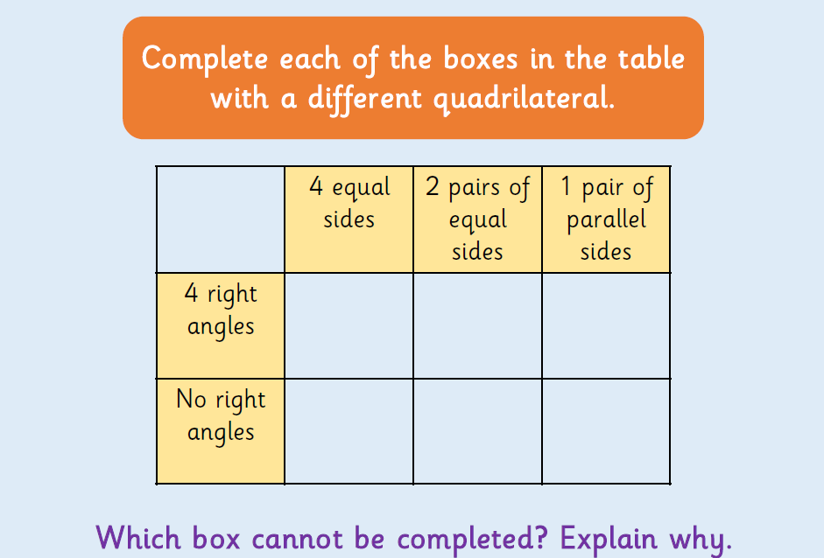

Using the shapes of squares, rectangles, trapezium, rhombus, parallelogram and kite think about their properties and put into the appropriate place on the diagram

