Speech punctuation
Make a conversation that could happen between these two monsters. One of them is good, kind and gentle and the other is fierce, mean and nasty.

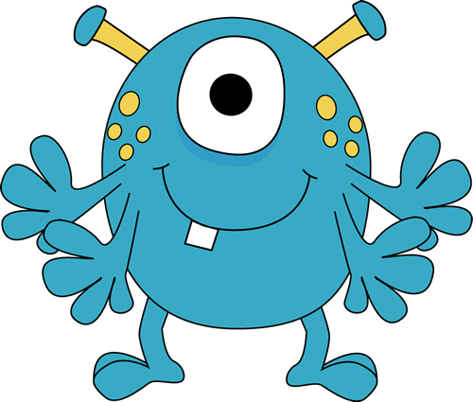 | 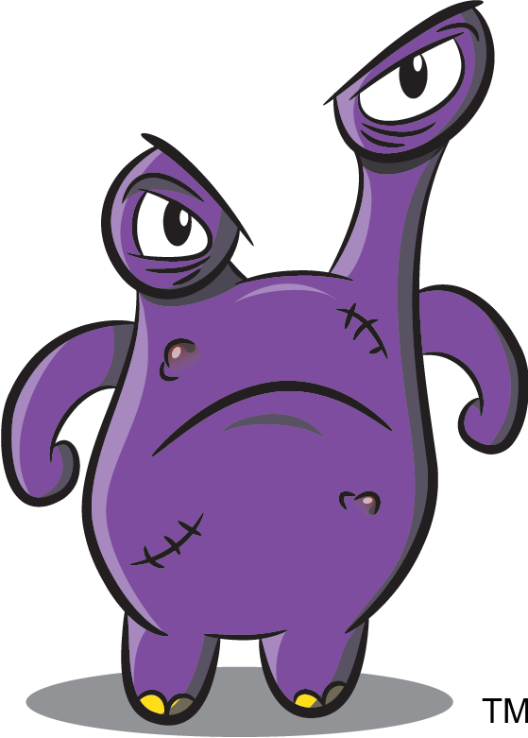
Grig | Harl

Don’t forget to use the relevant punctuation.

A conversation between Grig and Harl

“What are you looking at ugly?” barked Harl
“I was actually just wondering what to get you for your birthday,” replied Grig, and then he continued, “I can’t decide between a new mountain or a large forest.”

Continue this conversation. Don’t forget to try and use words other than just ‘said’. Here are some to help you.

grumbled | shouted | cried | yelled | demanded
insisted | murmured | blurted | agreed | spat
pleaded | explained | mumbled | stammered | begged
whispered | repeated | groaned | snapped | screamed
shrieked | comforted | laughed | questioned | exclaimed
advised | added | argued | told | hissed

