Two star English- adverbial openers
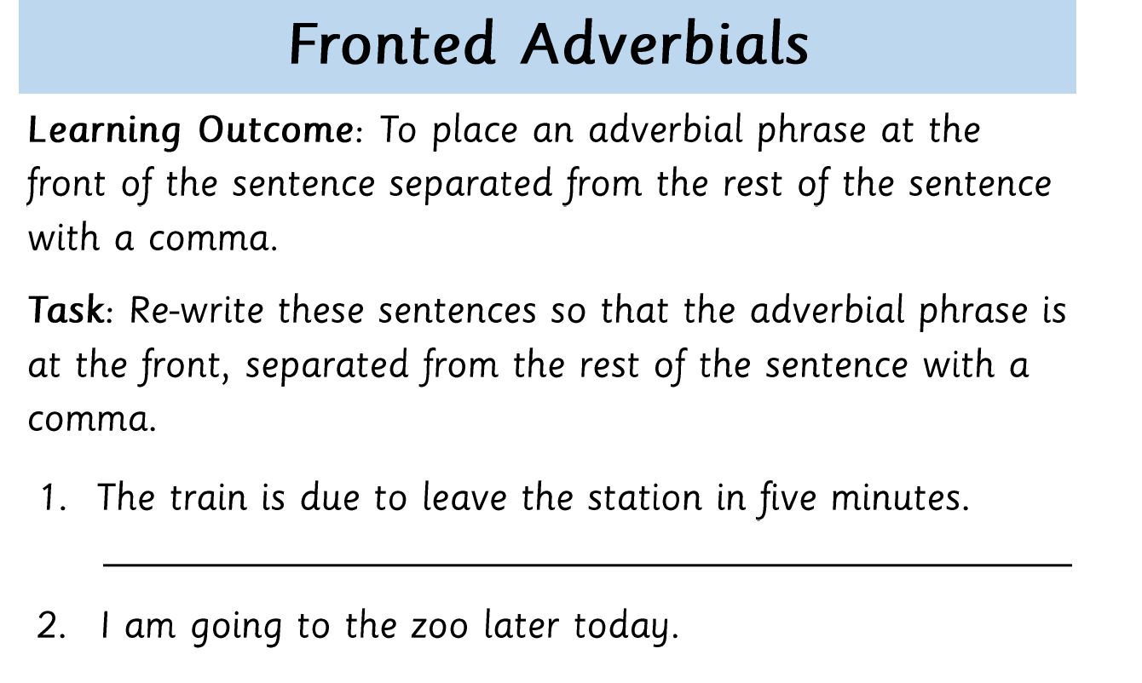
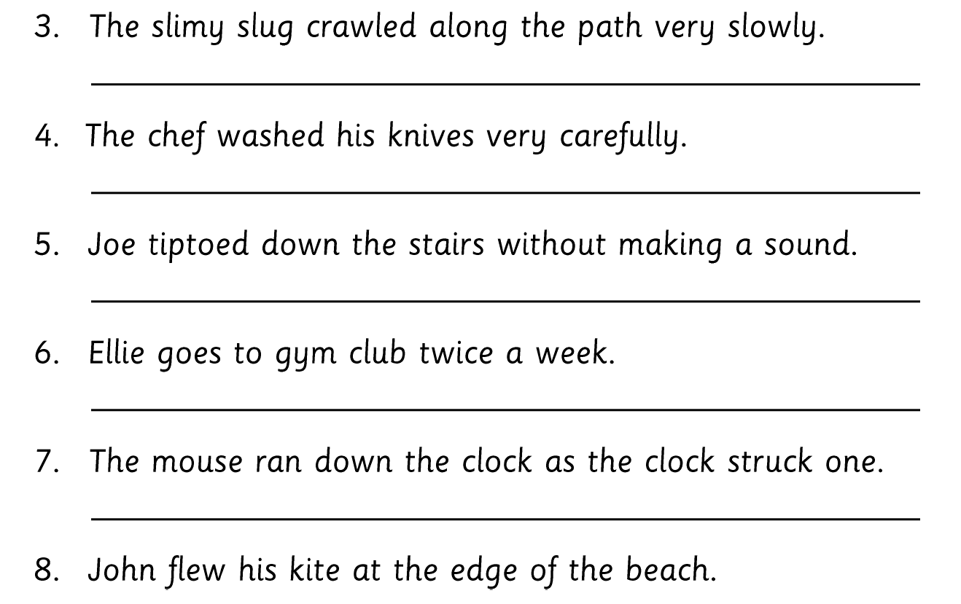
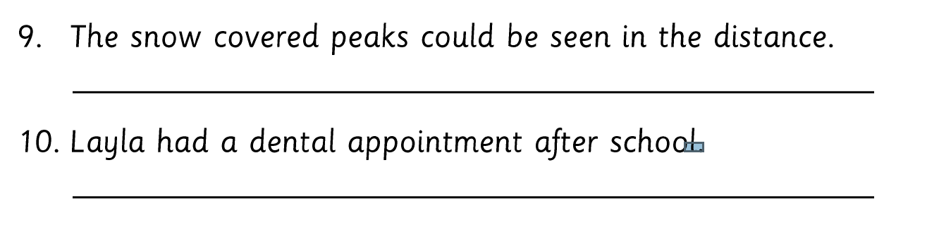
To give you a clue the answer to 1 is…. In five minutes, the train is due to leave the station.

