Speech punctuation
Write the conversation that happened between these two monsters and punctuate it. One of them is good, kind and gentle and the other is fierce, mean and nasty.

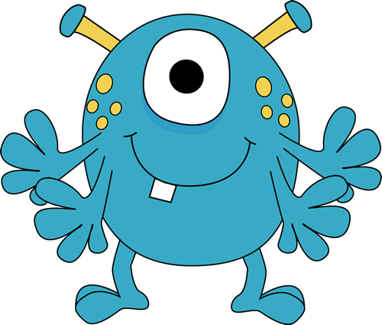
Grig | Harl

A conversation between Grig and Harl

What are you looking at ugly barked Harl

I was actually just wondering what to get you for your birthday. I can’t decide between a new mountain or a large forest replied Grig

I wouldn’t like either of them insisted Harl

That’s a shame as I don’t have any other ideas declared Grig.

You could just give me the money blurted Harl

Grig sighed and said You really are a difficult monster to buy a present for.

First you will need to punctuate the start of the conversation.
Now see if you can continue this conversation.

