Year 3 Homework: Autumn 2nd Half Term
Issued on: Monday 2nd November 2020, Due in: Monday 12th December 2020
Maths
Target: To confidently and quickly recall multiplication facts from the 2x, 3x, 4x, 5x, 6x, 8x and 10x tables.
EXT: - to improve your TTRS STUDIO speed per question from what it is now, over the duration of the homework.

Here are some suggested activities to record in the orange Homework Book – you do not have to do them all, and in fact you could choose activities that aren’t listed here, as long as they meet the above target. Children who can show evidence of regular homework activities in their Homework Book by 12/12/20 will be handsomely rewarded with house points!

- Use arrays and blocks to create multiplication facts in a visual or physical way and send in pictures / bring the posters in, if possible. You could even create a number of ‘Array cities’ posters for each times table, using a few full pages in your homework books, or separate
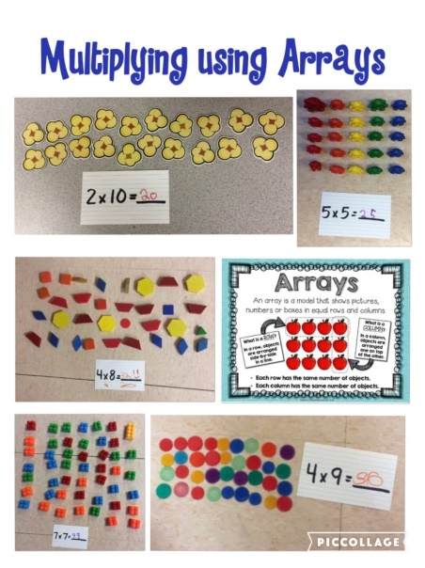
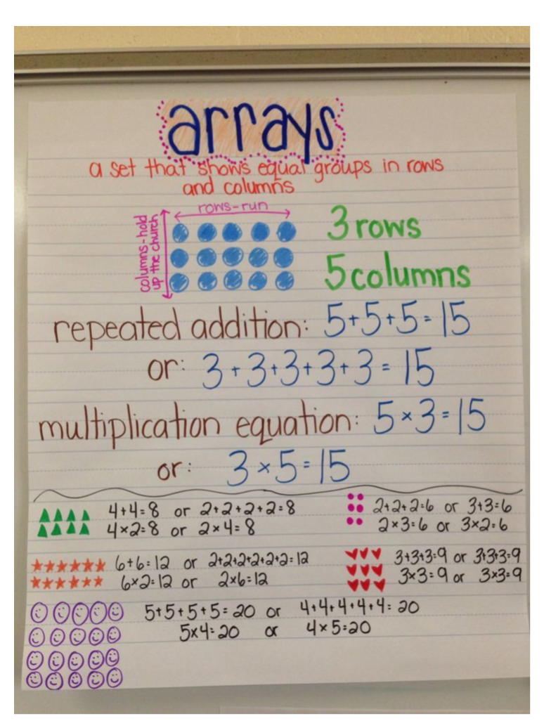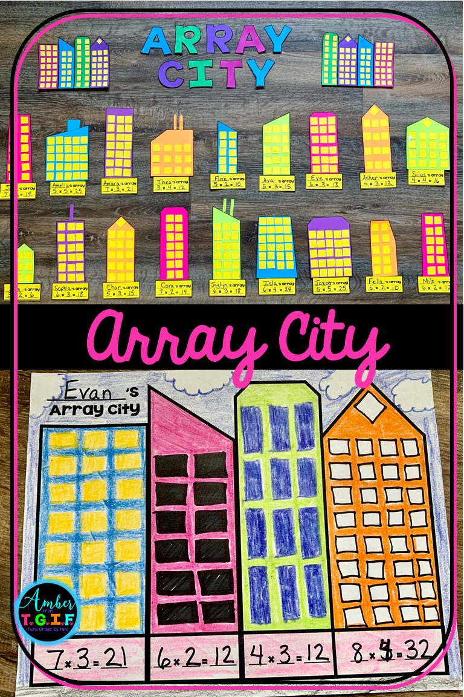

- Complete challenges by multiplying the numbers on two dice or use an online random number generator to multiply by 2x, 3x, 4x 5x and 10x tables. Record calculations.
- Challenge your friends or teachers to a TTRS Rockslam!
- https://mathsframe.co.uk
This website has some free content but also provides some subscription content. See website for details.
- https://www.topmarks.co.uk/ - A great website for free content! Choose multiplication and then the number
- The following links are all on TopMarks:
- https://www.topmarks.co.uk/maths-games/hit-the-button
- https://www.topmarks.co.uk/maths-games/mental-maths-train
- https://www.topmarks.co.uk/maths-games/multiples-and-factors (harder)
- https://www.mathschase.com/times-tables/
- And obviously, please also continue to regularly complete Times Tables Rock Stars! Class teachers will be checking regularly to see evidence of participation.
For the TTRS EXTENSION challenge, your current speed can be found by clicking on your name icon and viewing your stats. You need to play as many Studio games as you can, and improve your response time by at least:
1 star: 0.25 seconds/question 2 Star: 0.5 seconds/question 3 star: 0.75 seconds/question
Spellings
Set 1 (Year 2 word list)  wild, climb, most, only, both, old, cold, gold, hold, told | Set 2 (Year 3 word list)  eight, eighth, caught, centre, century, heart, breath, breathe, busy, great, grate
Children should know how to spell all the words in Set 1 – please review these with them. Your child will be tested on the set they have been given at the end of this current half term. To help your child learn these, you could:
- Ask the children to record definitions of the words or write the words within sentences.
- Ask the children to colour code the sounds within the words.
- Complete test challenges.
- Ask the children to create a wordsearch containing all the words.
See the Spelling Menu sheet for further ideas. Try to record your spelling practice in your orange homework book.
Reading
Read at home at least three times a week, preferably every day. Children, you should allow parents to record entries in your Reading Diaries and sign it. These will be checked weekly by a member of staff. Consider trying a range of genres e.g. comics, newspapers, biographies, narrative etc. Reading books and Reading Diaries need to be in school every day. House points will be awarded for each parental entry in the Reading Diary.
Science Project
This term, we will be studying the Human body. We would like you to create some display work for this topic. Suggested ideas are:
- Create a model of the human skeleton. This could be out of card, paper, or other materials.
- Draw a labelled diagram of the human skeleton, identifying the major bones (skull, neck, upper arm (humerus), lower arm (radius/ulna), spine, ribs, pelvis, wrist, finger bones (phalanges), leg bones (femur, tibia, fibula), ankle, heel and toes (phalanges).
- Write a fact file or poster about the human body; include interesting or unusual facts and ideas about the human body.
PE Reminders
This half term, PE is on Mondays for Year 3. Please bring in PE kits on a Monday and take home on a Friday.

