* She became a very strong doing manual labour
* She suffered a horrendous head injury that nearly killed her. Someone threw an iron weight at her head thinking she was another slave.
* She suffered for the rest of her life with black out and dizziness
* In 1849 she escaped the underground and was finally free.
* When she was 6 years old, she was loaned to another family and helped take care of a baby.
* She was sometimes beaten and all she was given was scraps
* Her birthname was Araminta Ross, but she took the name of her mother, Harriet, when she was only thirteen years old.

Life as a slave

* Life as a slave was difficult
* Harriet first lived in one room cabin with her family that included 11 children!
* Harriet Tubman was born in 1820 in Dorchester county, Maryland
* She was known as a leader in the underground railroad.
* Harriet was born as a slave on

plantation in Maryland.

* Historians think she was born in 1820
* or possibly 1821, but birth records weren’t kept by most slave owners.

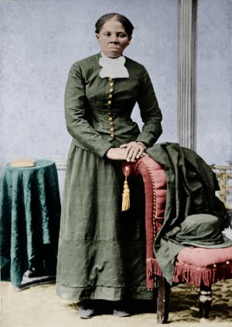

**HARRIET TUBMAN**

* 1850 the fugitive slave act was passed so slaves could return to their own state to be free people who had to escape Canada
* Harriet wanted to help people and her family to become free
* She became a famous conductor on the underground she helped 19 people escape and over 300 in total.
* She was known as Moses like in the bible helping people.
* She was never caught and slaves never lost a slave
* She helped a military campaign and saved over 750 slaves
* She helped Nurses and soldiers that were injured in the civil war too. Such a brave lady who put others first.

Underground Railroad

