Name _________________________________ Date ___________________

LO: To divide numbers up to 4 digits by a two-digit whole number using long division.
Set out the formal written long division with plenty of working space. Read: “How many 15s in 432?”
Note useful facts – multiples of divisor. Subtract multiples of the divisor from the dividend. “Bring down” next place value.
Continue until complete or until a remainder. Deal with the remainder appropriately.

Challenge 1.
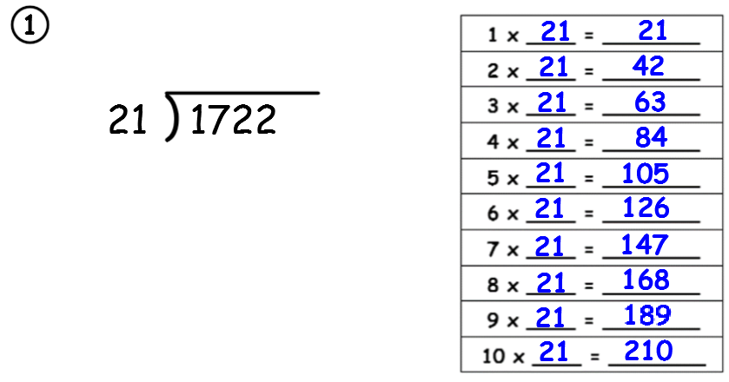

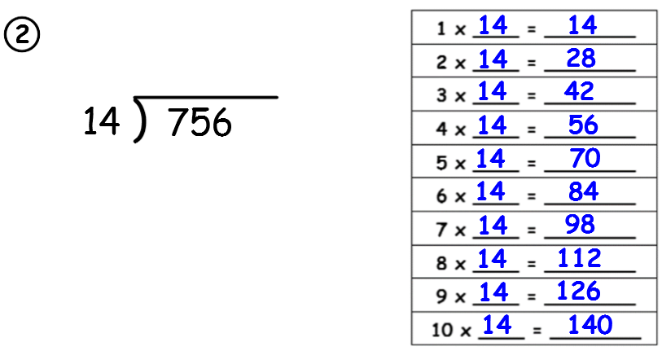

Challenge 1 continued.
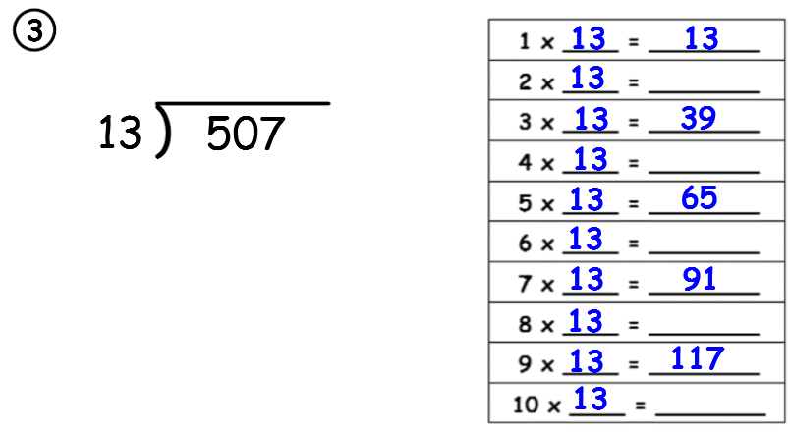

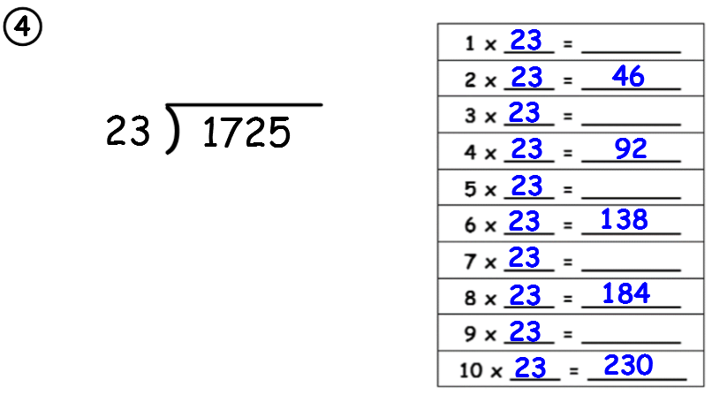

Name _________________________________ Date ___________________

LO: To divide numbers up to 4 digits by a two-digit whole number using long division.
Set out the formal written long division with plenty of working space. Read: “How many 15s in 432?”
Note useful facts – multiples of divisor. Subtract multiples of the divisor from the dividend. “Bring down” next place value.
Continue until complete or until a remainder. Deal with the remainder appropriately.
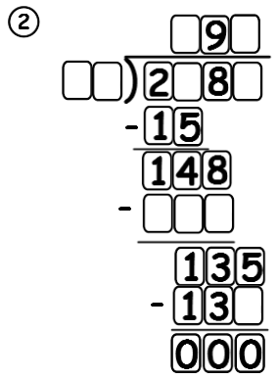
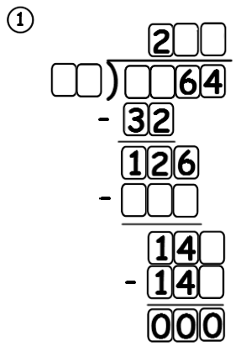
Challenge 2.

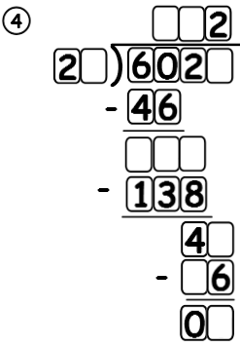
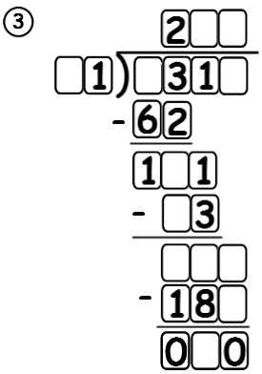

Name _________________________________ Date ___________________

LO: To divide numbers up to 4 digits by a two-digit whole number using long division.
Set out the formal written long division with plenty of working space. Read: “How many 15s in 432?”
Note useful facts – multiples of divisor. Subtract multiples of the divisor from the dividend. “Bring down” next place value.
Continue until complete or until a remainder. Deal with the remainder appropriately.

The Treasure of the Elves. Challenge 1.
Celerone the Elf Princess has hidden the location of the Magical Crown of Everhaven.
Solve her long division puzzle and find the four words which will make up the place you seek.
E.g. It could be at the Blue Volcano of Magical Dragons or the Green River of Brave Dwarfs.
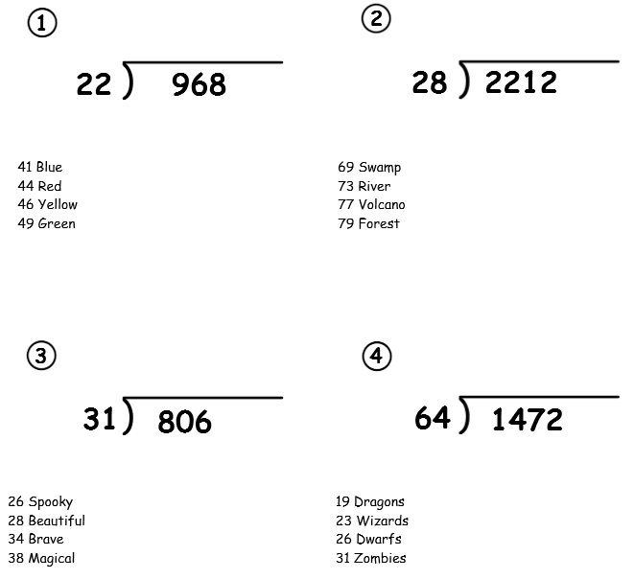

The Magical Crown is in The ________¹ ________² of ________³ ________⁴.

