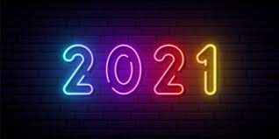
Sports day
Sports day!!!
There’s:
Jebb the blue,
Have a brew,
Darwin the yellow,
Have a great bellow,
Write the red,
Land ahead,
Owen the green,
Look at the screen.
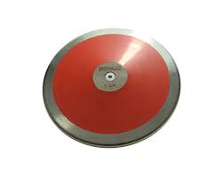
I love sports day,
Even if it’s on my doorway,
It makes us fit,
Even it is bit,
We have javelin and sprint,
Don’t forget discus and ball throws,
Sacks and eggs/spoon races,
Make sure you tie your shoelaces,
I missed last years,
It just disappears,
I did long jump and under over in lockdown,
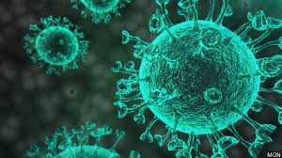
It made my mental health rise too,
As long as being in blue,
I want blue to win,
Even if it’s in a tin.
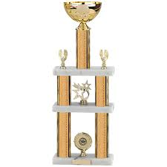
We do events,
And present awards,
If I will come in the top three,
Then I will dance in glee,
We only have one hour for sports day this year,
So we have to make the most of it,
My parents are going to come,
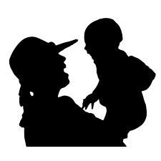
So I better make them proud.

