

Autumn Term’s News

Facts about dyslexia, taken from Nessy.com:

1. 10-20% of people have dyslexia.1  
That’s as many as 1 in 5 people. It affects as many boys as girls.2 For most people who struggle to read and write, the cause will be dyslexia.  
   
2. People with dyslexia can be taught to read, it is not an excuse for not reading. Some dyslexic children read well but they struggle with spelling and writing.  
   
3. Intelligence is not affected. Most dyslexics have at least an average IQ.

***“It has nothing to do with how intelligent you are.  
You can be extremely bright and still have dyslexia.”*  
– Tim Tebow**

4. Early identification followed up with right teaching approach gives people the best chance of overcoming their difficulties. Dyslexic children are more likely to succeed at school, in jobs and life, if they have had the right kind of support when they are younger.

5. Dyslexia is genetic – it’s passed on through families. Where a birth parent has dyslexia then there is a 50% chance that their child has dyslexia. Where both parents have dyslexia, it is almost certain that children will also have dyslexia.3

1. The Yale Center for Dyslexia and Creativity: <http://dyslexia.yale.edu/dyslexia/dyslexia-faq/>  
2. <https://jamanetwork.com/journals/jama/article-abstract/382980>  
3. <https://www.understood.org/en/learning-thinking-differences/child-learning-disabilities/dyslexia/is-dyslexia-genetic>

Dear Parents/Carers,

Welcome back to the new school year! We hope that everyone is enjoying being back in school and getting back into the routines.

At Newport Junior School, all our children’s needs, both academic and personal wellbeing, are of the upmost importance to all our staff and we look forward to working closely with you over the coming year to make it successful for them.

Termly focus

Each term we will focus the spotlight on a particular area of special educational needs and disabilities. This term we will focus on specific literacy difficulties including dyslexia dyslexia.

What is dyslexia?

The British Dyslexia Association (BDA) defines ‘Dyslexia as a learning difference which primarily affects reading and writing skills. However, it does not only affect these skills. Dyslexia is actually about information processing. Dyslexic people may have difficulty processing and remembering information they see and hear, which can affect learning and the acquisition of literacy skills. Dyslexia can also impact on other areas such as organisational skills and maths.’



**Ways to help at home:**

**Look out for signs of emotional stress**

Consequences of dyslexia are frustration, anger, low self-esteem or becoming withdrawn.  
Before reading and spelling can be improved your child needs to believe they can succeed.

**People with dyslexia need constant praise and support to rebuild self-esteem**

It is very important to have someone who believes in you and is supportive.  
Praising even very small achievements will build self-confidence.

**Organisation Strategies**

A person with dyslexia is likely to find it difficult to organise everyday tasks.

1. Provide checklists. Set routines.

2. Colour-code their timetable so that lessons can be seen at a glance.

3. Pack school bags the night before and put them by the front door.

4. Establish a place where everything must be put away immediately after use.

**Some common characteristics:**

* Difficulties remember and using phonics
* Difficulties following instructions
* Lack of fluency (affecting comprehension

/understanding)

* Inaccurate decoding
* Persistent and marked difficulty with spelling
* Trouble remembering sequences e.g. alphabet, numbers, days of the week
* Find it hard to copy from the board
* Visual discomfort when reading
* Mixing up letters/symbols
* Needs additional time to respond to questions asked.

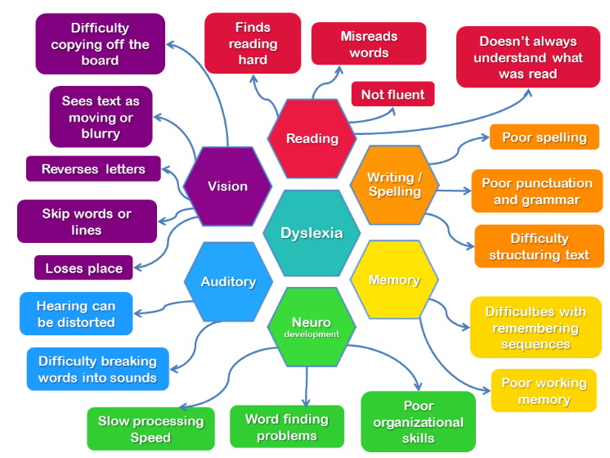



**Spelling Strategies**

**1. Mispronounce the word the way it is spelled**

For example, ‘want’ say ‘w…ant’. This is good for silent letters and for ‘Wed…nes…day’.

**2. Link the word to a picture or movement**

A picture is more readily remembered, as a visual clue. For example, ‘first’ is often misspelled as ‘ferst’. Draw an ‘i’ winning a race and say ‘I come first’. They will remember the picture of the ‘i’ which is the part of the word which is forgotten.

**3. Mnemonic**

This strategy uses a phrase where the first letter of each word spells the one you want to remember.  
As a mnemonic for ‘does’ say “**d**oes **O**liver **e**at **s**paghetti?”  
The first letter of each word spells the word ‘does’.  
Try to start the mnemonic with the word you want to remember.

**4. Overlearn tricky words**

Keep going over difficult words to put the spelling into the long term memory.

**5. Look at the shape of the word or break it down into sections and write in different colours.**

Visual memory can be a useful way to remember spellings. Does it look right?

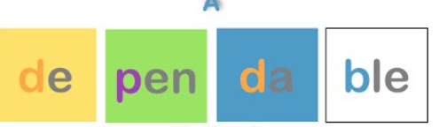

**Reading Strategies**

1. As you read, create simple thumbnail drawings in the margin beside each point.

Many people with dyslexia focus so much effort upon the mechanics of reading that they cannot remember what they have read. When you look back the pictures will help remember what you have read.

2. Build up words by uncovering part at a time.

Encourage your child to use their finger or a small card to reveal a word in chunks. Build up the word by syllable and learn to recognise prefixes and suffixes.

3. Use a coloured background and reading rulers to help with tracking.

Some people with dyslexia experience a ‘glare’ when reading black text on a white background. This can make it difficult to focus and tiring to read. Try laying a sheet of coloured acetate over the page to see if it helps.

4. After a short burst, take over the reading to provide a rest period.

Discuss what you have read to make sure it is understood.

5. Listen to audiobooks.

6. Use highlighters to support comprehension.

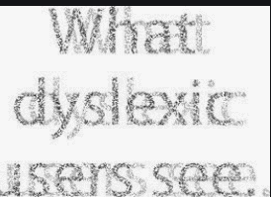



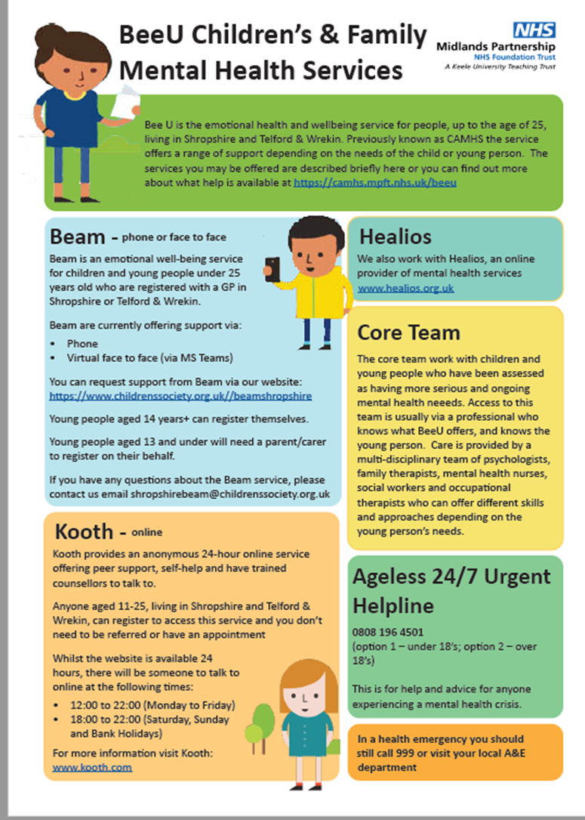

Key Contacts

SENDCO: Jane Kerr

[njs.send@taw.org.uk](mailto:njs.send@taw.org.uk)

Inclusion Manager: Megan Hardy

SEND admin: Vicky Potter

Headteacher: Nicola Moody

01952 386600