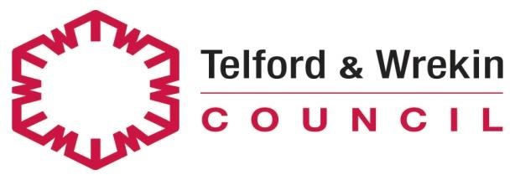
Coronavirus (COVID-19): Amendments to School Risk Assessments from 1.9.2021

- Schools must ensure that this and all their risk assessment reflects the local setting and context of the school.
- Staff and unions must be consulted with regard to this risk assessment and any changes to existing COVID 19 risk assessments.
- The document advises of amendments that need to added/considered to existing school risk assessments, it is not exhaustive and some of the controls will be dynamic. This is issued to schools as a template to assist in the production of a full comprehensive document that covers the particular circumstance of the setting – as such, the risks and risk controls should be deleted/ amended/ added-to to reflect the school.
- This should be viewed alongside relevant advice and guidance from the Department of Education and reflect any additional subsequent guidance issued to schools.
- When implemented in line with a revised risk assessment, these measures create an inherently safer environment for children and staff where the risk of transmission of infection is substantially reduced.
- Implementing the system of controls, creates a safer environment for pupils and staff where the risk of transmission of infection is substantially reduced. The way to control this virus is the same, even with the current new variants.
- https://assets.publishing.service.gov.uk/government/uploads/system/uploads/attachment_data/file/964351/Schools_coronavirus_operational_guidance.pdf

Key:
Level of risk prior to control | Identifies the risk before any steps to reduce the risk have been taken
Risk Description: | Outlines the area of concern. This list is not exhaustive, and schools should add/amend/delete where appropriate e.g. risks for pupils with complex needs.
Risk Controls: | The measures that will be taken to minimise the risk. These are generic and should be adapted for the school context.
Impact: | Could be L/M/H or numeric, depending on what is used in the school setting.
Likelihood: | Could be L/M/H or numeric, depending on what is used in the school setting. NB IF IMPACT AND LIKELIHOOD ARE BOTH HIGH, THEN THE ACTIVITY SHOLD BE STOPPED UNTIL ADDITIONAL CONTROL MEASURES ARE PUT IN PLACE.
Responsible person: | The identified staff member(s) responsible for implementing the risk controls  Head Teacher Sign ………N Moody……………………………………………… Date ……4.11.2021……………………………………  Chair of Governors sign …………………………………………………… Date …………………………………………
Completion Date: | The date by which required plans for controls will be in place. 4.11.2021

Risk  Description/Are a of Concern | Level of risk  prior to  contro  l  <> | Risk Controls | Leve l of  risk is  now  <> | Likelihoo d  <> | Responsibl e person | Planned completio n Date | Comment  s / Actions needed
Clinically Extremely vulnerable (CEV) individuals | L | In line with guidance CEV staff to attend for work.  Actions identified in the Outbreak Management Plan. | L | L | Nicola Moody | 1.9.2021
Testing of staff and pupils | L | The asymptomatic testing programme in education currently covers all staff at school and pupils – see further details in LFT testing in secondary/primary or special schools.  Those who are identified contacts of a positive case asked to take a PCR. If this is negative they are asked to lateral flow daily for 7 days. | L | L | Nicola  Moody  Andrew  Rotherham | 25.1.2021

 |  | 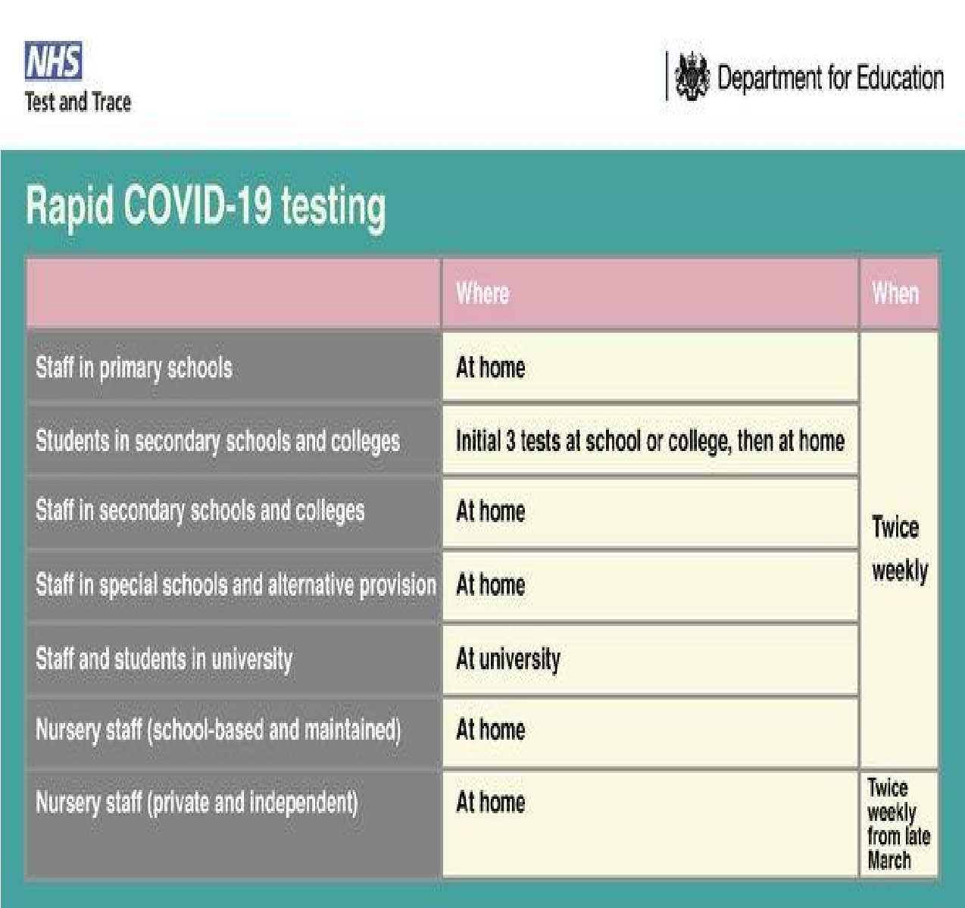
System of  Controls - Prevention | L | Prevention You must always:  1) Stay at home and get a PCR test if you have symptoms: cough, temperature or loss of taste or smell. Or any of the precautionary symptoms.  2) Ensure good ventilation.  3) Practise good hand hygiene. | L | L | Nicola  Moody  Andrew  Rotherham  Laurie  Boardman | Sep 2021

System of  Control -  Responsive |  | L | Response to any infection  - Promote and engage with the NHS Test and Trace process. Manager to advice Health Protection hub via email of positive cases. Complete online form to assist with contact tracing https://www.telford.gov.uk/testandtrace  - Manage confirmed cases of coronavirus (COVID-19) amongst the school community. Manager to advice Health Protection hub via email of positive staff. Complete online form to assist with contact tracing https://www.telford.gov.uk/testandtrace  - Contain any outbreak by following local health protection team advice. | L | L | Nicola  Moody  Andrew  Rotherham  Laurie  Boardman | Sep 2020
Poor hygiene practice – specific - spread of | L |  | Follow Master Risk Assessment for Return to school in phase one & two and review all controls you previously applied to ensure they are still effective. | L | L | Nicola  Moody | 8.3.2021

potential infection at the start of the school day. |  | We maintain some arrangements for distancing at start and end of the day:  *8.45-8.55 and 3.15-3.25  *Year 3: Security gate  Year 4 and 6 Black Gates  Year 5: Year 5 gate |  |  | Andrew  Rotherham  Laurie  Boardman

Face coverings | L | Staff recommended to wear face coverings in communal areas around school.  Parents and Carers recommended to wear face coverings on school site. | L | L | Nicola  Moody  Andrew  Rotherham | 8.3.2021
Reducing contacts | L | NJS to work in Year group bubbles to reduce contacts.  Staff to work within bubbles where possible.  Only activities that can take place within bubbles to happen. | L | L | Nciola Moody | 14.5.2021

 |  |  | Safe wearing of face coverings requires the;  - Cleaning of hands before and after touching, this includes removal and putting on  - Safe storage of them in individual, sealable plastic bags  Children in primary school do not need to wear a face covering.  When face coverings become damp, it should not be worn, and the face covering should be replaced carefully  Ensure there are sufficient waste bins located around the school for disposal of face masks and face covers  See further advice in the Face Coverings guidance  Exemptions -Some individuals are exempt from wearing face coverings.  You should have a small contingency supply available for people who:  - are struggling to access a face covering  - are unable to use their face covering as it has become damp, soiled or unsafe  - have forgotten their face covering  There will be supplies in Reception and each bubble area. |  |  | Laurie  Boardman
A pupil is tested and has a confirmed case of coronavirus. | L |  | In line with government advice:  • Follow guidance from the Test and Trace team in the Health Protection Hub | L | L | Nicola  Moody  Andrew  Rotherham | Sep 2020

Ventilation | L | Keeping occupied spaces well ventilated  Once the school is in operation, it is important to ensure it is well ventilated and a comfortable teaching environment is maintained.  • Natural ventilation – opening windows (in cooler weather windows should be opened just enough to provide constant background ventilation and opened fully during breaks to purge the air space. Opening internal doors can also assist with creating a throughput of air  The Health and Safety Executive guidance on air conditioning and ventilation during the coronavirus out break https://www.hse.gov.uk/coronavirus/equipment-andmachinery/air-conditioning-and-ventilation.htm  And  CIBSE - CIBSE - Coronavirus COVID 19  Provide more information  See further information in T&W Ventilation guidance | L | L | Nicola  Moody  Andrew  Rotherham  Laurie  Boardman | Sep 2020

Breakfast club/After school provisions | L | From 8 March, you should work to resume all your before and after-school educational activities and wraparound childcare for your pupils, where this provision is necessary to support parents to work, attend education and access medical care, and is as part of pupil’s wider education and training.  We will amend the Health Protection (Coronavirus,  Restrictions) (All Tiers) (England) Regulations 2020 to allow for this. Vulnerable children can attend these settings regardless of circumstance.  Noahs Ark resume from 8.3.2021 | L | L | Nicola  Moody  Andrew  Rotherham  Laurie  Boardman | 8.3.2021
Cleaning is not sufficiently comprehensive. | L | Follow Master Risk Assessment for Return to school in phase one & two and review all controls you previously applied to ensure they are still effective.  Introduce enhanced cleaning, including cleaning frequently touched surfaces often using standard products, such as detergents and bleach. | L | L | Nicola  Moody  Andrew  Rotherham  Laurie  Boardman | 8.3.2021
See further guidance for cleaning in educational settings for advise on general cleaning required in addition to the current advice on COVID-19: cleaning of non-healthcare settings guidance.

Review what cleaning products you use, know the contact time of the products and ensure the products are appropriate for the task: Telford and Wrekin Let’s Clean Risk assessment

Review any equipment that is frequently used and how it is cleaned after use

