Year 3 Homework: Spring 2022 1st Half Term
Issued on: Thursday 6th January 2022 Due in: Monday 7th February 2022
Maths
Target 1: To recall multiplication facts confidently and quickly from the 2x, 3x, 4x, 5x, 6x, 8x and 10x tables.
Target 2: To learn and rapidly recall number bonds totalling up to 20.
Target 3: To be able to calculate TU x U and HTU x U, using more formal, written methods.

As usual, here are some suggested activities to record in the yellow Homework book – you do not have to do them all, and in fact you could choose activities that aren’t listed here, as long as they meet the above targets. Children who can show evidence of regular homework activities in their Homework Book by 7/2/20 will be handsomely rewarded with house points!
For Target 1, the same websites apply, but any you can find which address the targets will do.

- http://www.topmarks.co.uk/number-facts/number-fact-families
- https://www.arcademics.com/games/meteor
- Complete challenges by multiplying the numbers on two dice or use an online random number generator to multiply by 2x, 3x, 4x 5x and 10x tables. Record calculations.
- Challenge your friends or teachers to a TTRS Rockslam!
- https://mathsframe.co.uk
This website has some free content but also provides some subscription content. See website for details.
- https://www.topmarks.co.uk/ - A great website for free content! Choose multiplication and then the number
- The following links are all on TopMarks:
- https://www.topmarks.co.uk/maths-games/hit-the-button
- https://www.topmarks.co.uk/maths-games/mental-maths-train
- https://www.topmarks.co.uk/maths-games/multiples-and-factors (harder)
- https://www.mathschase.com/times-tables/
- And obviously, please also continue to regularly complete Times Tables Rock Stars! Class teachers will be checking regularly to see evidence of participation.

To complete Target 3, children should use the method they learned in school, or the following methods:

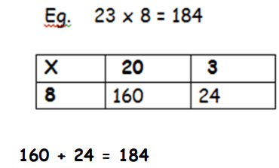
327 x 4 = 1308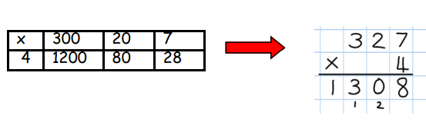
Spellings
Set 1 (Year 2 word list)  every, great, break, steak, pretty, beautiful, after, fast, last, past, father, class, grass, pass | Set 2 (Year 3 word list)  continue, decide, decision, minute, difficult, earth, consider, enough, February
For spellings, the number of Set 1 words will increase, to accommodate words that should already be known. Children can learn and be tested on both sets of words if they wish. However, your child will be tested on the set they have been given at the end of this current half term. To help your child learn these, you could:
- Ask the children to record definitions of the words or write the words within sentences.
- Ask the children to colour code the sounds within the words.
- Complete test challenges.
- Ask the children to create a wordsearch containing all the words.
See the Spelling Menu sheet for further ideas. Try to record your spelling practice in your Homework book.
Reading
Read at home at least three times a week, preferably every day. Children, you should allow parents to record entries in your Reading Diaries and sign it. House points will be awarded for each parental entry in the Reading Diary. These will be checked weekly by a member of staff. Consider trying a range of genres e.g. comics, newspapers, biographies, narrative etc. Reading books and Reading Diaries need to be in school every day.
History Project – The Romans – due Monday 7th February
This term, in History, we will be studying the Romans. We would like you to create some display work for this topic. You do not need to print off lots of things, and often, drawings are much better and showcase your skills more! Children should be encouraged to create their own versions of any text they copy, as much as possible. As before, you are not obliged to choose something from this list, but what you choose must be about the Romans.
Suggested ideas are:
- Draw a poster or create a model of the Colosseum or some other Roman building or invention. This could be out of card, paper, or other materials.
- Draw a labelled diagram of a gladiator, identifying his equipment (different gladiators have different names and equipment, e.g.: Retiarius, Secutor, Murmillo, Hoplomachus, Andabatus, Dimachaerius).
- Write a fact file or poster about the Romans; include interesting or unusual facts and ideas about the Romans. You could investigate Roman Baths, Invasions, the Roman Army, Sanitation, Food and Drink, Roman Society, the Roman Legacy (what they did for us!)
PE Reminders
This half term, Children will be Swimming on Tuesdays. Please ensure your child has appropriate kit for this day.
For the remaining PE lessons, please bring in PE kits on a Monday and take home on a Friday.
For your information, PE days are usually as follows, but may be subject to change, hence the requirement to bring kits in Mon-Fri:

Class 3L and 3P PE day: Wednesday

Class 3B PE day: Friday

