Spring Term’s News
Common characteristics:
Students with dyscalculia may:
- have difficulty learning to count or have a poor memory for numbers
- have trouble writing numbers, finding correct place values, and lining up equations
- have trouble remembering math facts
- be unable to follow a sequence of steps
- have difficulty understanding numbers, math symbols, and word problems,
- have no sense of whether any answers that are obtained are right or nearly right,
- find it hard to visualize patterns
- have difficulty measuring things
- have an exceptionally slow and difficult time solving math problems
- avoid games that require strategies involving math
- become extremely frustrated or anxious with schoolwork related to maths.

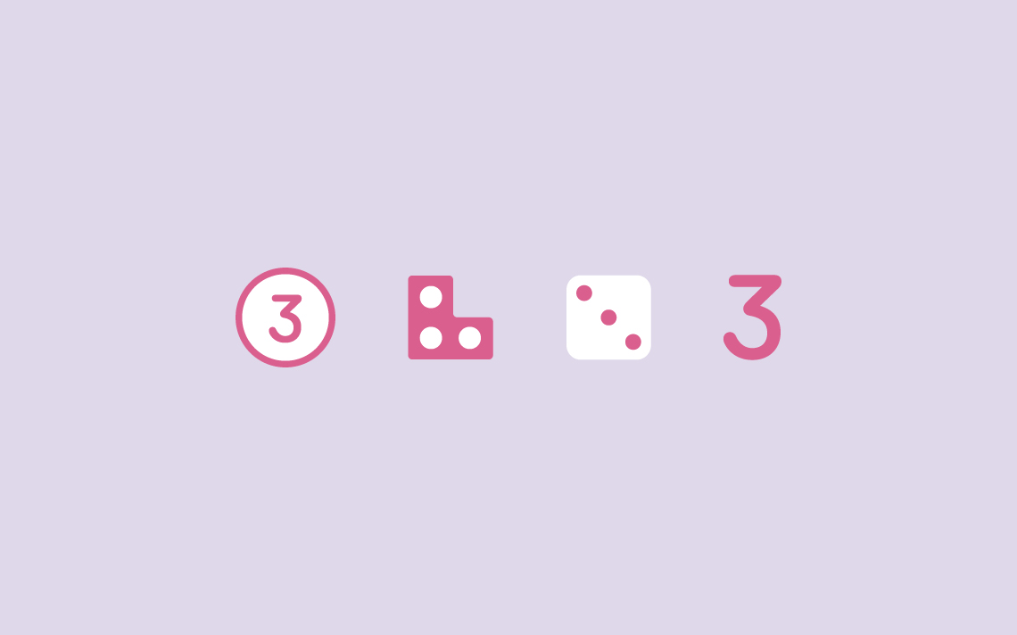
Dear Parents/Carers, Happy New Year! We hope that everyone has had a happy and peaceful Christmas and new year and are ready for an exciting new term.
Termly focus
Each term we will focus the spotlight on a particular area of special educational needs and disabilities. This term we will focus on specific learning difficulties, focussing on dyscalculia.
What is dyscalculia?
The British Dyslexia Association (BDA) defines
Dyscalculia as a specific and persistent difficulty in understanding numbers which can lead to a diverse range of difficulties with mathematics. It will be unexpected in relation to age, level of education and experience and occurs across all ages and abilities.
Mathematics difficulties are best thought of as a continuum, not a distinct category, and they have many causal factors. Dyscalculia falls at one end of the spectrum and will be distinguishable from other maths issues due to the severity of difficulties with number sense, including subitising, symbolic and non-symbolic magnitude comparison, and ordering. It can occur singly but often co-occurs with other specific learning difficulties, mathematics anxiety and medical conditions.

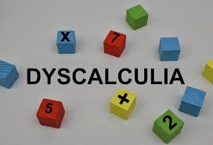
Ways to help at home:
Play With Dominoes
Playing games that use dominoes can help a child more easily understand simple math concepts. Specialist Ronit Bird states that a child should learn to recognise the number patterns on the dominoes and dice instead of counting the individual dots each time.
Play games rather than worksheets.
Whenever possible, children should play games to reinforce math facts instead of relying on worksheets. They present math as fun challenges to solve instead of boring concepts to memorize.
Use Manipulatives and creating visual models.
Seeing and handling a tangible object will help a child better understand the abstract principles of mathematics. Legos and simple blocks can be used to teach addition and subtraction. TheSchoolRun.com suggests using a counter when working with children. Actually covering a certain number of counters with your hands will enable your child to more easily visualize different groups of numbers.
Learn the Language of Math
Children should talk out loud as they work through a problem or new math concept. Children who struggle with maths may have good language skills that could help make the mathematical process easier. It's a good idea for children to learn several synonyms for a variety of math terms e.g add, plus, together.
Use Accommodations
Accommodations can include everything from circling keywords in math sentences to giving your child extra paper to work out math problems. You should also discuss with your child's teacher accommodations that can be implemented at school. A few include extra time given for tests and access to a maths resources.
Teach Toward Understanding
While learning math can be broken into sections, it's always a good idea to have the end goal in mind. Memorizing facts -- such as multiplication tables -- is a good idea, but simply memorizing facts won't always lead to real understanding of a math concept or process. Start by instructing your child to reason through a problem using logic instead of rote memorization. It's also a good idea to memorize a few basic strategies that have wide application.

Other strategies for inside and outside the classroom include:
- giving extra time to work on math-related assignments
- using graph paper for students who have difficulty organizing problems on paper
- planning and organizing students' approach to math problems
- using estimating as a way to approach solving math problems
- using objects and visuals to help solve problems
- starting with concrete examples before moving to harder, more abstract concepts
- explaining math concepts and terms clearly and encouraging students to ask questions
- providing a quiet place to work with few distractions.

Interventions in school

Cool kids
Cool Kids is a simple, fun and structured exercise programme designed to develop children’s coordination, balance, attention and self-esteem. It is based on sensory motor development working through developmental stages of lying on the back, tummy, rolling, creeping and crawling.
Cool Kids offers opportunities for: Proprioception is the sensation from the muscles and joints that gives us our sense of position in space (where we are in relation to objects around us). Activities include: crawling, pulling.

Vestibular is our sense of movement and gravity. We receive more vestibular input when we do activities that involve movement and change of head position. Activities include: rolling, jumping, hopping, and spinning/twirling.

Praxis is the ability to plan an action. Some children may find planning new motor actions difficult. They may be hesitant and need to watch others before attempting an activity. They may also have difficulty with ideation (being able to see play potential). They may also be disorganised. Activities include: different ways of moving, using equipment, planning activities.

At NJS, we use a variety of interventions to best support the needs of our children.
LEGO Build to express
LEGO® BuildToExpress (BTE) encourages pupils to express their thoughts and ideas symbolically, a more playful, creative and hands on method to engage pupils of all abilities and achieve results.
The method ensures a secure and non-judgemental process for solving problems, express personal feelings and breaking down barriers to achievement for curriculum based topics.
When using Lego Build to Express, we are offering the children opportunities to:
• Communicate more effectively.
• Encourages reflection.
• Enhances creative, abstract and critical thinking skills. • Promotes active listening.
• Improves problem solving.
• Supports time management
• Develops cooperative working.

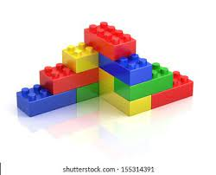

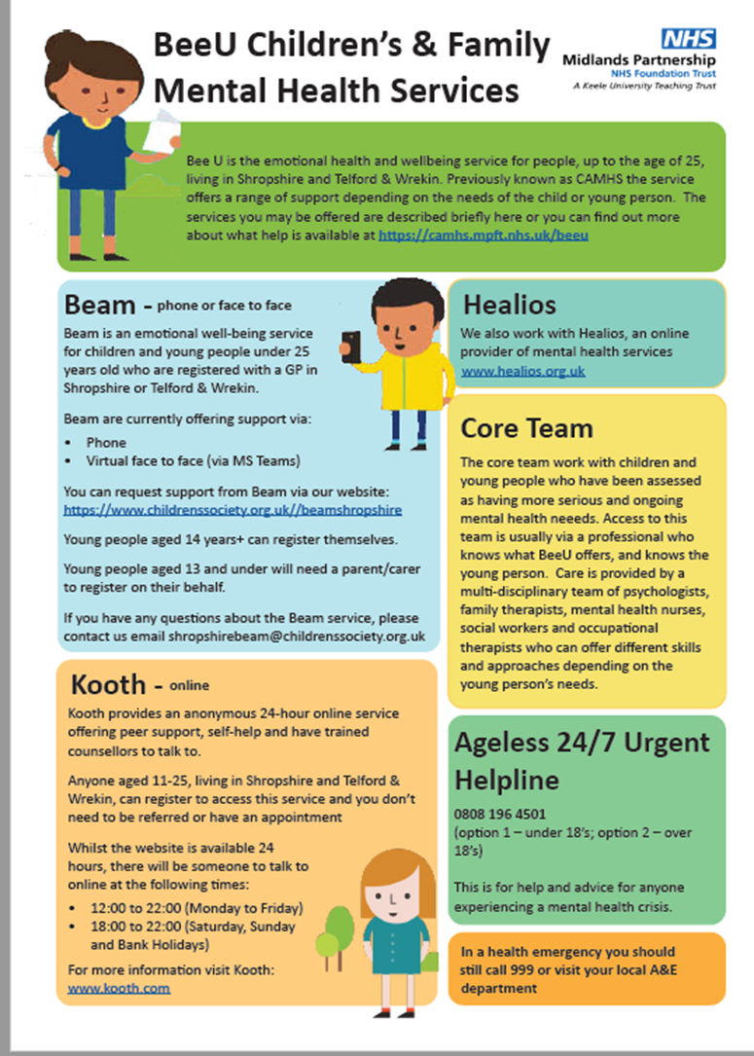
Key Contacts
SENDCO: Jane Kerr
njs.send@taw.org.uk
Inclusion Manager: Megan Hardy
SEND admin: Vicky Potter
Headteacher: Nicola Moody
01952 386600
Local offer: https://www.telfordsend.org.uk/site/index.php
Telford and Wrekin SEND parent newsletter:
www.telfordsend.org.uk/info/1/home/109/send_news

