Maths | Children have just completed their work on decimals. We are now moving onto percentages and looking at the relationship between fractions, decimals and percentages.  More info on how to convert between these can be found here: https://www.mathsisfun.com/decimal-fraction-percentage.html
English | The children have really enjoyed finishing off The Diary of King Henry VIII’s Executioner!  We are now planning and writing our own ending to the narrative. Children have worked in groups to come up with alternative ideas for what might happen next.
Physical Education | We are currently developing our football skills in P.E. Focusing mainly on passing, dribbling, ball control and communication.  We are aiming to build up towards 7-a-side matches.
Art | 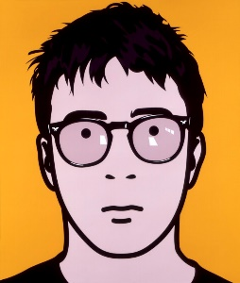  Some fantastic artwork has been placed on display in the Year 6 area! We have been focusing on portraits, including how to draw portraits using proportion and matching the style of famous visual artist Julian Opie.
Computing | The children have recently marked E-Safety Day 2022 by completing work on ‘Respectful Relationships Online.’ We focused on gaming online, and how to establish and maintain appropriate relationships across electronic platforms.  This was a really important lesson and there were lots of important discussions with the children.

