What to Bring? Kit List - 1 Night Stay

Please pack a backpack with these things
- Water Bottle
- Torch
- Towel
- Wash kit (shower gel, toothpaste and toothbrush)
- Sleepwear + comfort teddy
- Underwear and socks for day 2
- Slippers for the bedroom if you want
- 1 x t-shirts / long sleeved t-shirts for day 2
- 1 x jumpers / fleece or warm long-sleeved tops for day 2
- 1 x long trousers for day 2
- 1 x old trainers
- Plastic bag for dirty clothing
NJS children will need to be able to carry their belongings themselves to the centre!
Please ensure your child is wearing
- Wellies
- Coat or / and Waterproof Jacket / Waterproof Trousers
- Thick socks
- Hat, Scarf, and Gloves; or Sunhat and Sun Cream
- Tracksuit bottoms and 3 layers on top!
Please name all the things children bring. Just bring old clothes as children will be outdoors having fun and getting muddy!

Where are we walking?
Where is Edgmond Hall?

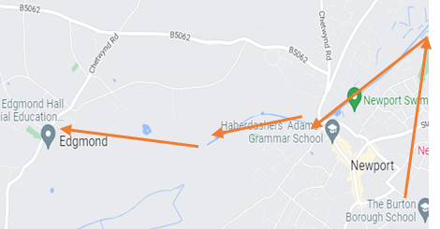
Walking Directions
Arrow 1 – School to Norbroom end of the canal
Arrow 2 – Length of canal to Shell garage
Arrow 3 – Canal to Edgmond basin
Arrow 4 – Across the fields to Edgmond Hall
Edgmond Hall 41 High Street Edgmond, Newport TF10 8JY Phone: 0121 569 4440 edgmond_hall@sandwell.gov.uk
sandwellresidentials.co.uk

…returning with experiences, skills and memories to share with you at home!
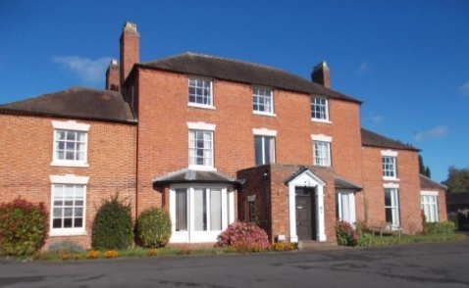

Parent and student information for a residential visit

The adventure starts here!
A warm welcome awaits!
·Getting Outdoors·Having Fun· ·Exploration· Working Together· ·Meeting the Animals· ·Personal Development· Learning New Skills· ·Positive Wellbeing· ·Creating Memories for Life·

Welcome to Edgmond Hall
Edgmond Hall is one of four centres that make up Sandwell Residential Education Service. It was bought by Oldbury Council in 1936 and converted a year later. It has been a Centre for residential education for over 80 years!
Edgmond Hall is in Shropshire. It sits on the edge of the historic village of Edgmond. It was originally a Georgian Farm House and still reflects this in the Grade II listed main house and outbuildings. It is set in 45 acres of grounds; including woodland, meadow, orchard and old marshland habitats as well as having playing fields and more traditional gardens.
Accommodation
The main house accommodates up to 60 in comfortable dormitory style bedrooms split over two floors. The toilets and showers are located on each floor next to the bedrooms.
The staff bedrooms are on each floor located close to the dormitories to enable good supervision. There are staff bathroom facilities near to their bedrooms.
Edgmond cottage is situated next to the courtyard opposite the main house with 12 more beds. It is fully accessible for wheelchair users or those with additional needs.
NJS staff have selected the dorms the children are using. They have all been thought of and are with a friend!

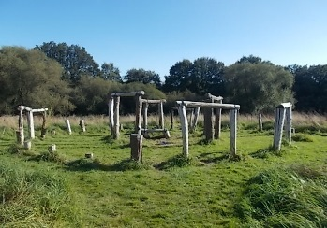
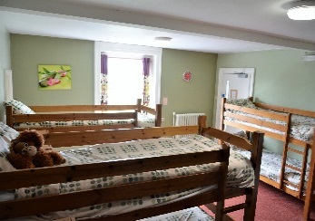

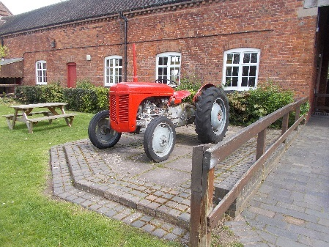

Facilities
- Large playing field with adventure play ground
- Boot room and locker room for keeping belongings to use outside
- Dining room, staff room, cloakroom and toilets in the main house
- Indoor classroom spaces, including the large classroom in the old barn
- Indoor games room
- Toilets and handwashing in the courtyard for easy access outdoors
- NJS will be… Problem Solving, Shelter Building, Orienteering, and having a campfire!

Meals
Each day there is breakfast, a packed lunch, a cooked evening meal and hot chocolate and a homemade biscuit for supper. Children are well fed and don’t need to bring their own snacks!
NJS have selected food options and children do NOT need any food with them!
Staff
We have an experienced and friendly team of tutors and support staff who are dedicated to:
- Providing a friendly, safe, homely environment
- Providing a high-quality educational experience
- Working closely with visiting staff
NJS have these adults going with the children:
Mrs Moody, Mr Butler, Mrs Pearson, Mr Lawson, Mrs Yates, Miss Whittington, Mr Leonard, Mr Jones, Mr Marsh, Miss Smith and Mr Moody.
We all understand issues children have at bedtime and we will do all we can to comfort your child during the stay. A phone call home will be last resort with 11pm as the cut off!
Timings
Depart NJS at 9.30am on Monday 14th
Arrive back at NJS at 3pm on Tuesday 15th
Please arrange collection of your (tired) child at 3pm from the usual year 3 entrance.

