Wednesday 27th April 2022
Dear Parents and Carers of Year 6 pupils,

I am writing to advise you about arrangements for the forthcoming SAT tests which will take place the week beginning 9th May.

ALL children MUST be in school during SAT week. If there are circumstances that mean your child will attend late or not attend PLEASE contact school before 8.30am on 01952 386600. Please speak to Mrs Moody, Miss Bold, Mr Jones or Mrs Kerr regarding the absence so that appropriate arrangements can be made.

Breakfast club will start at 8am. Children should come straight to the hall as soon as they arrive (even if this is earlier than 8am) at school rather than waiting on the yard. Staff will meet the children and serve breakfast. Children will have time to relax before registration at 8.50am and tests will start around 9am. The timetable for testing is below (your child will find out whether they are in Group 1 or 2 next week):

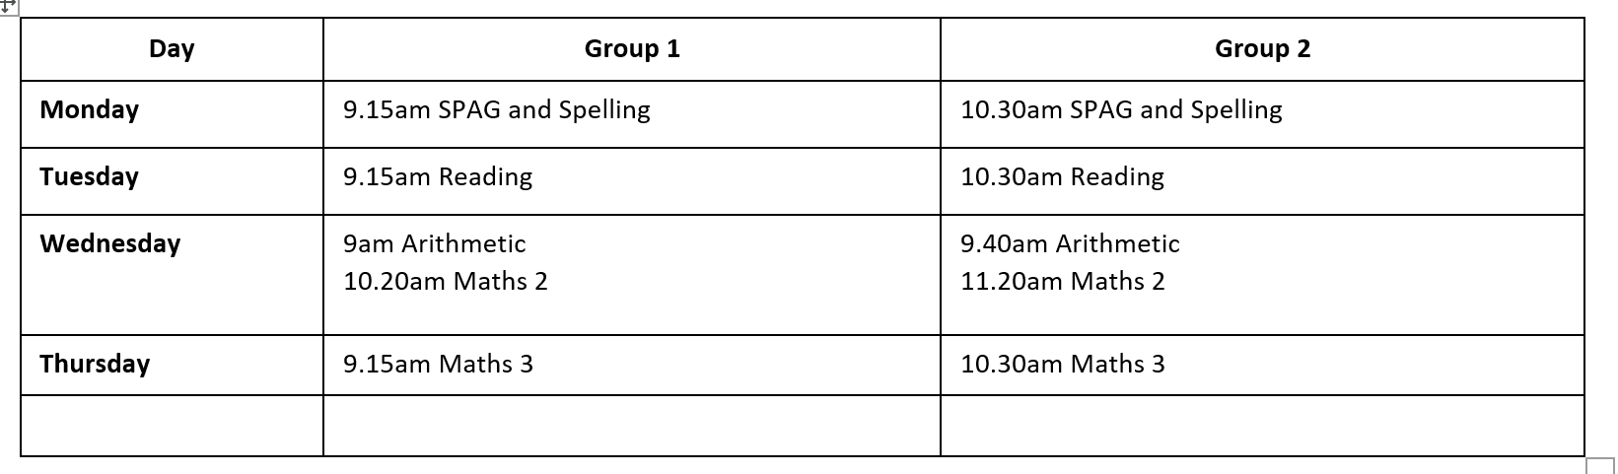

Children will be provided with the equipment they need to complete the tests e.g. pencils, rulers etc. Personal equipment will not be allowed to be used in the tests. The tests will be completed in the children’s usual classrooms.

Where children are sitting two tests on a morning they will have an extended break time between tests. Please send your child to school with a drink and healthy snack to have at this time. Children will require their PE kits in school each day during SAT week.

By working together to ensure the children are as well prepared as possible we can give them the best chance of achieving their potential. Please know that we are administering these tests to meet the statutory obligations set for schools by the government; we absolutely appreciate that this can be an anxious time for children. A little bit of anxiety is normal and we will be talking to the children about this but if you feel you have concerns please do talk to us.

Unfortunately these tests won’t recognise the fantastic friends, amazing artists, marvellous musicians or successful sportsmen amongst our children; but as a school we absolutely recognise these talents. These tests will however mark their incredible efforts in class in English and Maths over recent weeks and their time at NJS. The children should feel proud if they have tried their very best; we can ask no more.

Staff and children are very grateful for your continued support ahead of the tests. If you have any questions please contact one of us.

Mrs Moody and the NJS Team

