Year 3 Spellings and Homework: Summer 2022 1st Half Term
Issued on: Tuesday 26th April Due in: Monday 23rd May
Maths
Target 1: To recall multiplication facts confidently and quickly from the 2x, 3x, 4x, 5x, 6x, 8x and 10x tables.

Target 2: To be able to calculate TU x U and HTU x U, using more formal, written methods.

We would like children to continue to develop their rapid recall of number bonds and mental calculations, using a selection of the websites below. Some are the same, but some are new. Please continue to support us, by encouraging your children to take an active role in their learning. Here are some suggested activities to record in the orange Homework Book – you do not have to do them all, and in fact you could choose activities that aren’t listed here, if they meet the above targets. Children who can show evidence of regular homework activities in their Homework Book by 23/5/22 will be handsomely rewarded with house points!
For Target 1, the same websites apply, but any website or app/game which addresses the targets will do.

- https://www.topmarks.co.uk/maths-games/daily10 - great for easily adjustable, quickfire mental maths number bonds, place value, all four operations. Work up to level 3 (year 3), and use level 1 and 2 for support if level 3 is too challenging.
- Complete challenges by multiplying the numbers on two dice or use an online random number generator to multiply by 2x, 3x, 4x 5x and 10x tables. Record calculations.
- Challenge your friends or teachers to a TTRS Rockslam!
- NUMBOTS – https://play.numbots.com/#/account/school-login-type - all children now have a logon for this number bond developer. This is a subscription site, paid for by school.
- https://mathsframe.co.uk - This website has some free content but also provides some subscription content. See website for details.
- https://www.topmarks.co.uk/ - A great website for free content! Choose multiplication and then the number. The following links are all on TopMarks:
- https://www.topmarks.co.uk/maths-games/hit-the-button
- https://www.topmarks.co.uk/maths-games/mental-maths-train
- https://www.topmarks.co.uk/maths-games/multiples-and-factors (harder)
- https://www.mathschase.com/times-tables/
- And obviously, please also continue to regularly complete Times Tables Rock Stars! Class teachers will be checking regularly to see evidence of participation.
To complete Target 2, children should use the method they learned in school. Please see your child’s teacher if your child is struggling with this, or you are not sure what to do.

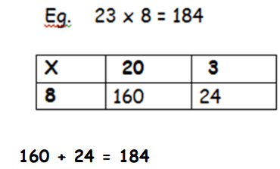
327 x 4 = 1308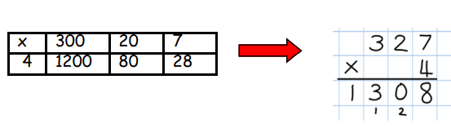

Spellings - to be tested w/c 23rd May
Set 1 (Year 2 word list)  plant, path, bath, hour, move, prove, improve, sure, sugar, eye, could, should, would, who, whole | Set 2 (Year 3 word list)  perhaps, address, guard, material, recent, guide, forward, fruit, famous, though, notice, quarter, length, library
For spellings, the number of words has increased, to accommodate for time lost due to lockdown. Some are words that should already be known. Children can learn and be tested on both sets of words if they wish. However, your child will definitely be tested on the set they have been told to learn by their class teacher. To help your child learn these, you could:
- Create a wordsearch containing your words, correctly spelled.
- Record definitions of the words or write the words within sentences.
- Ask the children to colour code the sounds within the words.
- Complete test challenges.
See the Spelling Menu sheet posted on the year 3 homework page for further ideas. Try to record your spelling practice in your orange homework book.
Reading
- As before, children need to read at home preferably every day.
- They need to show evidence of reading at home with an adult at least three times a week.
- Reading books and Reading Diaries need to be in school every day.
- Children, you should allow parents to record entries in your Reading Diaries and sign it.
- These will be checked weekly by a member of staff. At this age, it is important that children are exposed to a wide variety of genres, such as comics, papers, information books and story books. House points will be awarded for each parental entry in the Reading Diary.
Newport Project – due Monday 23rd May
This term, we will be studying Towns and Cities, with a focus on Newport and Birmingham. We would like you to complete some project work about NEWPORT for this topic. You do not need to print off lots of things, and often, your own writing and drawings are much better and showcase your skills more!
Children should be encouraged to create their own versions of any text they copy, as much as possible. As before, you are not obliged to choose something from this list, but what you choose must be about Newport. Suggested ideas are:
1* - Draw a poster about Newport or create a model of a well-known Newport building. This could be out of card, paper, or other materials.
2** - find out about the Great Fire of Newport and either: -
- create a report about it (eg: news report style)
- write a story about it (ideally at least a page of A4) and draw a picture of it
- create a model of the great fire and what it would have looked like (using cardboard / coloured paper, paint etc.
3*** - create your own Monopoly game about Newport (‘Newportopoly’), or a different game, with the aim of teaching player about the town’s features and history. Try to include it’s historic buildings and well-known places and streets.

PE Reminders
There is NO swimming for Year 3 this half term. Therefore, please ensure your child brings appropriate PE kit on a Monday, to leave in school all week and take home on Fridays.
As the weather improves, hopefully we will be doing PE outdoors more often. Please pack a pair of joggers and plain sweatshirt / spare school jumper for your child to wear during PE lessons, in case the weather is cool.

