WHAT YOU'LL NEED
- gloves
- bag or basket for collection
- water for washing
- hob or fire for cooking
- pan
- potatoes
- stock cube/powder
- spoon
- liquidiser or blender – or masher!
- bowls & spoons for eating
This activity has been provided by

INGREDIENTS:
- 2 handfuls of washed nettles
- 2 potatoes (diced)
- 1 onion (chopped)
- 1 litre of stock (chicken/veg)
- garlic/salt/pepper (as you like it)
- a dollop of cream for added deliciousness!
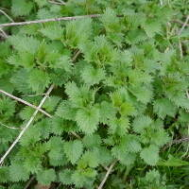

STEP #1PICKING
Look out for young, fresh, pale green nettles just coming through. If you are picking later in the season then just pick off the tops (pick before the end of May as older nettles leaves have a bitter taste).
Wear protective gloves to pull off the young shoots/tops of the nettle and collect them in a bag or basket.
NB:
'At the first sign of flowers you must stop picking. The plant will now start producing cystoliths - microscopic rods of calium carbonate - which can be absorbed by the body where they will mechanically interfere with kidney function.'
Taken from John Wright's Hedgerow book.
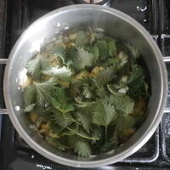

STEP #2COOKING
In a pan fry the onion (add wild garlic leaves for extra flavour) and potatoes in a splash of oil (or in some homemade wild garlic butter) for a few minutes.
In the meantime pull off the nettle leaves from the stems, wash the leaves and add them to the pan.
Add the stock and boil for 10-15 minutes until the potatoes are cooked.
Liquidise, season and serve!

