Summer Term’s News
Different OT teams in Shropshire:

Mainstream Schools

The mainstream team provide a service for children age 5 -18 that attend mainstream school and who have functional difficulties relating to self-care, classroom activities and leisure that are having an impact on their ability to manage in their daily lives. These difficulties cannot be attributed to significant physical difficulty or general delay.

Physical Disabilities
The Physical Disabilities Team provide a service for children from 0-19 who have a diagnosis of physical disability and requiring functional assessment and advice. The team support children who may need rehabilitation following trauma, deteriorating conditions and children receiving palliative care.

Learning Disabilities
The Learning Disabilities team see children and young people who experience sensory processing and/or complex neurological difficulties affecting their ability to participate in daily living tasks at home or school.

New patients
We operate an open referral system and accept referrals from parents, school or any other professional with parents’ consent for children between the ages of 0 to 18.
Dear Parents/Carers, The better weather is hopefully on the way and summer term has arrived.
Termly focus
Each term we will focus the spotlight on a particular area of special educational needs and disabilities. This term we will focus on occupational therapy.

What is occupational therapy?
The role of the occupational therapist is to enable children and young people to function to the best of their ability. Occupational Therapists provide advice for children whose ability to carry out functional skills is compromised.
The Shropshire service is available for children aged between 0 – 18 (19 years in full time education) who are registered with a GP within either Shropshire or Telford and Wrekin geographical boundaries.

In school, we support children with both fine and gross motor skills needs through OT programmes including Cool kids.

If you wish to discuss any concerns you have in regards to gross and fine motor skills please speak to the class teacher or contact the SENDCO.

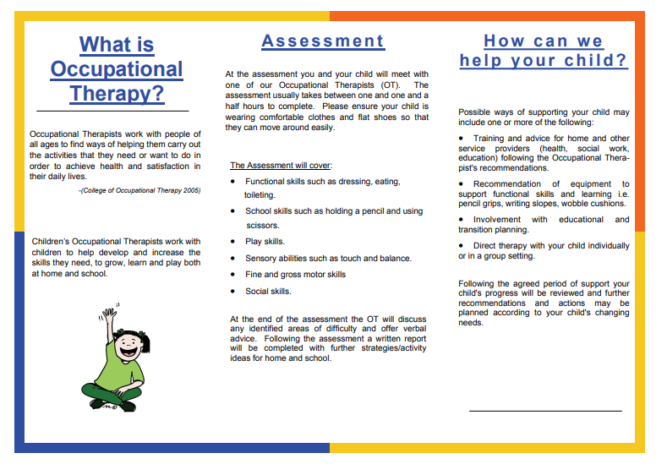

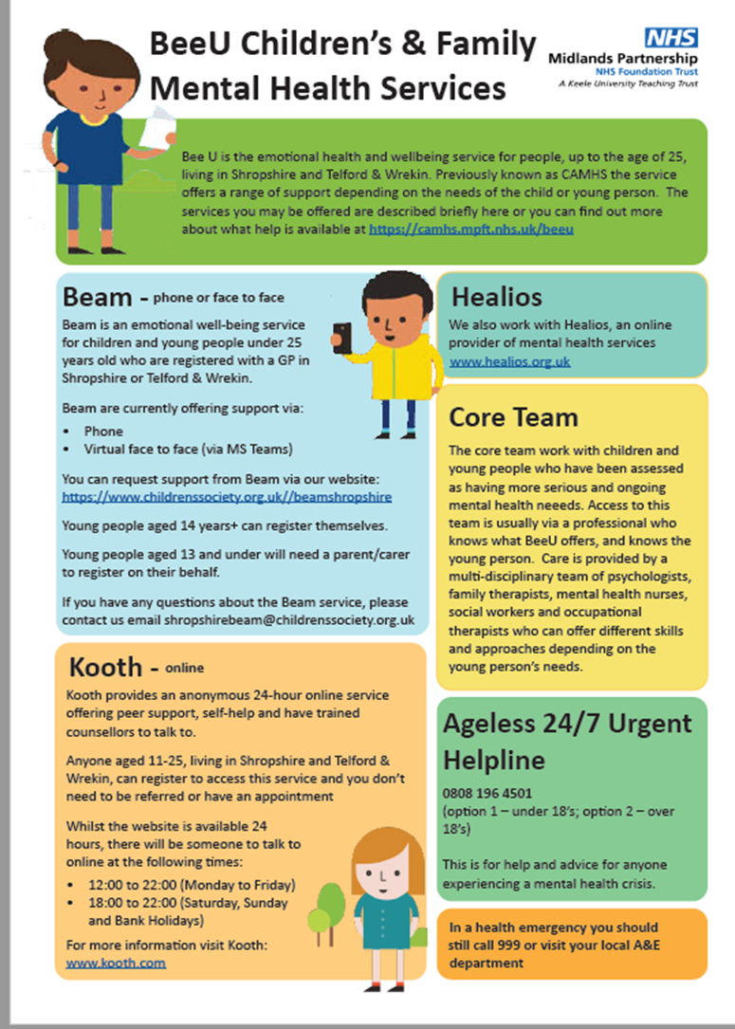
Key Contacts
SENDCO: Jane Kerr
njs.send@taw.org.uk
Inclusion Manager: Megan Hardy
SEND admin: Vicky Potter
Headteacher: Nicola Moody
01952 386600
Local offer: https://www.telfordsend.org.uk/site/index.php
Telford and Wrekin SEND parent newsletter:
www.telfordsend.org.uk/info/1/home/109/send_news

