Year 3 Homework: Autumn 1st Half Term
Issued week ending: Friday 16th September 2022. Due in: Monday 17th October 2022
As much work as possible should be completed regularly at home, in the Homework book issued in class.
Maths
Target: To recall number bonds, confidently and quickly, totalling up to 10 and 20.
EXT: - To confidently recall number bonds to 100
You could:
- Use blocks or coins to make amounts that add up to totals up to 10 and 20, plus numbers in between. E.g., 1+2, 2+3, 7+3, 6+4, 6+5, 9+6, 10+1, 10+2, 11+4, 13+7, 15+5 etc.
- Complete challenges when travelling, by adding the numbers on a car number plate.
- Write out 20 questions and time your child to complete - can they beat their last time?
- https://mathsframe.co.uk
This website has some free content but also provides some subscription content. See website for details.
- https://www.topmarks.co.uk/ - A great website for free content! Choose addition or subtraction and then the number bonds to 10 or 20, or something harder!
- The following links are all on TopMarks:
- https://www.topmarks.co.uk/maths-games/hit-the-button
- https://www.topmarks.co.uk/maths-games/mental-maths-train
- https://www.topmarks.co.uk/maths-games/5-7-years/counting Recap your KS1 knowledge
- https://www.topmarks.co.uk/maths-games/7-11-years/ordering-and-sequencing-numbers
- For the extension objective, complements to 100, children need to know pairs of numbers that add to 100, eg 43 and 57, 21 and 79, and so on. You could test them by giving them a number and they have to say the other one, which adds to make 100.
Please also continue to regularly complete Numbots and Times Tables Rock Stars! Your class teacher will check regularly that you are using this, to assess progress and participation.
Spellings
Set 1 (Year 2 word list)  door, floor, poor, because, find, kind, mind, behind, child, children |  | Set 2 (Year 3 word list)  actual, learn, early, heard, group, arrive, circle, often, build
Children should know how to spell all the words in Set 1 – please review these with them. Your child will be tested on the set they have been given at the end of this current half term. To help your child learn these, you could:
- Ask the children to record definitions of the words or write the words within sentences.
- Ask the children to colour code the sounds within the words.
- Complete test challenges – try to use the handwriting style shown separately – see sheet stuck in homework book.
- Ask the children to create a wordsearch containing all the words.
See the Spelling Menu sheet for further ideas. Try to record your spelling practice in your homework book.
Reading
Read at home at least three times a week, preferably every day. Record this reading in your Reading Diary. These will be checked weekly by a member of staff. Consider trying a range of genres e.g., comics, newspapers, biographies, narrative etc. Reading books and Reading Diaries need to be in school every day.
PE Kit
Please bring in your PE kit on a Monday and take home on a Friday. This allows maximum timetabling flexibility, as occasionally, sessions are shifted around because of events or assemblies.
Foundation Project
The Foundation Project is for children to develop their independent study skills and they will be offered the chance to complete a different project each term. Children do not have to complete every part of the project that follows, but the more they do, the greater their house point reward will be!
This term’s Foundation subject project is about Art. Please complete your work on suitable materials, or in the Homework book if possible. To develop the children’s appreciation of different artists and art styles, we would like them to complete one of the following projects listed below:
Traditional Art - art made using traditional techniques passed on from one generation to the next, like painting, sculpture, fine art. It is often 2D in form, when painted.
Modern Art - art of a style that is deliberately different from traditional art, created between the late 19th and the late 20th centuries.
Contemporary Art - art of any form, produced since World War 2 (late 1940s), right up to the recent past.

TASK:

- Here are some examples of works by traditional, modern, and contemporary artists. Can you create your own version of some of these works, using different materials? (e.g.: if it is painted, can you do a pencil crayon sketch / collage / sculpture / pencil or pen drawing / model / montage, and vice versa?)
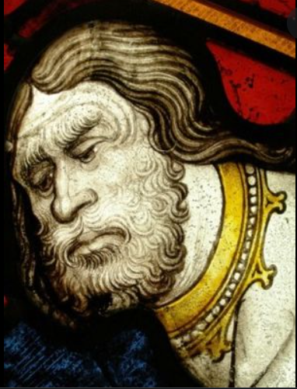 | 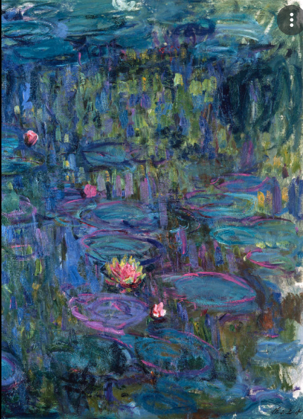 |  | 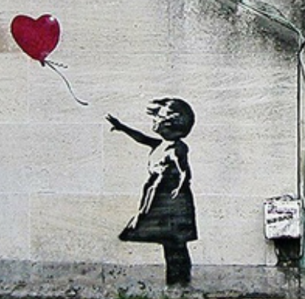
Traditional Art  St John the Baptist by John Thornton 1405-1433 – A famous medieval Glass painter from England.  Suggestions:  - Make a papier mâché head version  - Do a black and white version of it  - Draw a picture of the person being baptised, in the style shown above. | Modern Art  The Blue Nympheas by Claude Monet 1840-1926 – A famous French painter founder of Impressionism.  Suggestions:  - Make a card and tissue paper model of the lily pond above.  - Create a version using reds, yellows, and oranges of the painting above.  - Sketch a picture of the surrounding area where the pond might be. |  | Contemporary Art  The Girl with the Balloon by Banksy 2002 – a famous contemporary graffiti artist.  Suggestions:  - Recreate a live action version of this picture, with you in it! (Can save electronically if you prefer)  - Draw a version of this with crowds of children releasing many balloons.  - Draw or paint a picture of the place where the balloon landed.

