Autumn Term’s News
Emotion Coached children and young people:

- Achieve more academically in school
- Are more popular
- Have fewer behavioural problems
- Have fewer infectious illnesses
- Are more emotionally stable
- Are more resilient

(Gottman 1997)

Many people feel uneasy with change or new situations and with the new school year upon us, we as a school, felt that it was important to ensure the wellbeing of all our members. Emotion coaching is one strategy we feel allows children to acknowledge their feelings and learn ways to cope with what might otherwise be very uncomfortable situations for them.
This Term’s News
Dear Parents/Carers,
Welcome back to the new school year! It has been lovely to see all the children back in after a beautiful summer. A warm welcome to all, especially those new to our school family.
All of the children’s needs, both academic and personal wellbeing, are of the upmost importance to all our staff and we look forward to working closely with you over the coming year to make it successful for them.

Termly focus
Each term we will focus the spotlight on a particular area of special educational needs and disabilities. This term we will focus on emotion coaching.

What is emotion coaching?
Emotion Coaching is based on the principle that nurturing and emotionally supportive relationships provide optimal contexts for the promotion of children's outcomes and resilience

According to parentingscience.com:
Emotion coaching is the practice of tuning into children’s feelings, and helping kids learn to cope with — and self-regulate — negative emotions like fear, anger, and sadness. As proposed by psychologist John Gottman, the practice includes these key components:
- becoming aware of emotions, even low-intensity emotions, in yourself and your child;
- viewing negative emotions as opportunities for “intimacy or teaching”;
- accepting and validating your children’s feelings;
- helping your child describe and label emotions with words; and (when a child has calmed down)
- talking with your child about practical strategies for dealing with the situations that trigger difficult emotions.

How does emotion coaching work?
Emotion Coaching uses moments of heightened emotion and resulting behaviour to guide and teach the child and young person about more effective responses. Through empathetic engagement, the child's emotional state is verbally acknowledged and validated, promoting a sense of security and feeling 'felt'. This activates changes in the child's neurological system and allows the child to calm down, physiologically and psychologically.

www.emotioncoachinguk.com
We will be holding our next SEND coffee afternoon in early November and will be focussed on emotion coaching through home and school. More details to follow shortly.

If you wish to discuss any concerns you have in regards wellbeing please speak to the class teacher, Mrs Wheat or contact the SENDCO.

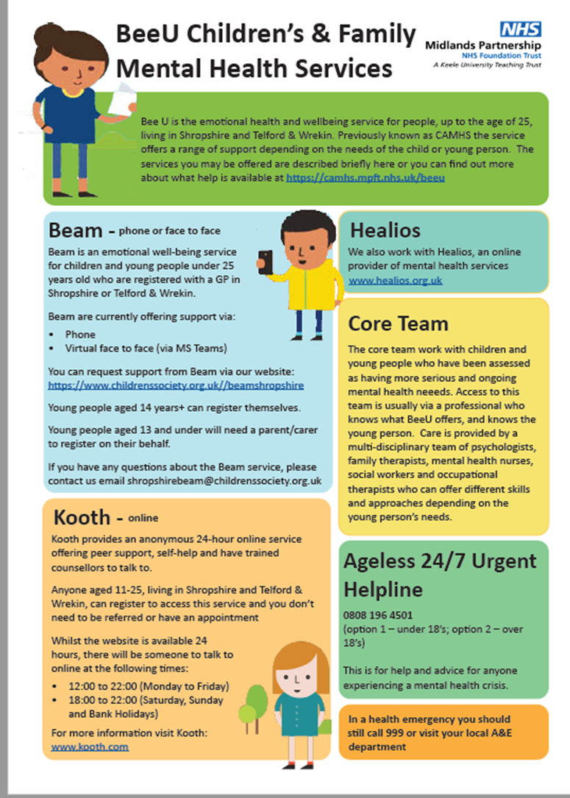
Key Contacts
SENDCO: Jane Kerr
njs.send@taw.org.uk
Inclusion Manager: Megan Wheat
SEND admin: Vicky Potter
Headteacher: Nicola Moody
01952 386600
Local offer: https://www.telfordsend.org.uk/site/index.php
Telford and Wrekin SEND parent newsletter:
www.telfordsend.org.uk/info/1/home/109/send_news

