Year 4 Homework: Summer 2nd Half Term
Issued on: Monday 12th June 2023,
Due in: Monday 17th July 2023
Maths
Throughout this half term, the Year 4 Maths curriculum has a strong focus on place value and the four main operations. There are a wide range of topics targeted such as;
- Place Value – order and compare numbers beyond 1000
- There will also be a focus on fractions. We will look at non-unit fractions, adding and subtracting fractions with the same denominator. Recognising and showing fractions using diagrams
- Recognise and write decimal equivalents, round decimals with one decimal place to the nearest whole number
- The four main operations for addition, subtraction, multiplication and division: Addition – column method, Subtraction – column with exchange, Multiplication including multiplying 3 digit numbers by a 1 digit number and Division – garage/bus stop method.
- Mental calculations for the four main operations. Estimate and use the inverse calculation to check answers
- TIME!! Learn to tell the time – converting between 12 and 24 hour clocks. Solve problems involving converting hours to minutes, minutes to seconds etc.
- TTRS; speed times tables, learning them all off by heart!
Some other activities you could try are:
- Write a list/take photos/show how you and your family have used Maths in everyday life over the half term.
We are also open to any other suggestions that you think are appropriate. We want the children to take ownership over their homework and complete it in a way of their choosing.

Spelling
Set 1  decision mountainous hesitation character machine league Science eight girls accept echo chef chalet crescent weightless grate missed knot invasion magician  (All taken from the Yr4 Key spelling document) | Set 2  come old are take into back just where which here their very so can’t it’s here they she asked of help  (Taken from the High Frequency words!)
You could:
- Ask the children to record definitions of the words or write the words within sentences.
- Ask the children to colour code the sounds within the words.
- Complete test challenges.
- Ask the children to create a wordsearch containing all of the words.
- Write the words yourself and ask the children to mark them.

Reading
Read at home at least three times a week. Record this reading in your Reading Diary. Consider trying a range of genres e.g. comics, newspapers, biographies, narrative etc. Reading books and Reading Diaries need to be in school every day. How about writing a book review for your favourite book?

Other
This homework is a family activity, which you can decide on:
- You don’t need to evidence this, but feel free to make a poster or write about how you have kept safe online if you wish.
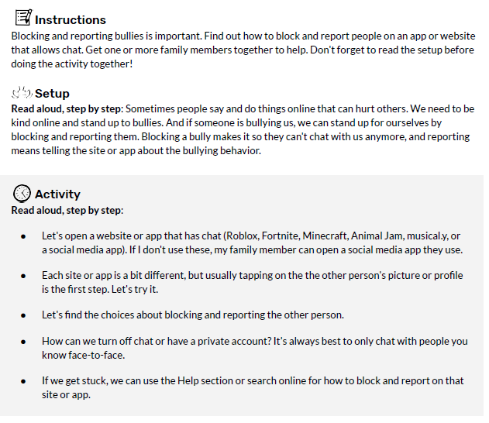
- Can you create a poster based on your memories from your year in Year 4? Make this is creative, colourful, and fun as you see fit.
PE Reminders:
Please remember to bring your P.E Kit and leave in school Monday to Friday.

