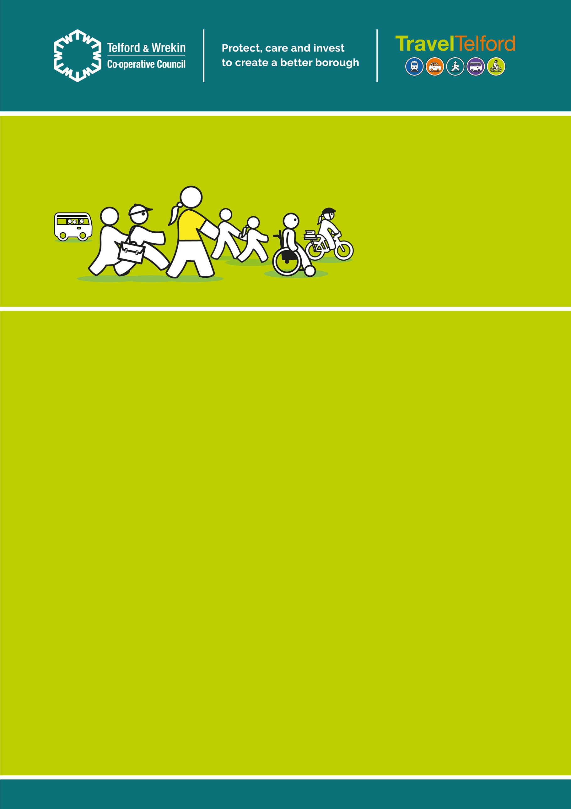

A New School Journey
  - Issue 1

Date: Dec 23

  - Welcome to A New School Journey Newsletter

We are delighted to inform you that Newport Junior School have agreed to take part in a new project in partnership with the Active Travel & Road Safety Education Team at Telford & Wrekin Council.
Newport Juniors is one of four schools selected to take part in ‘A New School Journey’ pilot which is the first of its kind to take place in Telford and Wrekin.
This programme has been developed for several reasons including:
• Improving road safety outside of school
• Easing congestion
• Encouraging more active travel to/from school
• Reducing emissions
We are aware of a number of road safety concerns around Newport Juniors and we hope that by working in partnership with parents/carers, pupils and the school, we can help alleviate these concerns.
Newport Junior School has been selected due to its commitment and passion for active travel. All we are asking for is one small change. As a minimum we ask that you either Park & Stride (park away from the school entrance, ideally a 10 minute walk away) scoot, cycle, wheel or walk to/from school at least once a week.
We are always interested to hear your thoughts so please do get in touch via roadsafety@telford.gov.uk
More information will follow over the next few months but for now we look forward to starting A New School Journey with you.

Be Bright Be Seen

Be Bold and Bright Both Morning and Night
With the dark nights and autumnal weather upon us, the Travel Telford team have been in to school to talk to pupils about how to stay safe and been seen by oncoming traffic. We delivered a whole school assembly where the JRSO’s (Junior Road Safety Officers) introduced their first in a series of themed competitions, design your own Be Bright Be Seen school bag.

Shine bright at night
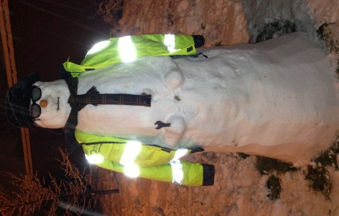
Year 4 continued their Be Bright learning by taking part in a Be Bright Be Seen workshop. The Active Travel & Road Safety Education team worked with pupils to conduct an experiment to find out which is the brightest Hi-Vis – Pink, Yellow, Green or Orange. This workshop teaches students the importance of bright, fluorescent, clothing during the day and reflective items during the evening. The children thoroughly enjoyed the workshop and each received a pair of brightly coloured gloves at the end.

Remember it’s the law to have clean and working lights on your bike.

White at the front and red at the back as well as a rear reflector.

Our final Be Bright Be Seen activity was a Be Bright Walk to School.
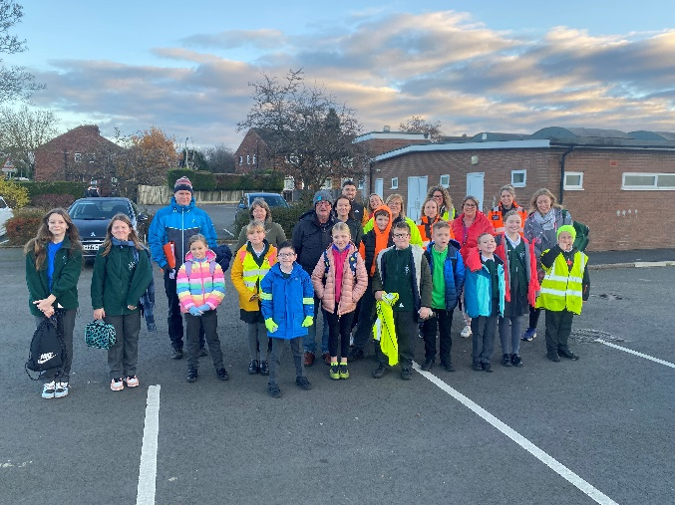
Thankfully, the weather was on our side and it was a dry, albeit chilly morning! Despite the early start, we were blown away by the amount of families who decided to join us and we lit up the morning with fluorescent clothing, hi-vis jackets and Be Bright accessories. Thank you so much to those families who joined us!

We have future walks to school planned and our next walk will be on the 8th December. Our theme for this walk will be Christmas! So why not put on your Christmas jumper or your reindeer headband and join us for a festive walk to school. (More details to follow

Looking Ahead..
Example of photo placement

Love Your Environment – Our theme for next term.
We can all help to conserve our environment by trying to live in a way that is more sustainable. Leaving the car at home once a week and walking/wheeling/scooting or cycling to or from school is a great place to start.

Active school runs improve both physical and mental health and helps to reduce stress and anxiety. It also helps children to arrive at school ready to learn and supports them in meeting their recommended 1 hour of physical activity per day.

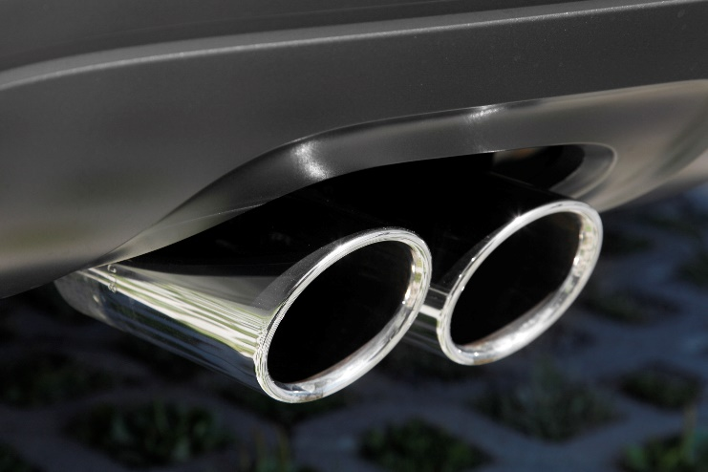
There are various reasons why you may need to travel by car on the school run and we appreciate it’s not always possible to leave the car behind. Park and Stride allows families to still enjoy the benefits of walking to school, while also keeping the front of school clear and safe for pupils and families.
Park and Stride Guidance

- Email helen.smith2@telford.gov.uk for your parking promise letter, map and car sticker to show your commitment to change.

- Park around a 10 minute walking distance away from the school entrance and walk/wheel/cycle or scoot the rest of the way!

Did you know: Anti-idling?
Leaving your engine running for just 1 minute, releases enough harmful emissions to fill 150 balloons!

