Maths
Throughout this half term, the year 5 maths curriculum has a strong focus on fractions. There are a wide range of topics targeted such as;
- Finding equivalent fractions
- Ordering and sequencing fractions
- Adding and subtracting fractions with the same and different denominators
- Converting between improper and mixed fractions
- Multiplying fractions
- Fractions of amounts
Try using these sites to enhance and develop your learning:
- https://www.topmarks.co.uk/maths-games/7-11-years/fractions-and-decimals
- https://www.mathplayground.com/index_fractions.html
- https://www.splashlearn.com/fraction-games
- https://www.coolmath4kids.com/math-help/fractions/adding-and-subtracting-fractions-different-denominators
- https://www.education.com/games/fractions/
While children extend their knowledge around fractions through maths lessons and their own personal research, they may wish to create yourself a ‘fraction formula grab sheet’. This is where they can create themselves helpful reminders on how to master the many methods we use to tackle fractions.
We are also open to any other suggestions that you think are appropriate. We want the children to take ownership over their homework and complete it in a way of their choosing.
If you are unsure about anything and would like any more information about this, please contact your child’s class teacher.
Spellings and Handwriting:
NB: Weekly spelling tests will occur every Friday and the sheets will be provided separately.  Children will also need to learn the following  spellings and will be tested on these when they return to school on Friday the 12th after Christmas. The children will also have handwriting sheets included to practise their handwriting. | NB: Spellings lists may be repeated as these are the statutory spellings for year 5.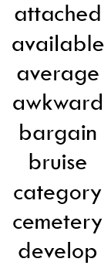
You could:
- Ask the children to record definitions of the words or write the words within sentences.
- Ask the children to colour code the sounds within the words.
- Ask the children to create a wordsearch containing all of the words.
- ABC Order: Write all of your spelling words in alphabetical (ABC) order.
- Word Parts: Write your words. Then use a coloured pencil to divide the words into syllables. e.g. jump ing cat er pill ar
- Other Handed: Write each word 5 times, switching the hand you write it with each time. Say the word as you spell it.
- Vowel Spotlight: Write your words using one colour for the vowels and another colour for the consonants (vowels: a, e, i, o, u)
- Use Technology: Type out your spelling words on the computer. Try to use at least 4 different fonts.
ALSO in the children’s homework book is a “Spelling Menu” with a range of different activities suited to any spelling.
Reading | Other Additional
Read at home at least three times a week. Record this reading in your Reading Diary. Consider trying a range of genres e.g. comics, newspapers, biographies, narrative etc. Your reading diary will be marked weekly, so please keep this up to date! | This TERM we would like the children to focus on their art appreciation for the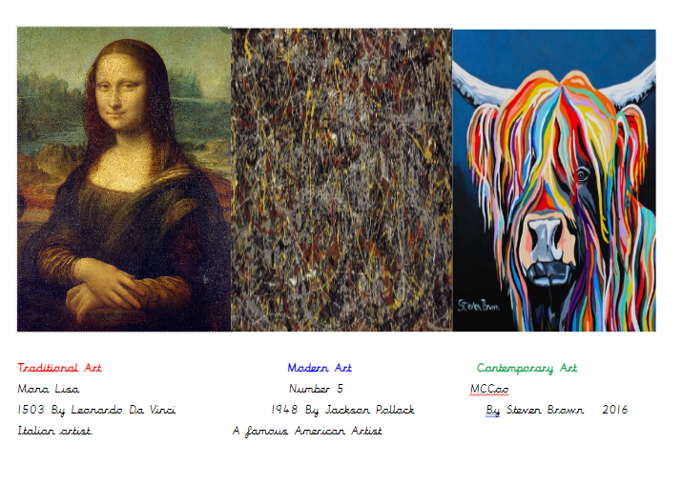 remainder of this half term. If the children could research the modern and contemporary pieces of art and design their own versions of these either by painting their own versions or making it on a digital art app that would be brilliant and some facts about the artists would be very welcome.
PE/Swimming
Please remember that this half term we are swimming.
PE kits will need to be in school on:
All week please.

