Year 3 Homework: Spring 2024 1st Half Term
Issued on: Monday 8th January 2024 Due in: Wednesday 31st January
Maths
Target 1: To recall multiplication facts confidently and quickly from the 2x, 3x, 4x, 5x, 6x, 8x and 10x tables.
Target 2: To learn and rapidly recall number bonds totalling up to 20.
Target 3: To be able to calculate TU x U and HTU x U, using more formal, written methods.

As usual, here are some suggested activities to record in the yellow Homework book – you do not have to do them all, and in fact you could choose activities that aren’t listed here, as long as they meet the above targets. Children who can show evidence of regular homework activities in their Homework Book by 15/02/23 will be handsomely rewarded with house points!
For Target 1, the same websites apply, but any you can find which address the targets will do.

- http://www.topmarks.co.uk/number-facts/number-fact-families
- https://www.arcademics.com/games/meteor
- Complete challenges by multiplying the numbers on two dice or use an online random number generator to multiply by 2x, 3x, 4x 5x and 10x tables. Record calculations.
- Challenge your friends or teachers to a TTRS Rockslam!
- https://mathsframe.co.uk
This website has some free content but also provides some subscription content. See website for details.
- https://www.topmarks.co.uk/ - A great website for free content! Choose multiplication and then the number
- The following links are all on TopMarks:
- https://www.topmarks.co.uk/maths-games/hit-the-button
- https://www.topmarks.co.uk/maths-games/mental-maths-train
- https://www.topmarks.co.uk/maths-games/multiples-and-factors (harder)
- https://www.mathschase.com/times-tables/
- And obviously, please also continue to regularly complete Times Tables Rock Stars! Class teachers will be checking regularly to see evidence of participation.

To complete Target 3, children should use the method they learned in school, or the following methods:

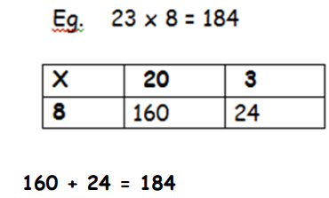
327 x 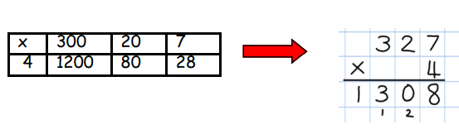4 = 1308

Spellings
Spellings this term are listed below – please try to practice each week, as these will be followed up and reviewed during English lessons.
To help your child learn these, you could:
- Ask the children to record definitions of the words or write the words within sentences.
- Ask the children to colour code the sounds within the words.
- Complete test challenges.
- Ask the children to create a wordsearch containing all the words.
See the Spelling Menu sheet for further ideas. Try to record your spelling practice in your Homework book.

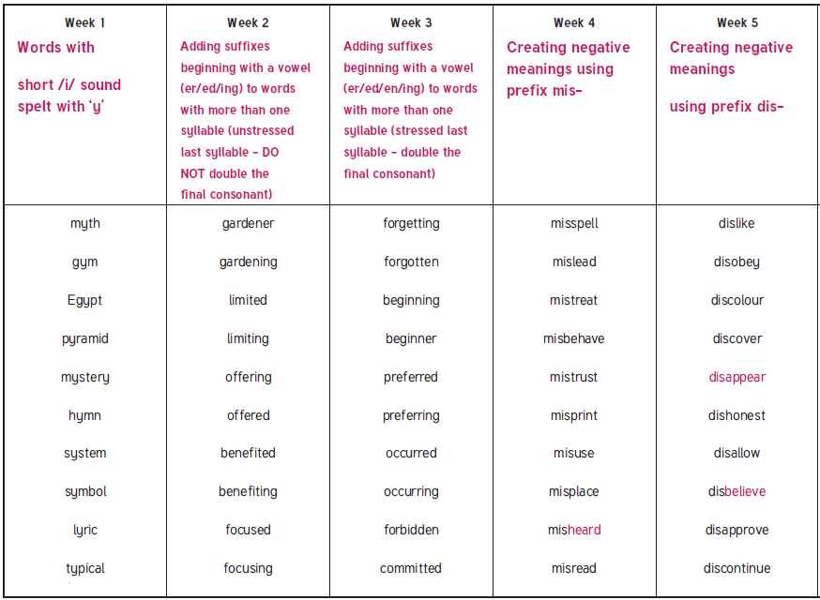

Raising Aspirations project
To celebrate our whole school raising aspirations project NJS will be hosting its very own wax work museum.
We need children to carefully think of someone who is an inspiration to them. They could be an author, actor, sportsperson, business tycoon or anyone who could inspire you in the future.
Across the week we will be writing a biography and creating fact files around their inspirational individual, as well as dressing up as them for the wax work museum (Thursday 8th).

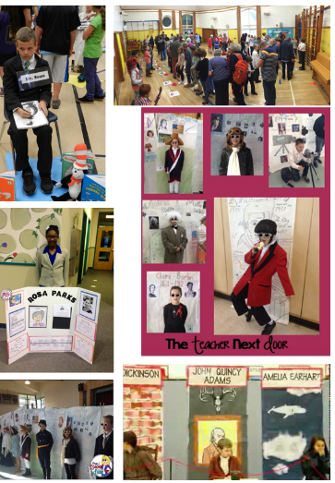
As part of the project your homework task is to start building research around your chosen individual, you may wish to present this as;
- Notes in the form of bullet points.
- Fact files
- Mind maps

Think about collating as much information as possible; this will support your biography writing and Raising aspirations project.
PE Reminders
This half term, Children will be Swimming on Mondays. Please ensure your child has appropriate kit for this day.
For the remaining PE lessons, please bring in PE kits on a Monday and take home on a Friday.
For your information, PE days are usually as follows, but may be subject to change, hence the requirement to bring kits in Mon-Fri:

