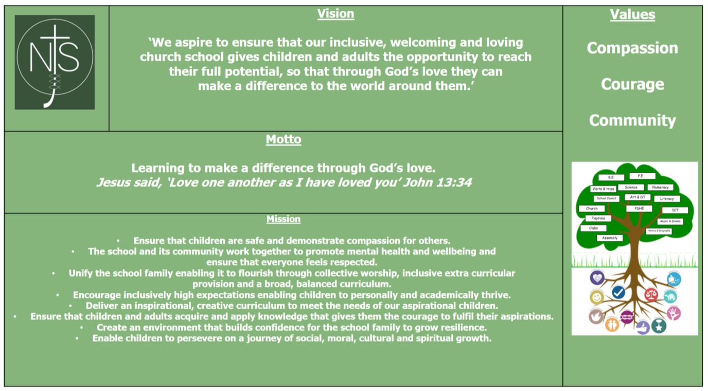
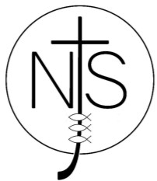
Curriculum Subject: Art and Design

Curriculum Overview and Statement of Intent, Implementation and Impact.

Intent  Our art curriculum offers a diverse and broad study of artistic styles which is inclusive for all children to access. These examples may include: abstract, cubism, surrealism, renaissance and impressionism.  Children will be given the opportunity to learn by participating in exciting learning tasks which will help them reach their full potential. Children will learn about famous and influential artists from both historic and modern periods. Our art curriculum will make a difference by helping children be more creative. We are also working towards our Artsmark Award and we hope that many cross-curricular links will embedded as well as links with artists within our community and from afar. | Implementation  The children will be provided with the opportunity to access art on a weekly basis. Children will be taught art which is sometimes crosscurricular linked to the specific topics the children are focusing on. Newport Junior School also offers the children opportunities to learn art when hosting art festivals, topic days and during our raising aspirations week. The children also have the chance to engage in new learning opportunities when artists come into school and work with the children. We will also encourage our art ambassadors to help other children appreciate and celebrate art across our school. | Impact  The arts curriculum provides children with a creative outlet to explore and express their emotions. It can help to build resilience and develop social skills. For many children the arts can be a creative outlet and provide the students with a freedom of expression which will help them express their emotions and explore their creativity. Our Art curriculum at NJS empowers children and enables them to celebrate their creativity and to provide them with knowledge and understanding of all of the various forms of art.
Subject Leader: Mrs Natalie Jukes

Newport CE Junior School: Curriculum Progress Map for __________2023/2024
 | Year 3 | _______  Year 4 | Year 5 | Year 6
Autumn | Unit Title:  Prehistoric World  Towns and Cities | Unit Title:  Roman Art  Complete Journeys | Unit Title:  Viking Art  kandinsky 3-D | Unit Title:  Landscapes  Clarice Cliff
 | Vocabulary:  shape, drawing, size, colour, painting, texture, artist, artists’ impression, scaly and pigment,3dimensional, sculpture. | Vocabulary:  Artists, Colour, mosaic, tesserae, symbols, terracotta, texture, Indigenous, Aborigines. | Vocabulary:  Colour, dragon head, knots, Celtic patterns, composition, texture, concentric,  Fabric, outfits, shapes, orphism. | Vocabulary:  Symbol, Size, Colour, Texture, Artist, Artists’, John Constable, Clarice Cliff, Historic, Landscape, Patterns, Pottery, Shapes and Decorative.
 | Key Knowledge:  To learn about features of cave paintings.  To learn about sculptures, building and landscapes. | Key Knowledge:  To know what artwork existed during the Roman times.  To identify aboriginal art. | Key Knowledge:  To identify features of Viking Art.  To understand what made Kandinsky’s art unique. | Key Knowledge:  To learn about landscape artists.  To learn about Clarice Cliff’s Pottery.
 | Key Skills:  To develop sketching skills and record Observations.  To build a sculpture. | Key Skills:  To be able to design a mosaic using tesserae.  To develop techniques, including control and use of different symbols. | Key Skills:  To create viking art  To use concentric shapes in my own art. | Key Skills:  To use a variety of sources including observational drawings, photographs and digital images to produce landscapes.  To produce a plate in the style of Cliff.
Spring | Unit Title:  Egyptian Art  Butterflies | Unit Title:  Heraldry  Rainforests | Unit Title:  Mapping it Out  Street Art | Unit Title:  Portraits  Tudor Art and Artists
 | Vocabulary:  Colour, texture, papyrus, Egyptian, collage, printing, textiles, cutting and joining. | Vocabulary:  Texture, size, symbol, doodling, tones, shading and hatching, coat of arms, shield, geometric and symmetrical. | Vocabulary:  3-Dimensional, texture, shading and hatching, imaginative, primary and secondary colours, patterns and shapes. | Vocabulary:  Imaginative, focal point, proportions, imaginative, facial features, horizontal and vertical lines, Tudor style.
 | Key Knowledge:  To learn features of Egyptian Art.  To understand symmetry. | Key Knowledge:  To learn about features of a coat of arms.  To learn what a mola is. | Key Knowledge:  To understand map representations.  To identify features of middle eastern art. | Key Knowledge:  To learn about famous portraits which have been painted from various artists.  To know features of Tudor Art.
 | Key Skills:  To Understand how to create detailed observational drawings.  To know how to create symmetrical patterns. | Key Skills:  To produce a coat of arms.  To create a traditional Mola from fabric. | Key Skills:  To make a 3D model.  To produce graffiti art. | Key Skills:  To produce portraits.
Summer | Unit Title:  Greek Pots  Van Gogh | Unit Title:  Henri Matisse  Plant Art | Unit Title:  William Morris  Seaside Art | Unit Title:  Warhol & The Pop Art Movement  Action Figures
 | Vocabulary:  Clay, ancient, symmetrical, Greek Meander Vincent Van Gogh, tones, lines and shades. | Vocabulary:  Blocking, pointillism, symbols, lines, patterns and collage. Abstract, composition, observational, lines, patterns. | Vocabulary:  Patterns, textures, fabrics, wallpaper, botanical, sand, sea, shades, tones, layering. | Vocabulary:  Pointillism, Cartoon, Observational, Blocks, Patterns, Marks, Creations, Variations, Geometric, Modified, Digital Images and Visual.
 | Key Knowledge:  To know features of ancient Greek pottery.  To learn about Van Gogh. | Key Knowledge:  To know about Henri Matisse.  To know how to use tints and shades in my work. | Key Knowledge:  To know about William Morris.  To identify features of seascape. | Key Knowledge:  To know about Andy Warhol.  To know about action figures used in cartoons and animations.
 | Key Skills:  To use clay to make a pot.  To use a variety of materials to replicate historic art. | Key Skills:  To complete life drawing.  To know how to use the V and Y method when drawing trees. | Key Skills:  To produce wallpaper in style of William Morris.  To produce a seascape. | Key Skills:  To know how to use colour to create atmosphere and to show the effect of various colours.  To produce a sculpture.

