Newport CE Junior School

History Policy

Date Policy Written and Agreed by Governors: | Date of last review: | Date of next review:
Spring 2020 | Spring 2023 | Spring 2024

‘We aspire to ensure that our inclusive, welcoming and loving church school gives children and adults the opportunity to reach their full potential, so that through God’s love they can make a difference to the world around them.’

Intent:
At Newport Junior School we believe that all children are entitled to an inclusive, broad and a balanced curriculum that allows all children to make progress and reach their full potential. Our History curriculum allows children to learn about the past, developing their understanding of compassion, courage and community through history. We endeavour to offer our children chronological knowledge of historical periods, the skills required to understand how historians have learnt about the past. As well as them being able to identify our six threads of history and how each period builds on the schema.

Implementation:
Each year children will complete three units in chronological order which extends across the school. Year 3 starting the year with Stone Age to Iron Age and ending with Year 6 covering the Tudors. We ensure the children have a knowledge of both British and non European history to give a broad and diverse view of the world and its history. We ensure children have the knowledge of a balance of World and British History topics including Stone Age to Iron Age, Roman Britain, a local study - Newport, Anglo-Saxons and Vikings, Ancient Egyptians, Benin, Ancient Greece and Tudor England. While studying these topics, the children will be able to identify six threads of history that are built upon over time. These threads (schema) are Invasion, Settlement, Religion, Monarchy, Pioneers and Kingdom.

Impact:
At Newport Junior School we strive to allow all pupils to develop their subject knowledge of topics covered and of the related skills. We ensure that every year the children complete topics that are chronological to ensure they understand how the threads of history have been built upon over time. We ensure that the children are able to understand the value of primary and secondary sources as well as how the local demographic impacts history. The children learn how historians interpret the past, preparing them for the next phase of their education so they can reach their full potential.

The Curriculum:

At Newport Junior School we believe that the national curriculum encompasses every experience the children encounter during their time at school.
We have developed a curriculum that inclusively ensures that all pupils have access to each of the National Curriculum subject areas as well as a range of other learning opportunities in order to reach their full potential.
We aim to promote an understanding of diversity and cultural capital in a variety of ways including through our key values of compassion, courage and community.
The curriculum evolves and is responsive to events around us; we want children to leave us able to make a difference.

Progression Planner:

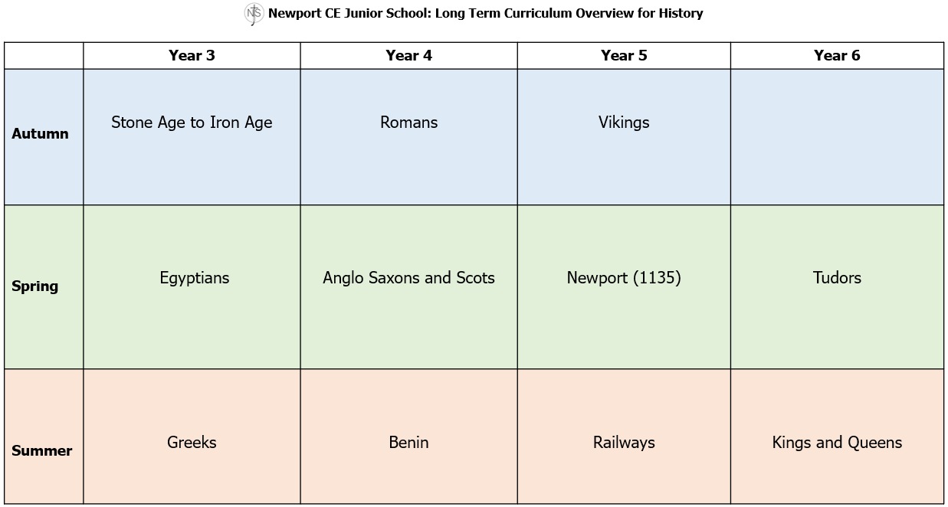

Statement on developing skills in History:

Historical skills are transferable and used across several subjects in the Curriculum and in the adult world. Skills including interpretation and enquiry of sources, organisation and managing the opinions of historians allow children to interact with information and data and be able to make sense of it as part of the bigger picture. Our history offer teaches children how understand bias and start to scrutinise sources for quality.

Special Educational Needs, Disabilities and Inclusion.

At Newport Junior School we believe in a broad and balanced curriculum that allows all children, no matter of ability or need, to access an innovative and imaginative history curriculum. This allows our children to meet their full potential. We do this by setting suitably challenging learning tasks, identifying teaching styles and making adaptations to the curriculum which allows the children to fully participate in all activities regardless of need or ability.
Where children are to participate in activities outside of the classroom, for example a visit to a historical site such as an archaeological dig in the Romans topic, we carry out a risk assessment prior to the activity, to ensure that the activity is safe and appropriate for all pupils. This is in line with the Equalities Act and our school policy.
Inclusion is seen to involve all and minimising of barriers to learning and participation, and the maximising of resources to support learning participation. We aim to set suitable learning challenges, respond to pupils’ diverse needs and overcome potential barriers to learning for individuals and groups of pupils. Every member of staff shares the responsibility to remove barriers to learning for all pupils, including those with a disability. As a result, we are committed to offering an inclusive curriculum to ensure the best possible progress for all our pupils.

Assessment:
Teachers use on-going teacher assessment to help inform their daily planning. Teachers use assessment grids, observations, marking, notes to teacher, peer and self-assessment and daily interactions with children to inform next steps in learning.
The children are involved in the assessment of their own work, using success criteria where they evaluate their progress against the learning outcome for their unit of learning. They can identify gaps and next steps for learning. Children also use schemas to ensure knowledge has stuck and can be recalled when building on the themes and threads of history during their time at Newport Junior School.

Teachers use end of year standards to make their on-going teacher assessment judgments when highlighting child friendly assessment grids. Teachers and children judge progress in areas of chronology, substantiative and disciplinary knowledge, historical interpretation, enquiry and organisation. History is formally teacher assessed twice a year, once in Spring and again at the end of July, but ongoing assessment to ensure progression occurs during the teaching cycle.

Monitoring:
Over the course of an academic year, the history leader will monitor the subject in line with the school Monitoring Policy, this will include pupil voice, book looks and analysis of data and will feed into the subject action plan and SDP if particular areas of work are identified.

Resources:
History resources are located across the school in each year group area. The school also buys into Shropshire Library Service Artefact box programme which provides the children an opportunity to understand primary and secondary sources within the classroom. Children have access to three artefact boxes per year according to their topic offer. All year groups are responsible for keeping the artefacts tidy and safe and will report to the History Lead if anything needs to be replaced. Resources are to be monitored annually by the History Subject Lead.

New resources may be sourced through permission of the Head Teacher/Deputy Head Teacher.
Resources can be shared through Year group team meetings.

Health and Safety:
The school is committed to ensuring that all pupils are safe within the school environment.
Please refer to the school’s policy for Health and Safety for further information.

Roles and Responsibilities:
Head Teacher and Governing Body
- support the use of appropriate teaching strategies by allocating resources effectively;
- monitor teaching strategies in the light of health and safety regulations;
- monitor how effective teaching and learning strategies are in terms of raising pupil attainment;
- ensure that staff development and performance management policies promote good quality teaching.

History Subject Lead
- ensures the effective implementation of the National Curriculum for History;
- completes a subject action plan which addresses key areas for development based on analysis of data and key messages from monitoring.
- supports colleagues in the teaching of History and identifying any training needs;
- maintains the availability of high-quality resources;
- maintains an overview of current trends and developments within the subject;
- ensures, together with the SLT, a rigorous and effective programme of monitoring and evaluation including planning reviews; lesson observations, learning walks, pupil voice interviews and book looks;
- gives feedback following monitoring and evaluation to individuals and teams as necessary to ensure teaching and learning improves/develops;

Class Teachers
- ensure the effective implementation of the National Curriculum for History;
- follow this agreed policy and related policies.
- teach high quality history lessons.

Parent Partnership:
Parents are vital in supporting their child’s development. It is a partnership where we encourage parents to fully engage in what their child is learning at school and help with any topic related research or enquiry that maybe set: working together to deepen their fascination for the past.
Children’s progress in history is reported at Parents’ Evening meetings in the autumn and spring terms and in their end-of-year report at the end of the summer term.

C. Pearson
Spring 2024

