There are different types of attachment.
Secure
Avoidant
Resistant/reactive
Disorganised.
Signs that a child may have an attachment disorder include:
- Bullying or hurting others.
- Extreme clinginess.
- Failure to smile.
- Intense bursts of anger.
- Lack of eye contact.
- Lack of fear of strangers.
- Lack of affection for caregivers.
- Oppositional behaviours

Reactive attachment disorder usually starts in infancy and is the most common type. There's little research on signs and symptoms of reactive attachment disorder beyond early childhood, and it remains uncertain whether it occurs in children older than 5 years.
Signs and symptoms may include:
- Unexplained withdrawal, fear, sadness, or irritability
- Sad and listless appearance
- Not seeking comfort or showing no response when comfort is given.
- Failure to smile.
- Watching others closely but not engaging in social interaction
- Failure to reach out when picked up.
- No interest in playing peekaboo or other interactive games.
- Behaviour problems
- Failing to seek support or assistance.

Summer term 2024
Dear Parents/Carers, It has already been a very busy term with lots of special events and activities in school.

Termly focus
Each term we will focus the spotlight on a particular area of special educational needs and disabilities. This term we will focus on attachment disorder.

Definition of Attachment disorder:
Attachment disorder is a broad term used to describe a series of emotional and behavioural problems that can develop in young children who struggle to form expected bonds to primary care givers.

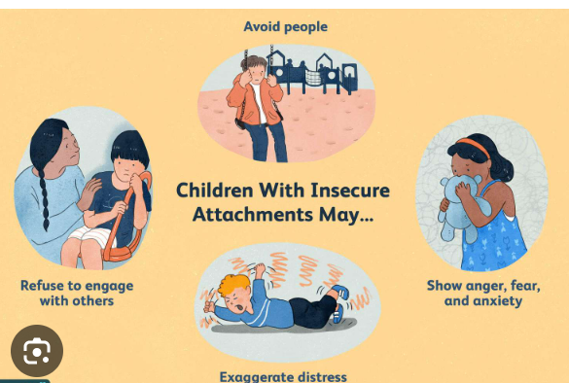

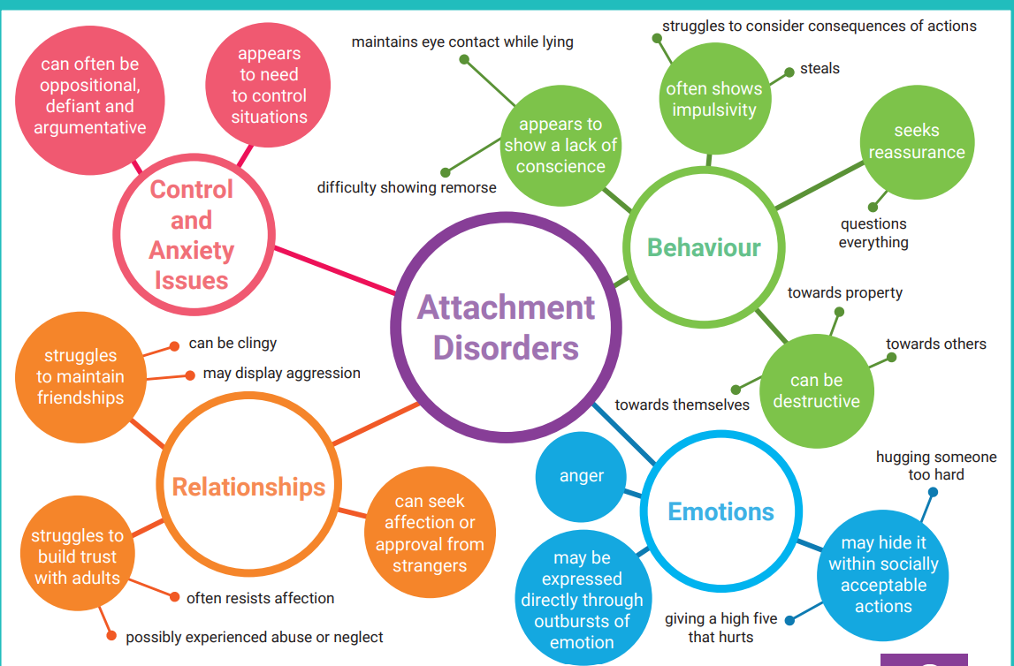
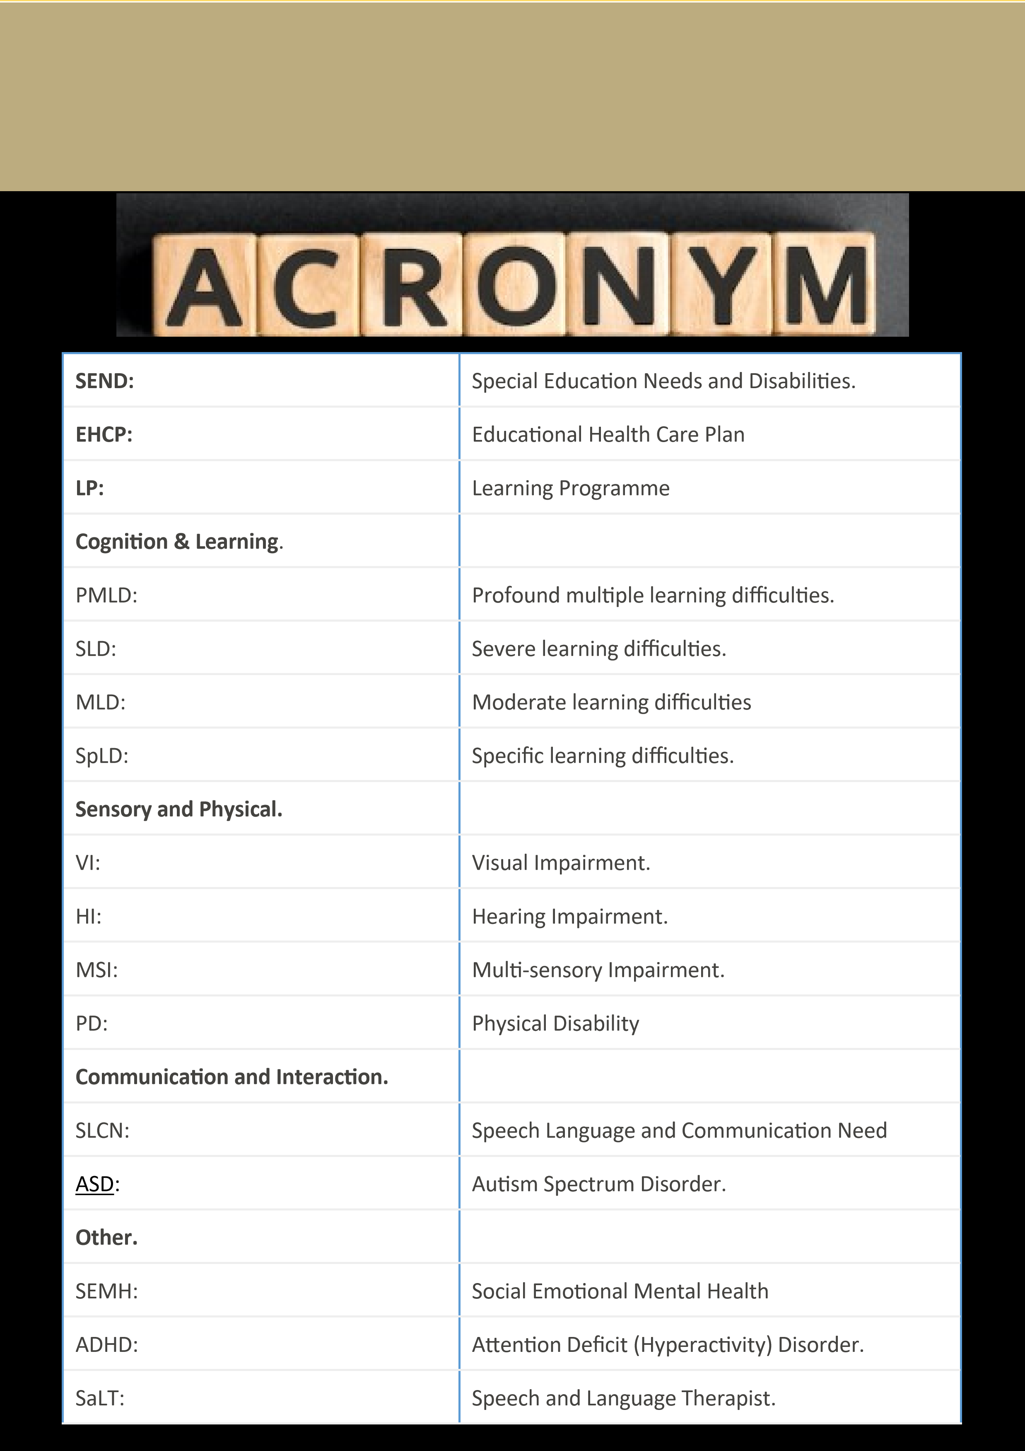

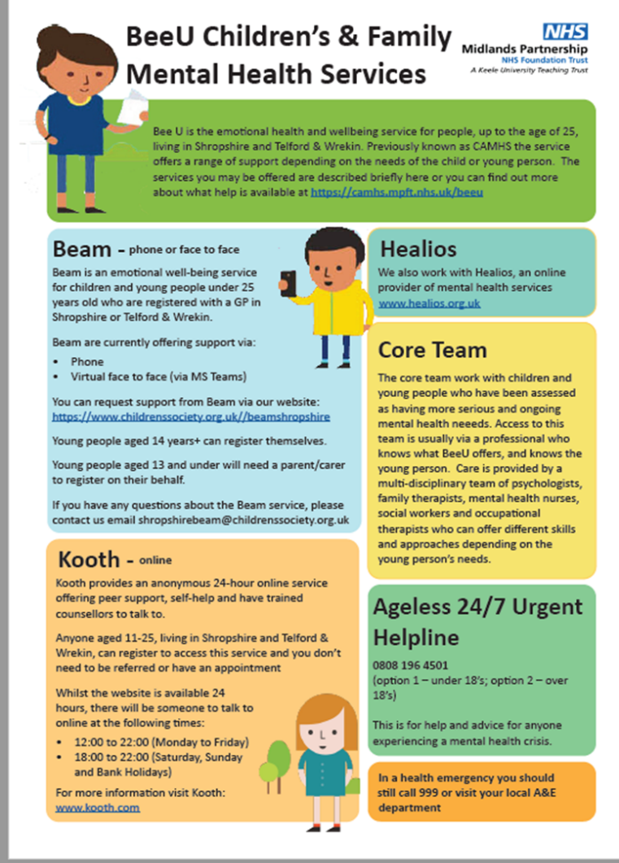

Key Contacts
SENDCO: Jane Kerr
njs.send@taw.org.uk
Inclusion Manager: Megan Wheat
SEND admin: Jo Anderson
Headteacher: Nicola Moody
01952 386600
Local offer: https://www.telfordsend.org.uk/site/index.php
Telford and Wrekin SEND parent newsletter:
www.telfordsend.org.uk/info/1/home/109/send_news
If you wish to discuss any concerns you have please speak to the class teacher or contact the SENDCO.

