
Newport CE Junior School

Child Sexual Exploitation Policy
(CSE)

Date Policy Written and Agreed by Governors: | Date of last review: | Date of next review:
Summer 2023 | Summer 2025 | Summer 2026
Newport CE Junior School
Child Sexual Exploitation Policy
(CSE)
‘We aspire to ensure that our inclusive, welcoming and loving church school gives children and adults the opportunity to reach their full potential, so that through
God’s love they can make a difference to the world around them.’

Our CSE Policy is based upon this core Christian message;
Jesus said,” Love one another as I have loved you”. (John 13:34)
Our Statement of Intent:
Newport Junior School strives to ensure the safety and wellbeing of all pupils at the school. In order to effectively achieve this, staff members at the school must safeguard and protect children against CSE.
This policy outlines the school’s procedures for preventing, managing and reporting cases of CSE.
The responsibilities of staff members in relation to safeguarding and protecting children are outlined; including those in relation to the Headteacher, DSL and the Governing Body.
Our CSE curriculum is to provide a range of opportunities and contexts for pupils to develop self-awareness, positive self-esteem and confidence in order to stay as safe and healthy as possible; keeping themselves and others safe; have worthwhile and fulfilling relationships; respect the differences between people; develop independence and responsibility; play an active role as members of a democratic society and to make the most of their own and others’ abilities.
In order to effectively implement this policy and ensure the necessary control measures are in place, parents are responsible for working alongside the school to identify concerns and potential risks, in order to ensure the health and safety of their children.

Legal Framework Legislation which supports our CSE Policy.
- Children Act 1989
- Children Act 2004
- Safeguarding Vulnerable Groups Act 2006
- The Education (School Teachers’ Appraisal) (England) Regulations 2012
- Sexual Offences Act 2003
- The General Data Protection Regulation (GDPR)
- Data Protection Act 2018
- The Childcare (Disqualification) and Childcare (Early Years Provision Free of
- Charge) (Extended Entitlement) (Amendment) Regulations 2018
- Statutory guidance
- DfE (2018) ‘Working Together to Safeguard Children’
- DfE (2022) ‘Keeping Children Safe in Education’
- Non-statutory guidance
- DfE (2015) ‘What to do if you’re worried a child is being abused’.
- DfE (2018) ‘Information sharing’
- DfE (2017) ‘Child sexual exploitation’
Other relevant school policies include:
- Child Protection and Safeguarding Policy ➢ Health and Safety Policy ➢ Equality Policy:
- Anti-Bullying Policy
- ICT Acceptable Use Policy
- Social Media Policy
- NJS Data Protection Policy

What is CSE?
CSE is defined as a form of sexual abuse where an individual or group takes advantage of an imbalance of power to coerce, manipulate or deceive a child or young person into sexual activity, for either, or both, of the following reasons:
- In exchange for something the victim needs or wants
- For the financial advantage or increased status of the perpetrator or facilitator
A child can be being sexually exploited even if the sexual activity appears consensual. Even where a young person is old enough to legally consent to sexual activity, the law states that consent is only valid where they make a choice and have the freedom and capacity to make that choice.

CSE:
- Can affect anyone under the age of 18, including 16 and 17-year-olds who can legally consent to having sex.
- Can take place in person, through the use of technology or a combination of both.
- Can involve both contact (penetrative and non-penetrative acts) and non-contact sexual activity.
- Can involve force and/or enticement, and may involve violence or threats of violence.
- Can occur without the child’s knowledge (e.g. through the copying of videos or images they have created and posted online).
- Can be perpetrated by males or females, children or adults, individuals or groups.
- Can involve one-off occurrences or regular incidents.
- Can be opportunistic or complex and organised.
- Normally involves a power imbalance in favour of the perpetrator. Age is the most obvious imbalance, but it can also be due to other factors such as gender, sexual identity, cognitive ability, physical strength, status and access to economic or other resources.
If sexual gratification, or exercising power and control, is the only motive of the perpetrator, this would not normally constitute CSE, but will be responded to as a different form of child sexual abuse and dealt with in line with the Child Protection and Safeguarding Policy.

Roles and Responsibilities
‘Safeguarding and promoting the welfare of children is everyone’s responsibility.’
Everyone who comes into contact with children and their families has a role to play and all school staff will undertake their responsibilities with due diligence to this policy and all safeguarding and child protection policies.
The Governing Body has a duty to:
- Ensure that the school complies with its duties under the above child protection and safeguarding legislation.
- Guarantee that the policies, procedures and training opportunities in the school are effective and always comply with the law.
- Guarantee that the school contributes to inter-agency working in line with the statutory guidance ‘Working Together to Safeguard Children’.
- Confirm that the school’s safeguarding arrangements consider the procedures and practices of the LA as part of safeguarding procedures.
- Understand the local criteria for action and the local protocol for assessment, and ensure these are reflected in the school’s policies and procedures.
- Comply with its obligations under section 14B of the Children Act 2004 to supply the local safeguarding arrangements with information to fulfil its functions.
- Ensure that staff members have due regard to relevant data protection principles that allow them to share (and withhold) personal information.
- Ensure that a member of the Governing Body is nominated to liaise with the LA and/or partner agencies on issues of child protection and in the event of allegations of abuse made against the Headteacher or another governor.
- Guarantee that there are effective child protection policies and procedures in place together with a Code of Conduct.
- Ensure all relevant persons are aware of the school’s local safeguarding arrangements, including the Governing Body itself, the SLT and DSL’s.
- Make sure that pupils are taught about safeguarding, including protection against dangers online (including when they are online at home), through teaching and learning opportunities, as part of providing a broad and balanced curriculum.
- Ensure that all staff members receive safeguarding and child protection training updates, such as e-bulletins, emails and staff meetings, as required, but at least annually.
- Make sure that pupils’ wishes and feelings are taken into account when determining what action to take and what services to provide to protect individual pupils.
- Guarantee that there are systems in place for pupils to express their views and give feedback.
- Establish an early help procedure and ensure all staff understand the procedure and their role in it.
- Introduce mechanisms to assist staff in understanding and discharging their roles and responsibilities.
- Put in place appropriate safeguarding responses for pupils who go missing from
- school, particularly on repeat occasions, to help identify any risk of abuse and • neglect, including sexual abuse or exploitation, and prevent the risk of their
- disappearance in future.
- Create a culture where staff are confident to challenge senior leaders over any
- safeguarding concerns.

The Headteacher has a duty to:
- Safeguard pupils’ wellbeing and maintain public trust in the teaching profession.
- Ensure that the policies and procedures adopted by the Governing Body, particularly concerning referrals of cases of suspected abuse and neglect, are followed by staff members.
- Provide staff, upon induction, with the Child Protection and Safeguarding Policy, Code of Conduct, part one of the ‘Keeping children safe in education’ (KCSIE) guidance, the Behavioural Policy, the Children Missing from Education Policy, online safety training, and the identity of the DSL and any deputies.
- Ensure the school’s Child Protection and Safeguarding Policy is available publicly, and parents are aware that the school may make referrals for suspected cases of abuse or neglect, as well as the role the school plays in these referrals.

The DSL has a duty to:
- Understand and keep up-to-date with local safeguarding arrangements.
- Make the necessary child protection referrals to appropriate agencies such as Family Connect.
- Understand when they should consider calling the police, in line with the National Police Chiefs’ Council (NPCC) guidance.
- Liaise with the other DSL(s) to ensure effective safeguarding outcomes.
- Act as a source of support, advice and expertise to staff members on matters of safeguarding by liaising with relevant agencies.
- Understand the assessment process for providing early help and intervention.
- Keep cases of early help under constant review.
- Be alert to the specific requirements of children in need, including those with SEND and those who are Young Carers.
- Keep detailed, accurate and secure records of concerns and referrals.
- Secure access to CSE related resources and attend any relevant training courses.
- Ensure that staff members receive safeguarding training, including that in relation to CSE, on a regular basis.
- Encourage a culture of listening to children and taking account of their wishes and feelings.
- Work with the Governing Body to ensure the school’s Child Protection and Safeguarding Policy is reviewed annually and the procedures are updated regularly.
- Ensure the best educational outcomes by identifying at-risk pupils to the school and its staff, so that the relevant personnel understand each pupil’s educational and welfare needs.
- Support teaching staff to identify the challenges that at-risk pupils may face and the additional academic support and adjustments they can make to support these pupils.
- Link with local safeguarding arrangements to make sure that staff members are aware of the training opportunities available and the latest local policies on safeguarding.

Other staff members have a responsibility to:
- Safeguard pupils’ wellbeing and maintain public trust in the teaching profession as part of their professional duties.
- Maintain an attitude of ‘it could happen here’ where safeguarding is concerned.
- Be aware of the signs of abuse and neglect.
- Be aware of the early help process and understand their role in it.
- Act as the lead professional in undertaking an early help assessment, where necessary.
- Be confident of the processing conditions under relevant data protection legislation, including information which is sensitive and personal, and information that should be treated as special category data.
- Make a referral to CSCS and/or the police immediately, if at any point there is a risk of immediate serious harm to a child.
- Be aware of and understand the procedure to follow in the event that a child confides they are being abused or neglected.
- Support social workers in making decisions about individual children, in collaboration with the DSL.
- Maintain appropriate levels of confidentiality when dealing with individual cases, and always act in the best interest of the child.
- Challenge senior leaders over any safeguarding concerns, where necessary.

Staff Training / CPD
- Staff members will undergo safeguarding and child protection training at induction, which will be regularly updated as required, but at least annually or whenever there is a change in legislation.
When planning training, the Headteacher / DSL will take the context of the school into consideration, ascertaining whether there are specific issues which need to be addressed as a priority.
During staff training, the following issues will be addressed:
- Warning signs and indicators of CSE
- The different forms of CSE
- Pupils most at risk of CSE
- Protecting and supporting pupils
- Procedures for reporting suspected cases of CSE
- Information sharing protocols
- Facilitating conversations with pupils and parents about CSE
Staff training will be updated on a regular basis, at the discretion of the Headteacher / DSL, ensuring that the information staff members have is up-todate with sector developments.
Training will cover, at a minimum:
- The issues surrounding sexual violence and sexual harassment.
- Contextual safeguarding.
- How to keep previously Children in Care safe.
- Child criminal exploitation and the need to refer cases to the National Referral Mechanism.
The DSL and deputy DSL will undergo updated child protection training every two years, as well as additional training to refresh their skills and knowledge at regular intervals (at least annually) to allow them to keep up-to-date with any developments relevant to their role.
All staff members will be trained to respond to concerns in ways that are:
- Child-centred.
- Developed and informed by the involvement of the child’s family, where appropriate.
- Responsive and pro-active.
- Relationship-based.
- Informed by an understanding of the complexities of CSE.

Indicators of CSE
Staff members will be aware of the pupils most at risk of being sexually exploited, including vulnerable pupils, excluded pupils and pupils with SEND.
All staff members are aware of the warning signs of CSE and will look out for the following indicators:
- Being secretive
- Acting withdrawn and isolated
- Acquiring money and goods without sufficient justification
- Unexplained school absences
- Staying out late or going missing
- Consuming alcohol or drugs
- Acting hostile or aggressive
- Associating with gangs
- Displaying inappropriate sexualised behaviour for age
- Developing relationships, particularly of a sexual nature, with a significantly older person
- Having older boyfriends or girlfriends
- Changing their physical appearance
- Acting in a defensive manner
- Becoming involved in petty crime
- Self-harming or displaying significant changes in emotional well-being
- Having physical injuries without plausible explanation
- Suffering from sexually transmitted infections or become pregnant
- Trying to conceal marks or scars on their body
- Refusing to uncover parts of their body
- Entering or leaving vehicles driven by unknown adults
- Having a lack of positive relationships
- Using the internet in a manner which causes concern
- Associating with other young people involved in exploitation
- Displaying a concerning use of internet and social media

Effects of CSE
CSE can have long-lasting effects on a child and the school is committed to early identification in order to reduce these effects.
All staff members will be made aware of the effects and signs of CSE in order to aid early identification.
Staff members are aware that CSE can affect every aspect of a child’s life, including, but not limited to, the following:
- Physical wellbeing
- Mental health
- Education
- Employment prospects
- Family relationships
- Social relationships, as children and as adults
- Their relationship with their own children in the future

Online safety
Online safety is embedded throughout the curriculum, with teaching always made appropriate to pupils’ ages and developmental stages; however, it is particularly addressed in the following subjects:
- Computing / E-Safety
- RSE
- Health Education
- PSHE
Pupils are taught the underpinning knowledge and behaviours that can help them to navigate the online world safely and confidently regardless of the device, platform or app they are using.
The underpinning knowledge and behaviours pupils learn through the curriculum include the following:
- How to evaluate what they see online
- How to recognise techniques used for persuasion
- Acceptable and unacceptable online behaviour
- How to identify online risks
- How and when to seek support
The school recognises that, while any pupil can be vulnerable online, there are some pupils who may be more susceptible to online harm or have less support from family and friends in staying safe online, e.g. pupils with SEND and Children in Care (CiC). Relevant members of staff, e.g. the SENCO and Designated Teacher for CiC, will work together to ensure the curriculum is tailored so these pupils receive the information and support they need, and the DSL will be involved with the development of the school’s online safety curriculum.
Through training, all staff members will be made aware of the following:
- Pupil attitudes and behaviours which may indicate they are at risk of potential harm online
- The procedure to follow when they have a concern regarding a pupil’s online activity
Further information regarding the school’s approach to online safety can be found in the ICT Acceptable Use Policy and Social Media Policy.
Where pupils need to learn online from home, the school will support them to do so safely.

Sexting
Sexting is defined as, ‘the production and/or sharing of sexual photos and videos of and by young people who are under the age of 18.’
It includes nude or nearly nude images and/or sexual acts. It is also referred to as ‘youth produced sexual imagery’. ‘Sexting’ does not include the sharing of sexual photos and videos of under-18 year olds with or by adults. This is a form of child sexual abuse and must be referred to the police.
Sending and receiving sexually explicit messages or images is a serious offence, and is often a primary method utilised by CSE offenders to communicate with victims.
Sexting will be handled as a child protection issue in line with the Child Protection and Safeguarding Policy.
As part of their training, staff members will be able to identify instances of sexting and will be made aware of the necessary procedures to follow and the need to inform the DSL immediately if they are made aware of any such incidents.

The dangers of sexting will be taught alongside CSE in the Curriculum, in order to convey to pupils how the two are linked and why they are dangerous.
Pupils will be made aware that, regardless of age, the police consider sexting amongst people under the age of 16 a criminal offence.
Parents will be made aware about the dangers of sexting and the appropriate safety measures to be implemented.

CSE in the Curriculum – (See Appendix A - CSE Curriculum Maps)
CSE will be taught through our PSHE and RSHE curriculum. Some aspects of building resilience and learning about healthy and unhealthy relationships will be drawn from other areas of the curriculum e.g. Computing or Guided Reading.
The Jigsaw PSHE Curriculum allows teachers from Year 5 and Year 6 to focus specifically on CSE through planned activities in the autumn term - Being Me in My World unit and in the summer term – Relationships unit.
Other areas of the whole school curriculum will also allow skills around CSE to be developed; anti-bullying week, our courageous advocates and Expect Respect lessons.
Relationships and Sex Education - Pupils will be taught about CSE in line with the school’s Relationships and Sex Education Policy.
CSE will be addressed as part of a wider programme of work regarding relationships and sex education (RSE), as well as part of PSHE. This will be more explicit in Year 5 and 6 but our curriculum in Year 3 and 4 is designed to build relevant skills to support their understanding and resilience to the dangers and risks of CSE.
The school is dedicated to delivering these programmes of work with sensitivity and respect, avoiding any derogatory or prejudicial terms which may cause offence.
The school understands that the teaching of some aspects of the programmes may be of concern to parents; therefore, the curriculum is shared with parents and a right to withdraw is built into the school’s RSE curriculum.
Pupils will be made aware of the dangers of CSE, along with how to spot the signs and symptoms of CSE, through assemblies, leaflets, posters and the curriculum.
The DSL will work in conjunction with the lead for RSE and PSHE to ensure that ageappropriate lessons are devised.
Teachers will consider the feelings of pupils who may have been traumatised by similar incidents in their past when teaching about CSE. Sensitivity will be given to the age and cultural background of pupils. Where possible, CSE education will build on existing topics that pupils may already be aware of. Only age-appropriate topics will be taught. Throughout every year group, age-appropriate resources, such as diagrams, videos, books, games, discussion and practical activities, will be used to assist learning. Teachers understand that they may need to be more explicit and will adapt their planning of work in order to appropriately deliver the programme to pupils with SEND.

Working with parents
The school will ensure that parents:
- Understand the risks of CSE and recognise that the issue is something that could affect their child.
- Understand that CSE can occur both online and offline.
- Know the warning signs of CSE.
- Know how to report any concerns that they may have.
- Know where to go for support if their child has been the victim, or is the suspected victim, of CSE.
- Are reassured that a range of services will, as appropriate, work with them to try to protect their child.
- Can access support to manage the emotional impact of CSE on their child and themselves.
- Can access support that is tailored to their specific circumstances, e.g. support that recognises culture or faith.
Parents will be provided with the contact information of relevant services and outside agencies via letters home and the school website. Where appropriate, training sessions will be provided to parents in order to help combat CSE at all levels within the school community. Parents will be made aware of whom to report concerns to within the school, via information posted on the school website. Parents’ concerns will always be listened to and taken seriously.
Parents will be consulted regarding the content of pupils’ RSE, including that in relation to CSE, and their views will be listened to and valued.
The school respects the legal right of parents to withdraw their child from all or part of the RSE programme, including that regarding CSE, except for the statutory parts included in the science national curriculum.

Reporting and Referrals
If a member of staff has any concern about a child’s welfare, or suspects that a pupil is at risk of, or has been the victim of CSE, they will act on them immediately by speaking to the DSL. This will be recorded using CPOM’s in line with our Safeguarding Policy and procedures.
All staff members are aware of the procedure for reporting concerns and understand their responsibilities in relation to confidentiality and information sharing, as outlined in the Child Protection and Safeguarding Policy.
If a pupil is in immediate danger, a referral will be made to Family Connect or the police immediately.
The DSL will work alongside external agencies, maintaining continuous liaison, including multi-agency liaison where appropriate, in order to ensure the wellbeing of the pupils involved. The DSL will work closely with the police to ensure the school does not jeopardise any criminal proceedings, and to obtain help and support as necessary.
Where a pupil has been harmed or is in immediate danger or at risk of harm, the referrer will be notified of the action that will be taken within one working day of a referral being made. Where this information is not forthcoming, the referrer will contact the assigned social worker for more information.
The school will not wait for the start or outcome of an investigation before protecting the victim and other pupils: this applies to criminal investigations as well as those referred onto Family Connect.
Where Family Connect decide that an investigation is not appropriate, the school will consider referring the incident again if it is believed that the pupil is still at risk of harm. Where Family Connect decide that an investigation is not appropriate and the school agrees with this decision, the school will consider the use of other support mechanisms, such as early help and pastoral support.
At all stages of the reporting and referral process, the pupil will be informed of the decisions made, actions taken and reasons for doing so. The school will ensure that the pupil’s wishes are always taken into account, and that there are systems available for pupils to provide feedback and express their views.
Discussions of concerns with parents will only take place where this would not put the pupil or others at potential risk of harm.
The school will work closely with parents to ensure that the pupil, as well as their family, understands that the arrangements in place, such as in-school interventions, are effectively supported and know where they can access additional support.
All concerns, discussions and decisions made, as well as the reasons for making those decisions, will be recorded in writing by the DSL and kept securely using CPOMs.
When responding to safeguarding concerns, staff members will act calmly and supportively, ensuring that the pupil feels like they are being listened to and believed.
All safeguarding and child protection concerns, including those in relation to CSE, will be dealt with in line with the procedures outlined in school policies, most notably the Child Protection and Safeguarding Policy.

Providing support
Staff members will undergo regular safeguarding training so that they can fully understand the needs of a pupil that has experienced CSE and provide effective support.
Pupils will be reassured that they can talk to staff members if they feel unsafe. All pupils will be able to identify at least three adults in the school who they feel like they could approach to talk to if they have a concern.
A listening culture within the school will be actively promoted by all staff members.
Mentors will be allocated to pupils who have experienced CSE and frequent contact will be maintained in order to develop a trustworthy and consistent relationship.
DSL’s will have access to Supervision Support.

Monitoring and review
This policy is reviewed annually by the Headteacher/DSL.
All members of staff are required to familiarise themselves with all processes and procedures outlined in this policy as part of their induction programme.
The effectiveness of this policy will be monitored and evaluated by all members of staff. Any concerns will be reported to the Headteacher immediately.
Pupil Voice interviews will be used to capture the children’s knowledge and feelings around CSE as part of RSE/ PSHE monitoring.

A Rotherham – Summer 2023

Appendix A- CSE Curriculum Maps

ow does our curriculum provide skills to help children be aware and resilient to hild Se ual ploitation S ighlight sectionsare key to supporting children develop resilience and prior knowledge
RSE and PSHE forms the basis of much of the appropriate curriculum, but not all. Some aspects of building resilience and lear ning about healthy and unhealthy relationships can be drawn from other areas of the curriculum e.g. Computing or Guided Reading.
nowing ore. emembering ore. pplying ore
 | utumn erm | Spring erm | Summer erm
Key Knowledge | I can explain why it is important to have | I can explain the different ways that help | I can explain how my life is influenced
and how it is applied. | rules and how that helps me and others in my class learn.  I can explain why it is important to feel valued.  I can describe different conflicts that might happen in family or friendship groups and how words can be used in hurtful or kind ways when conflicts happen.  I can tell you how being involved with a conflict makes me feel and can offer strategies to help the situation. e.g. Solve It Together or asking for help. | me learn and what I need to do to improve.  I can identify things, people and places that I need to keep safe from, and can tell you some strategies for keeping myself safe and healthy including who to go to for help.  I can express how being anxious/ scared and unwell feels. | positively by people I know and also by people from other countries.  I can explain why my choices might affect my family, friendships and people around the world who I don t know.  I can explain how boys and girls bodies change on the inside/outside during the growing up process and can tell you why these changes are necessary so that their bodies can make babies when they grow up.  I recognise how I feel about these changes
and how it is applied. |  |  | happening to me and can suggest some ideas to cope with these feelings.
PSHE Units | eing e in y World elebrating ifference | reams and Goals ealthy e | elationships  S hanging e
Other areas of the curriculum. | Computing- E-Safety Being Kind Online  Anti-Bullying Week  PANTS  Mentoring sessions  Children in Need  Courageous Advocates | Computing- E-Safety Emails  Safer Internet Day  Courageous Advocates  Mentoring sessions  Residential Visits  Mental Health Week | Expect Respect - Resolving Conflict and Where to  Get Help  Childline- https://www.childline.org.uk/kids  Computing E safety Cyber Bullying  Refugee Week  Mentoring Sessions  Courageous Advocates

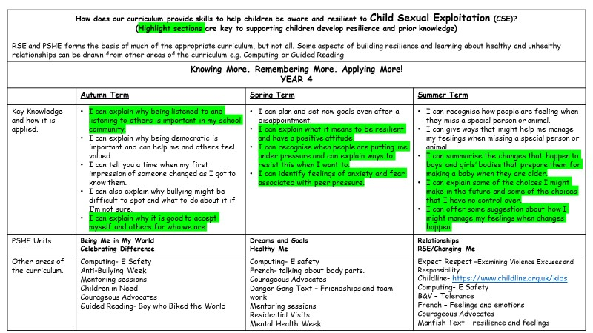
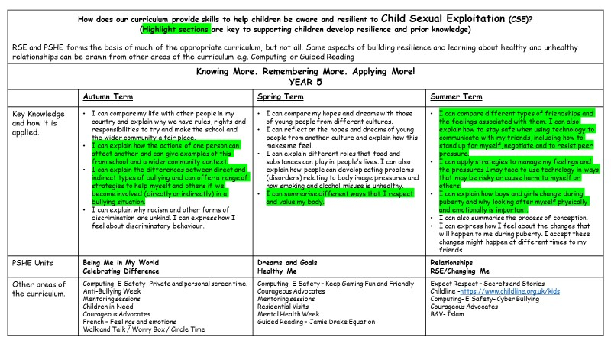

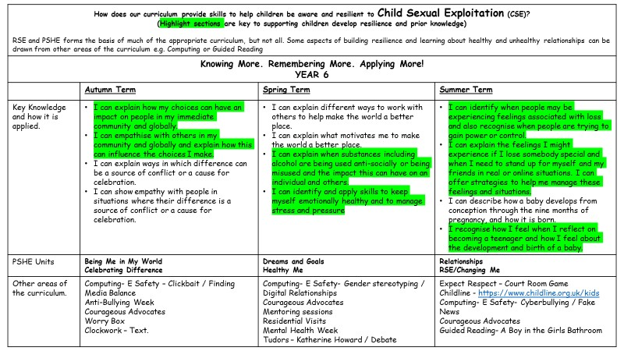

Appendix B
Useful Contacts and Links For pupils
hink U now This website includes different sections designed for children and young people aged 5-7, 8-10, 11-13 and 14+, ensuring that children and young people are taught about CSE using the appropriate resources and terminology for their age. For more information, visit: https://www.thinkuknow.co.uk
OP This national crime agency website can be used to make a report when a child is worried about online sexual abuse or the way someone has been communicating with them online. For more information, visit: https://ceop.police.uk/safety-centre
S the Signs Within this website there is a specific section designed for teaching children about CSE, including in relation to spotting warning signs, developing healthy relationships, staying safe, getting help and busting CSE myths. For more information, visit: http://csethesigns.scot/young-people/.

For parents
Parents Protect A child sexual abuse awareness and prevention website created by the child protection charity Lucy
Faithfull Foundation and Stop it Now ampaign. This site provides information on CSE and where to get help, as well as a list of useful contacts. For more information, call 0808 1000 900 or visit: https://www.parentsprotect.co.uk/home.htm.
S the Signs Within this website there is a specific section designed for parents regarding recognising the signs of CSE, keeping your child safe online and how to access help and support for your child. For more information, visit: http://csethesigns.scot/parents/.
Safe and Sound Group This organisation fighting CSE has created a parent support resource pack providing various sources of useful information regarding supporting a child who is a victim of CSE. For more information, call 01332 362 120 or visit: http://safeandsoundgroup.org.uk/help-support/parentscarers/parentsupport-pack/.

For teachers
hink U now This website includes a section specifically designed for teachers which provides information about CSE, advice about teaching children about CSE and a resource library with materials suitable for both primary and secondary aged children.
For more information, visit: https://new.thinkuknow.co.uk/professionals/.
It’s Not Okay A CSE related website reinforcing the duty of school staff and the role that schools play in the protection of children and prevention of CSE. For more information, visit: http://www.itsnotokay.co.uk.
hildnet This online safety website has an area specifically designed for teachers, providing numerous resources to use within the classroom in order to teach children how to use the internet safely. For more information, visit:
https://www.childnet.com/teachers-and-professionals

