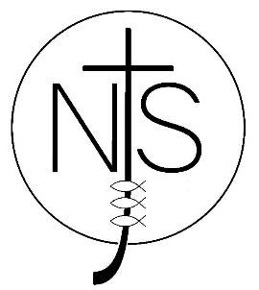 Newport CE Junior School

Lockdown and Evacuation Policy

Date Policy Written and Agreed by Governors: | Date of last review: | Date of next review:
January 2019 | May 2025 | May 2026

A copy of this policy is available by request from h3082@telford.gov.uk

